Section 6 - Software development (6b)
In this section of the project, I will be presenting my final product. I will firstly begin by presenting some annotated listings, followed by the code for each subroutine.
The program was developed in VB.net and used the .NET framework. The namespaces included in this framework are:
- System
- System.Collections
- System.Data
- System.Drawing
- System.IO
- System.Text
- System.Threading
- System.Timers
- System.Web
- System.Web.Services
- System.Windows.Forms
- System.Xml
The most notable and used frameworks were System.IO to be able to import the .csv files, and System.Windows.Forms for creating the forms. This library reduced the inconvenience of creating the forms from scratch, by providing me with both the foundations and the options to customise these forms, which enabled me to create both an intiuitive and aesthetically pleasing product.
Login Form
The label on the top right of the login form acts a a close button, so when clicked; closes the form itself.
The username textbox will have the text “username” in dim gray until clicked, when clicked the text will become darker and will be the user input.
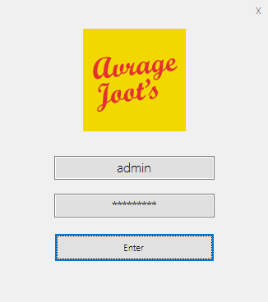

The “Enter” Button takes the user to the main form, only if the username and password is correct. If it is not correct, then you will be unable to access the program.
The password text box will have the text “password” in dim gray until clicked. When clicked, the text becomes darker and is masked by asterisks for security reasons (because it is a password).

Main Menu Form
You also have the capability to search using the search textbox, you can then refine your search using the combo box and then click search, and “reset” which reloads the table and “clear” which clears the boxes.

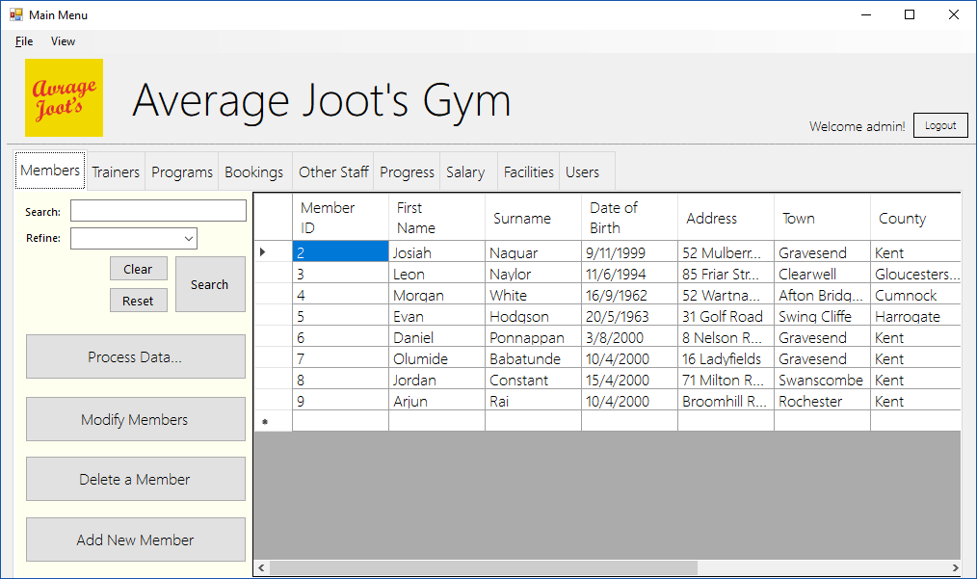

The logout button closes the main form and takes you back to the login screen.

The four buttons include process data, modify, delete and add new records. The process data takes you to the analysis menu, the delete button takes you to the delete form, and the add new takes you to the add new record form
The datagridview loads on startup with the data in the .csv file.
You also have the capability to search using the search textbox, you can then refine your search using the combo box and then click search, and “reset” which reloads the table and “clear” which clears the boxes.

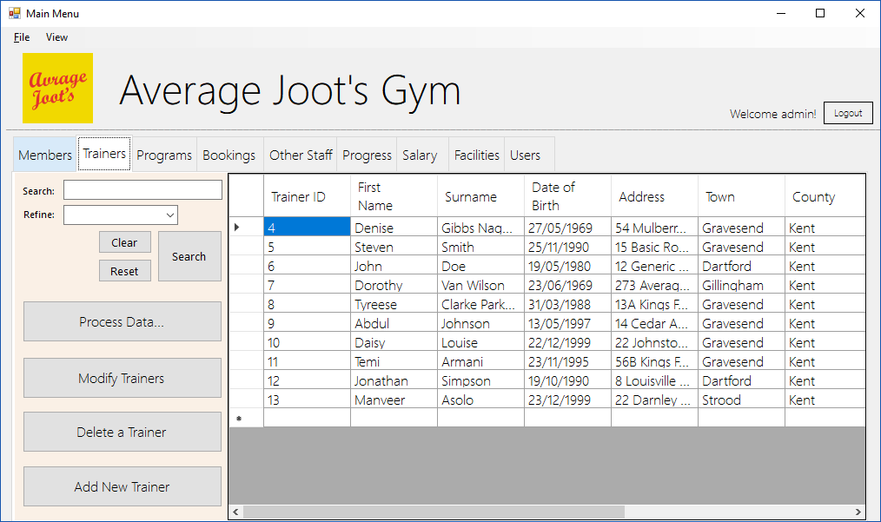
The logout button closes the main form and takes you back to the login screen.
The four buttons include process data, modify, delete and add new records. The process data takes you to the analysis menu, the delete button takes you to the delete form, and the add new takes you to the add new record form
The datagridview loads on startup with the data in the .csv file.
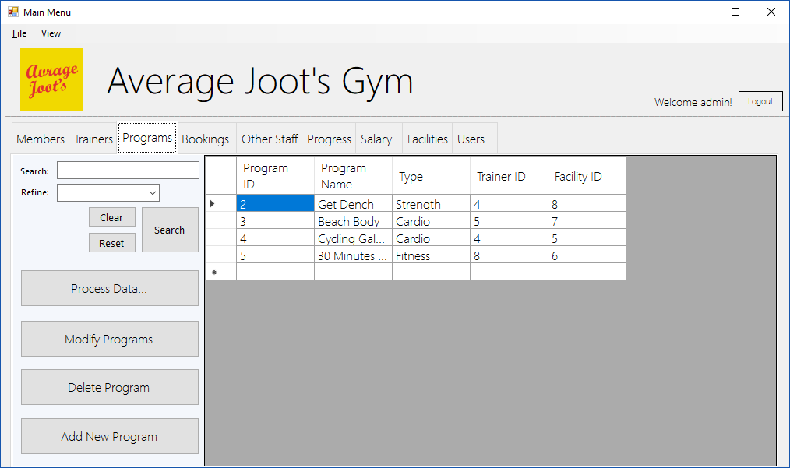
The four buttons include process data, modify, delete and add new records. The process data takes you to the analysis menu, the delete button takes you to the delete form, and the add new takes you to the add new record form
You also have the capability to search using the search textbox, you can then refine your search using the combo box and then click search, and “reset” which reloads the table and “clear” which clears the boxes.
The datagridview loads on startup with the data in the .csv file.
The logout button closes the main form and takes you back to the login screen.

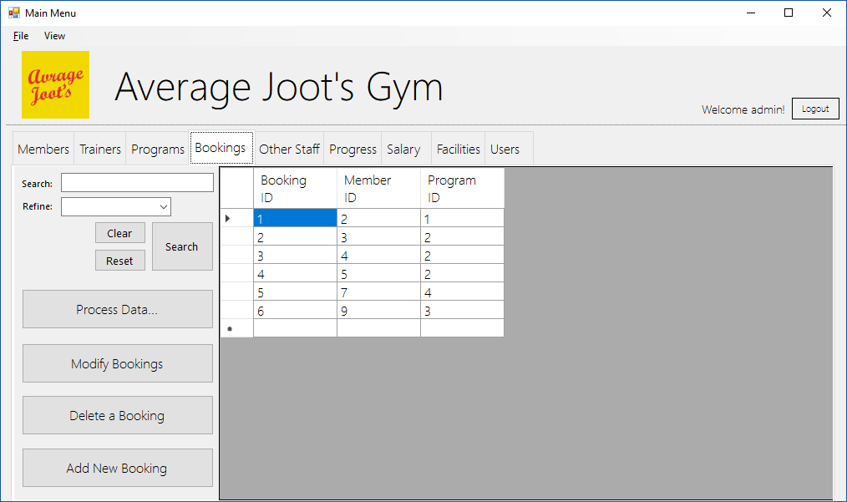
You also have the capability to search using the search textbox, you can then refine your search using the combo box and then click search, and “reset” which reloads the table and “clear” which clears the boxes.
The four buttons include process data, modify, delete and add new records. The process data takes you to the analysis menu, the delete button takes you to the delete form, and the add new takes you to the add new record form
The datagridview loads on startup with the data in the .csv file.
The logout button closes the main form and takes you back to the login screen.

The logout button closes the main form and takes you back to the login screen.
You also have the capability to search using the search textbox, you can then refine your search using the combo box and then click search, and “reset” which reloads the table and “clear” which clears the boxes.
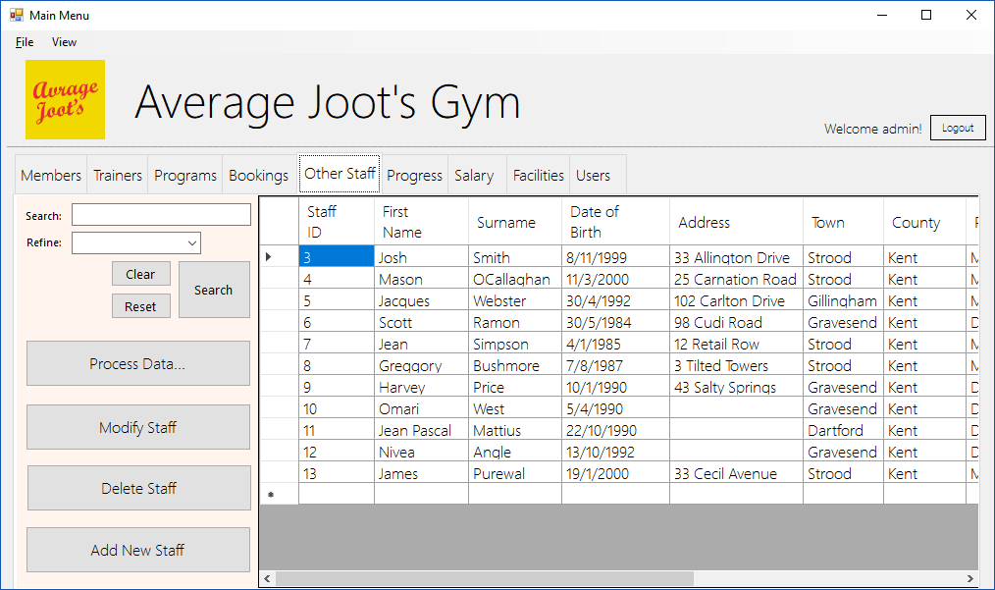
The four buttons include process data, modify, delete and add new records. The process data takes you to the analysis menu, the delete button takes you to the delete form, and the add new takes you to the add new record form

The datagridview loads on startup with the data in the .csv file.
The logout button closes the main form and takes you back to the login screen.
The datagridview loads on startup with the data in the .csv file.
You also have the capability to search using the search textbox, you can then refine your search using the combo box and then click search, and “reset” which reloads the table and “clear” which clears the boxes.
The four buttons include process data, modify, delete and add new records. The process data takes you to the analysis menu, the delete button takes you to the delete form, and the add new takes you to the add new record form
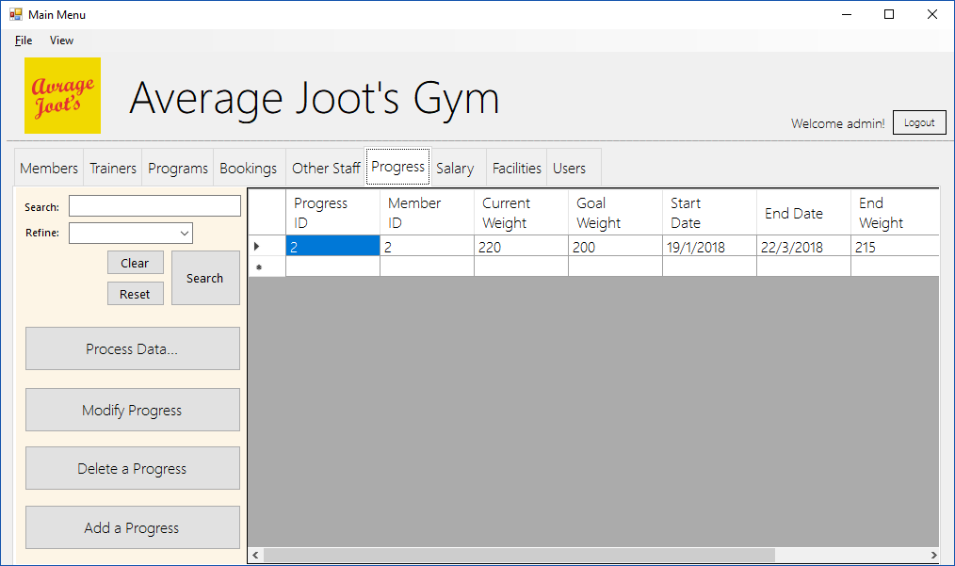

The four buttons include process data, modify, delete and add new records. The process data takes you to the analysis menu, the delete button takes you to the delete form, and the add new takes you to the add new record form
You also have the capability to search using the search textbox, you can then refine your search using the combo box and then click search, and “reset” which reloads the table and “clear” which clears the boxes.
The datagridview loads on startup with the data in the .csv file.
The logout button closes the main form and takes you back to the login screen.
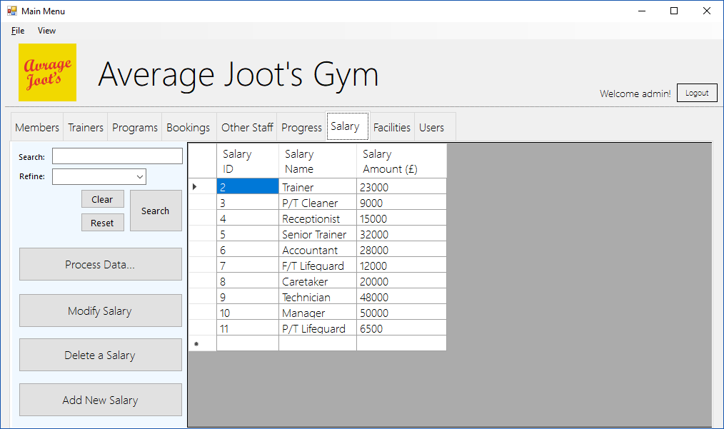

The logout button closes the main form and takes you back to the login screen.
The datagridview loads on startup with the data in the .csv file.
You also have the capability to search using the search textbox, you can then refine your search using the combo box and then click search, and “reset” which reloads the table and “clear” which clears the boxes.
The four buttons include process data, modify, delete and add new records. The process data takes you to the analysis menu, the delete button takes you to the delete form, and the add new takes you to the add new record form
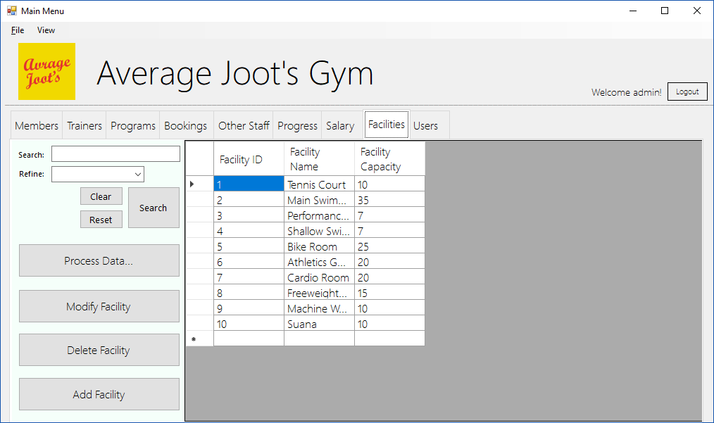

Add Member Form
The “Clear” button clears all textboxes.
The “Return to home” button closes the form and opens the main menu, if not already open.

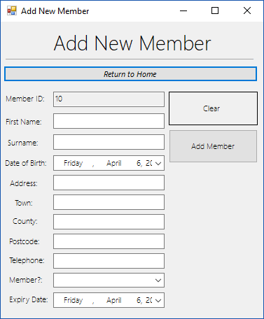

The Add Record Button Validates the entries using 3 validation types (presence, type and range check), and if successful; adds the data to the list.
Text, Combobox and DateTimePickers to input the required data corresponding to the labels. The ID is pre-existing due to a search algorithm and does not require input.

Modify Member Form
You first type in a record you want to search based upon a refinement made using the combo box and then click search, “clear” clears the text boxes.

The “Return to home” button closes the form and opens the main menu, if not already open.

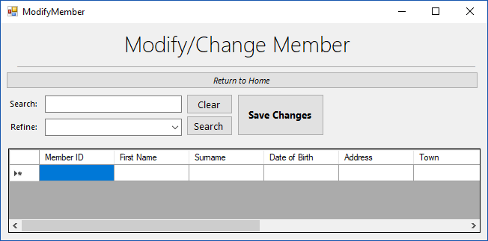
The save changes button overwrites the data in the datagridview over the data within the list which corresponds to its unique identifier (ID).

Data can then be modified within the datagridview and then overwritten by clicking “save changes”.

Delete Member Form

The “Return to home” button closes the form and opens the main menu, if not already open.
The Delete button looks at the selected index, then compares the data to an ID via a search algorithm, then deletes all records associated with that ID.
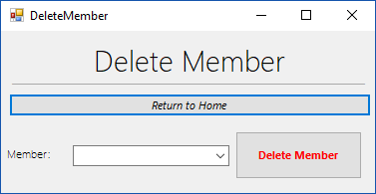

The combobox can be used to select the record you wish to delete. This being more convenient than searching for a record completely.

Add Trainer Form
The “Return to home” button closes the form and opens the main menu, if not already open.
The Add Record Button Validates the entries using 3 validation types (presence, type and range check), and if successful; adds the data to the list.
The “Clear” button clears all textboxes.
Text, Combobox and DateTimePickers to input the required data corresponding to the labels. The ID is pre-existing due to a search algorithm and does not require input.

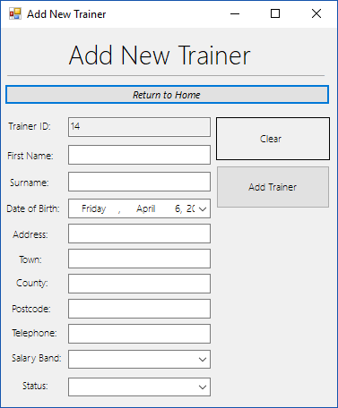

Modify Trainer Form
The “Return to home” button closes the form and opens the main menu, if not already open.
Data can then be modified within the datagridview and then overwritten by clicking “save changes”.
The save changes button overwrites the data in the datagridview over the data within the list which corresponds to its unique identifier (ID).
You first type in a record you want to search based upon a refinement made using the combo box and then click search, “clear” clears the text boxes.

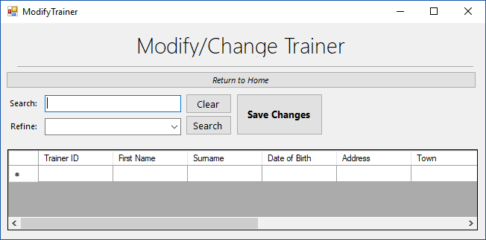

Delete Trainer Form

The “Return to home” button closes the form and opens the main menu, if not already open.
The combobox can be used to select the record you wish to delete. This being more convenient than searching for a record completely.
The Delete button looks at the selected index, then compares the data to an ID via a search algorithm, then deletes all records associated with that ID.

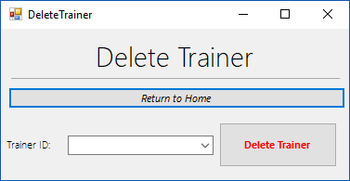

Add Program Form

The Add Record Button Validates the entries using 3 validation types (presence, type and range check), and if successful; adds the data to the list.
The “Clear” button clears all textboxes.
Text, Combobox and DateTimePickers to input the required data corresponding to the labels. The ID is pre-existing due to a search algorithm and does not require input.
The “Return to home” button closes the form and opens the main menu, if not already open.

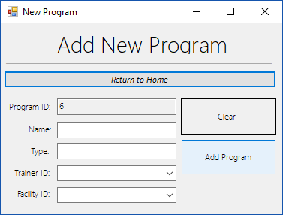

Modify Program Form
The “Return to home” button closes the form and opens the main menu, if not already open.
You first type in a record you want to search based upon a refinement made using the combo box and then click search, “clear” clears the text boxes.
The save changes button overwrites the data in the datagridview over the data within the list which corresponds to its unique identifier (ID).
Data can then be modified within the datagridview and then overwritten by clicking “save changes”.

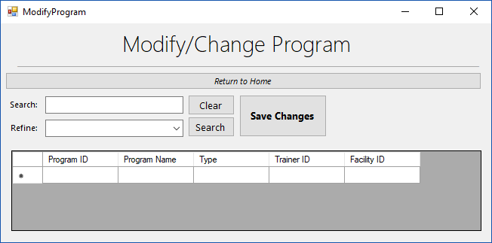

Delete Program Form

The combobox can be used to select the record you wish to delete. This being more convenient than searching for a record completely.
The Delete button looks at the selected index, then compares the data to an ID via a search algorithm, then deletes all records associated with that ID.
The “Return to home” button closes the form and opens the main menu, if not already open.
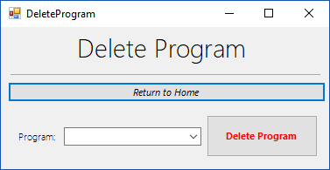

Add Booking Form

The Add Record Button Validates the entries using 3 validation types (presence, type and range check), and if successful; adds the data to the list.
The “Clear” button clears all textboxes.
Text, Combobox and DateTimePickers to input the required data corresponding to the labels. The ID is pre-existing due to a search algorithm and does not require input.
The “Return to home” button closes the form and opens the main menu, if not already open.

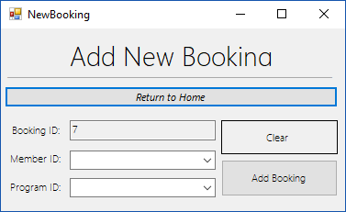

Modify Booking Form
Data can then be modified within the datagridview and then overwritten by clicking “save changes”.
The save changes button overwrites the data in the datagridview over the data within the list which corresponds to its unique identifier (ID).
You first type in a record you want to search based upon a refinement made using the combo box and then click search, “clear” clears the text boxes.
The “Return to home” button closes the form and opens the main menu, if not already open.

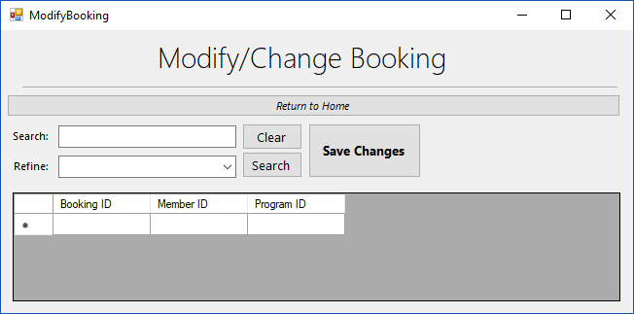

Delete Booking Form

The “Return to home” button closes the form and opens the main menu, if not already open.
The Delete button looks at the selected index, then compares the data to an ID via a search algorithm, then deletes all records associated with that ID.
The combobox can be used to select the record you wish to delete. This being more convenient than searching for a record completely.
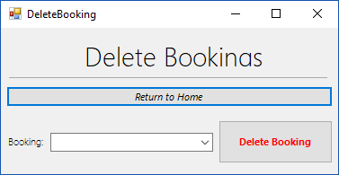

Add Staff Form
The Add Record Button Validates the entries using 3 validation types (presence, type and range check), and if successful; adds the data to the list.
The “Clear” button clears all textboxes.
Text, Combobox and DateTimePickers to input the required data corresponding to the labels. The ID is pre-existing due to a search algorithm and does not require input.
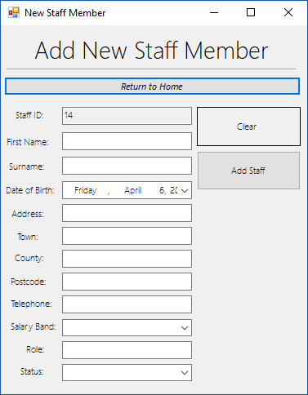
The “Return to home” button closes the form and opens the main menu, if not already open.

Modify Staff Form
The “Return to home” button closes the form and opens the main menu, if not already open.
You first type in a record you want to search based upon a refinement made using the combo box and then click search, “clear” clears the text boxes.
The save changes button overwrites the data in the datagridview over the data within the list which corresponds to its unique identifier (ID).
Data can then be modified within the datagridview and then overwritten by clicking “save changes”.

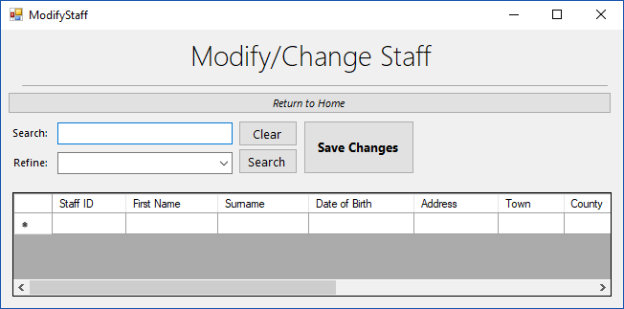

Delete Staff Form

The “Return to home” button closes the form and opens the main menu, if not already open.
The combobox can be used to select the record you wish to delete. This being more convenient than searching for a record completely.
The Delete button looks at the selected index, then compares the data to an ID via a search algorithm, then deletes all records associated with that ID.
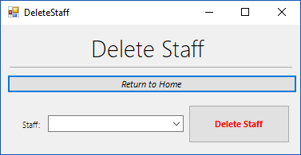

Add New Progress
Text, Combobox and DateTimePickers to input the required data corresponding to the labels. The ID is pre-existing due to a search algorithm and does not require input.
The “Clear” button clears all textboxes.
The Add Record Button Validates the entries using 3 validation types (presence, type and range check), and if successful; adds the data to the list.
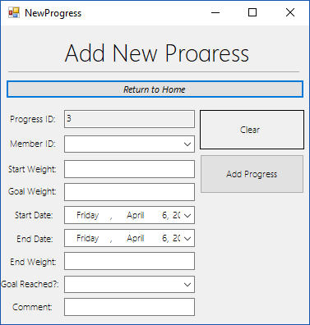
The “Return to home” button closes the form and opens the main menu, if not already open.

Modify Progress
The “Return to home” button closes the form and opens the main menu, if not already open.
You first type in a record you want to search based upon a refinement made using the combo box and then click search, “clear” clears the text boxes.
The save changes button overwrites the data in the datagridview over the data within the list which corresponds to its unique identifier (ID).
Data can then be modified within the datagridview and then overwritten by clicking “save changes”.

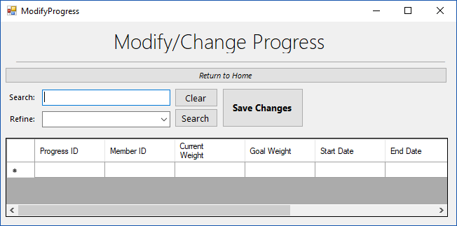

Delete Progress

The “Return to home” button closes the form and opens the main menu, if not already open.
The combobox can be used to select the record you wish to delete. This being more convenient than searching for a record completely.
The Delete button looks at the selected index, then compares the data to an ID via a search algorithm, then deletes all records associated with that ID.
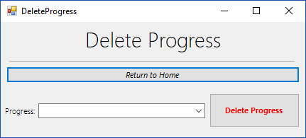

Add New Salary

The “Return to home” button closes the form and opens the main menu, if not already open.
The Add Record Button Validates the entries using 3 validation types (presence, type and range check), and if successful; adds the data to the list.
The “Clear” button clears all textboxes.
Text, Combobox and DateTimePickers to input the required data corresponding to the labels. The ID is pre-existing due to a search algorithm and does not require input.

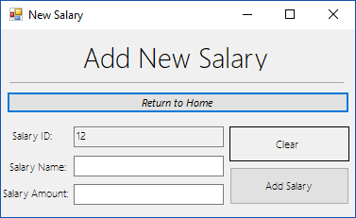

Modify Salary
Data can then be modified within the datagridview and then overwritten by clicking “save changes”.
The save changes button overwrites the data in the datagridview over the data within the list which corresponds to its unique identifier (ID).
You first type in a record you want to search based upon a refinement made using the combo box and then click search, “clear” clears the text boxes.
The “Return to home” button closes the form and opens the main menu, if not already open.

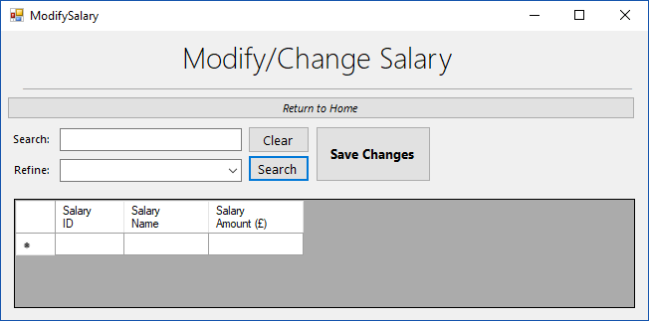

Delete Salary

The “Return to home” button closes the form and opens the main menu, if not already open.
The Delete button looks at the selected index, then compares the data to an ID via a search algorithm, then deletes all records associated with that ID.
The combobox can be used to select the record you wish to delete. This being more convenient than searching for a record completely.
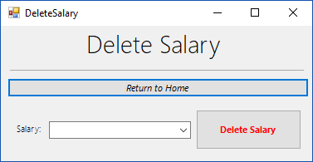

Add New Facility

The Add Record Button Validates the entries using 3 validation types (presence, type and range check), and if successful; adds the data to the list.
The “Clear” button clears all textboxes.
Text, Combobox and DateTimePickers to input the required data corresponding to the labels. The ID is pre-existing due to a search algorithm and does not require input.
The “Return to home” button closes the form and opens the main menu, if not already open.

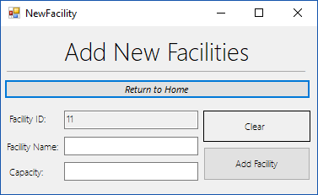

Modify Facility
Data can then be modified within the datagridview and then overwritten by clicking “save changes”.
The save changes button overwrites the data in the datagridview over the data within the list which corresponds to its unique identifier (ID).
You first type in a record you want to search based upon a refinement made using the combo box and then click search, “clear” clears the text boxes.
The “Return to home” button closes the form and opens the main menu, if not already open.

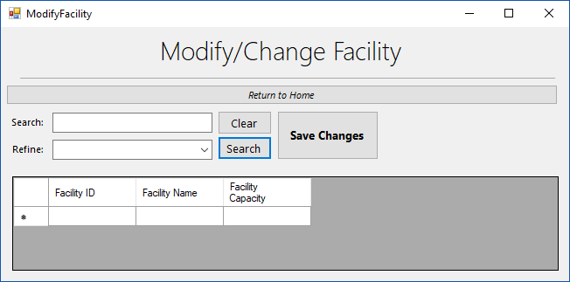

Delete Facility

The Delete button looks at the selected index, then compares the data to an ID via a search algorithm, then deletes all records associated with that ID.
The combobox can be used to select the record you wish to delete. This being more convenient than searching for a record completely.
The “Return to home” button closes the form and opens the main menu, if not already open.
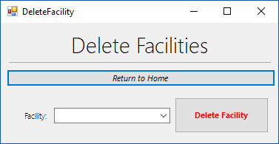

Add User

The “Return to home” button closes the form and opens the main menu, if not already open.
Text, Combobox and DateTimePickers to input the required data corresponding to the labels. The ID is pre-existing due to a search algorithm and does not require input.
The “Clear” button clears all textboxes.
The Add Record Button Validates the entries using 3 validation types (presence, type and range check), and if successful; adds the data to the list.

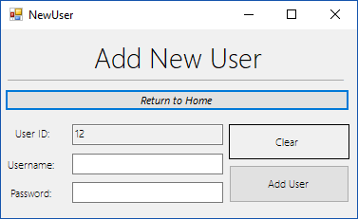

Delete User

The “Return to home” button closes the form and opens the main menu, if not already open.
The Delete button looks at the selected index, then compares the data to an ID via a search algorithm, then deletes all records associated with that ID.
The combobox can be used to select the record you wish to delete. This being more convenient than searching for a record completely.
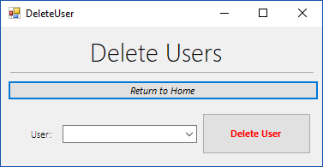

Anaylsis Form
The tab control enables users to navigate through the 3 analysis types and see the corresponding graph, minimising forms used.

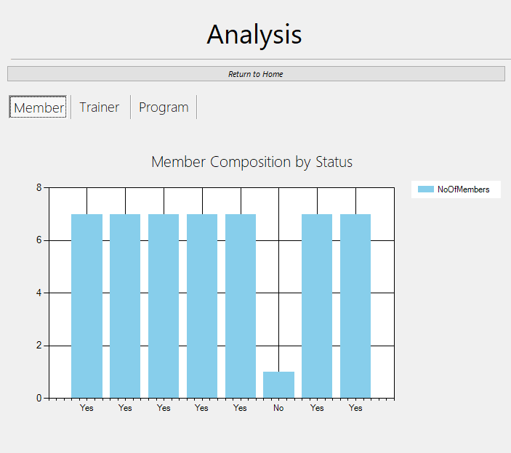
The “Return to home” button closes the form and opens the main menu, if not already open.

A Graph based on the list data and a subroutine in the form.

Main Menu Form Code
Imports System.IO
Public Class MainMenu

Dim needpas As Boolean = False

Dim MemberFile As String = "member.csv" 'This loads the file data into the MemberList structure.
Dim TrainerFile As String = "trainer.csv" 'This loads the file data into the TrainerList structure.
Dim ProgramFile As String = "program.csv" 'This loads the file data into the ProgramList structure.
Dim BookingFile As String = "booking.csv" 'This loads the file data into the BookingList structure.
Dim StaffFile As String = "otherstaff.csv" 'This loads the file data into the StaffList structure.
Dim ProgressFile As String = "progress.csv" 'This loads the file data into the ProgressList structure.
Dim SalaryFile As String = "salary.csv" 'This loads the file data into the SalaryList structure.
Dim FacilityFile As String = "facility.csv" 'This loads the file data into the FacilityList structure.
Dim UserFile As String = "user.csv" 'This loads the file data into the UserList structure.

Private Sub Form1_Load(sender As Object, e As EventArgs) Handles MyBase.Load
WelcomeLabel.Text = ("Welcome " & userWelcome & "!")

If Updated = False Then 'When the form loads, since update is false (as the forms just started), the below subroutines will be called.
memberTableUpdate() 'These subroutines update each table by being called when the updated boolean = false (on startup)
trainerTableUpdate()
facilityTableUpdate()
programTableUpdate()
bookingTableUpdate()
otherstaffTableUpdate()
progressTableUpdate()
salaryTableUpdate()
userTableUpdate()
Updated = True 'updated then becomes true, as the subroutines have been called and excecuted.
End If

'These called subroutines show each table on the corresponding DataGridView.
ShowMember()
ShowTrainer()
ShowBookings()
ShowFacility()
ShowProgram()
ShowOtherStaff()
ShowSalary()
ShowProgress()
ShowUser()
passwordAccess()

End Sub

'Member Section
Private Sub Button_ClearMemberSearch_Click(sender As Object, e As EventArgs) Handles Button_ClearMemberSearch.Click
searchMemberTextBox.Text() = " " 'When clear is clicked on, the textbox and the refinement combo is set to nothing, which clears it.
refineMemberComboBox.Text() = " "
End Sub

Sub passwordAccess()
If userWelcome <> "admin" Then 'If the user is not an administrator, they cannot access the passwords or data.
needpas = True
End If
End Sub

Sub progressTableUpdate()
progressList.Clear() 'Clears the list of its contents
If File.Exists(ProgressFile) Then 'If the file declared on the top of the main sub code exists, then complete the if statement.
Dim progressData() As String = File.ReadAllLines(ProgressFile) 'Declare data within the .csv file as the variable
Dim DataList As New List(Of String) 'DataList Represents a new list, this will contain the data from the table correalting to the list.
Dim inputstring As String 'Inputstring distinguishes the split between data, this being a comma due to using .csv files
Dim aProgress As New progress() 'Creates a variable which inherits the class corresponding to the tables data.
DataList = progressData.ToList 'Sets the value of the datalist.

For i = 0 To DataList.Count - 1 'An arrayy which adds the data from the .csv to the list.
inputstring = DataList(i)
Dim splitstring = inputstring.Split(",")
aProgress = New progress()
aProgress.progressID = splitstring(0)
aProgress.memberID = splitstring(1)
aProgress.currentWeight = splitstring(2)
aProgress.goalWeight = splitstring(3)
aProgress.startDate = splitstring(4)
aProgress.endDate = splitstring(5)
aProgress.endWeight = splitstring(6)
aProgress.goalReached = splitstring(7)
aProgress.comment = splitstring(8)
progressList.Add(aProgress)
Next

End If
End Sub
Sub otherstaffTableUpdate()
otherstaffList.Clear()
If File.Exists(StaffFile) Then
Dim staffData() As String = File.ReadAllLines(StaffFile)
Dim DataList As New List(Of String)
Dim inputstring As String
Dim astaff As New otherstaff()
DataList = staffData.ToList

For i = 0 To DataList.Count - 1
inputstring = DataList(i)
Dim splitstring = inputstring.Split(",")
astaff = New otherstaff()
astaff.staffID = splitstring(0)
astaff.staffFName = splitstring(1)
astaff.staffSName = splitstring(2)
astaff.staffDOB = splitstring(3)
astaff.staffAdd = splitstring(4)
astaff.staffTown = splitstring(5)
astaff.staffCounty = splitstring(6)
astaff.staffPostcode = splitstring(7)
astaff.staffTelephone = splitstring(8)
astaff.staffSalaryBand = splitstring(9)
astaff.employmentStatus = splitstring(10)
otherstaffList.Add(astaff)
Next

End If
End Sub
Sub bookingTableUpdate()
bookingList.Clear()
If File.Exists(BookingFile) Then
Dim bookingData() As String = File.ReadAllLines(BookingFile)
Dim DataList As New List(Of String)
Dim inputstring As String
Dim aBooking As New booking()
DataList = bookingData.ToList

For i = 0 To DataList.Count - 1
inputstring = DataList(i)
Dim splitstring = inputstring.Split(",")
aBooking = New booking()
aBooking.BookingID = splitstring(0)
aBooking.MemberID = splitstring(1)
aBooking.ProgramID = splitstring(2)
bookingList.Add(aBooking)

Next
End If
End Sub
Sub salaryTableUpdate()
salaryList.Clear()
If File.Exists(SalaryFile) Then
Dim salaryData() As String = File.ReadAllLines(SalaryFile)
Dim DataList As New List(Of String)
Dim inputstring As String
Dim aSalary As New salary()
DataList = salaryData.ToList

For i = 0 To DataList.Count - 1
inputstring = DataList(i)
Dim splitstring = inputstring.Split(",")
aSalary = New salary()
aSalary.salaryID = splitstring(0)
aSalary.salaryName = splitstring(1)
aSalary.salaryAmount = splitstring(2)
salaryList.Add(aSalary)

Next
End If
End Sub
Sub facilityTableUpdate()
facilityList.Clear()
If File.Exists(FacilityFile) Then
Dim facilityData() As String = File.ReadAllLines(FacilityFile)
Dim DataList As New List(Of String)
Dim inputstring As String
Dim afacility As New facility()
DataList = facilityData.ToList

For i = 0 To DataList.Count - 1
inputstring = DataList(i)
Dim splitstring = inputstring.Split(",")
afacility = New facility()
afacility.facilityID = splitstring(0)
afacility.facilityName = splitstring(1)
afacility.facilityCapacity = splitstring(2)
facilityList.Add(afacility)
Next

End If

End Sub

Sub trainerTableUpdate()
trainerList.Clear()
If File.Exists(TrainerFile) Then
Dim trainerData() As String = File.ReadAllLines(TrainerFile)
Dim DataList As New List(Of String)
Dim inputstring As String
Dim atrainer As New trainer()
DataList = trainerData.ToList

For i = 0 To DataList.Count - 1
inputstring = DataList(i)
Dim splitstring = inputstring.Split(",")
atrainer = New trainer()
atrainer.trainerID = splitstring(0)
atrainer.trainerFName = splitstring(1)
atrainer.trainerSName = splitstring(2)
atrainer.trainerDOB = splitstring(3)
atrainer.trainerAdd = splitstring(4)
atrainer.trainerTown = splitstring(5)
atrainer.trainerCounty = splitstring(6)
atrainer.trainerPostcode = splitstring(7)
atrainer.trainerTelephone = splitstring(8)
atrainer.trainerSalaryBand = splitstring(9)
atrainer.trainerEmploymentStatus = splitstring(10)
trainerList.Add(atrainer)
Next

End If
End Sub
Sub memberTableUpdate() 'This subroutine is for updating the customer table.
memberList.Clear()
If File.Exists(MemberFile) Then
Dim memberData() As String = File.ReadAllLines(MemberFile)
Dim DataList As New List(Of String)
Dim inputstring As String
Dim aMember As New member()
DataList = memberData.ToList

For i = 0 To DataList.Count - 1
inputstring = DataList(i)
Dim splitstring = inputstring.Split(",")
aMember = New member()
aMember.memberID = splitstring(0)
aMember.memberFName = splitstring(1)
aMember.memberSName = splitstring(2)
aMember.memberDOB = splitstring(3)
aMember.memberAdd = splitstring(4)
aMember.memberTown = splitstring(5)
aMember.memberCounty = splitstring(6)
aMember.memberPostcode = splitstring(7)
aMember.memberTelephone = splitstring(8)
aMember.memberStatus = splitstring(9)
aMember.memberExpiryDate = splitstring(10)
memberList.Add(aMember)

Next
End If
End Sub

Sub userTableUpdate() 'This subroutine is for updating the user table.
userList.Clear()
If File.Exists(UserFile) Then
Dim userData() As String = File.ReadAllLines(UserFile)
Dim DataList As New List(Of String)
Dim inputstring As String
Dim aUser As New userandpass()
DataList = userData.ToList

For i = 0 To DataList.Count - 1
inputstring = DataList(i)
Dim splitstring = inputstring.Split(",")
aUser = New userandpass()
aUser.userID = splitstring(0)
aUser.username = splitstring(1)
aUser.password = splitstring(2)
userList.Add(aUser)

Next
End If
End Sub

Sub programTableUpdate()
programList.Clear()
If File.Exists(ProgramFile) Then
Dim programData() As String = File.ReadAllLines(ProgramFile)
Dim DataList As New List(Of String)
Dim inputstring As String
Dim aProgram As New program()
DataList = programData.ToList

For i = 0 To DataList.Count - 1
inputstring = DataList(i)
Dim splitstring = inputstring.Split(",")
aProgram = New program()
aProgram.programID = splitstring(0)
aProgram.programName = splitstring(1)
aProgram.programType = splitstring(2)
aProgram.trainerID = splitstring(3)
aProgram.facilityID = splitstring(4)
programList.Add(aProgram)

Next
End If
End Sub

Sub ShowTrainer()

Dim str(10) As String
trainerGridView.Rows.Clear()
'MessageBox.Show("No. of items in the Trainer List is: " + trainerList.Count.ToString)
For i = 0 To trainerList.Count - 1
str(0) = trainerList.Item(i).trainerID
str(1) = trainerList.Item(i).trainerFName
str(2) = trainerList.Item(i).trainerSName
str(3) = trainerList.Item(i).trainerDOB
str(4) = trainerList.Item(i).trainerAdd
str(5) = trainerList.Item(i).trainerTown
str(6) = trainerList.Item(i).trainerCounty
str(7) = trainerList.Item(i).trainerPostcode
str(8) = trainerList.Item(i).trainerTelephone
str(9) = trainerList.Item(i).trainerSalaryBand
str(10) = trainerList.Item(i).trainerEmploymentStatus
trainerGridView.Rows.Add(str)
Next
End Sub

Sub ShowMember()
Dim str(10) As String
MemberGridView.Rows.Clear()
'MessageBox.Show("No. of items in Customer List is: " + memberList.Count.ToString)
For i = 0 To memberList.Count - 1
str(0) = memberList.Item(i).memberID
str(1) = memberList.Item(i).memberFName
str(2) = memberList.Item(i).memberSName
str(3) = memberList.Item(i).memberDOB
str(4) = memberList.Item(i).memberAdd
str(5) = memberList.Item(i).memberTown
str(6) = memberList.Item(i).memberCounty
str(7) = memberList.Item(i).memberPostcode
str(8) = memberList.Item(i).memberTelephone
str(9) = memberList.Item(i).memberStatus
str(10) = memberList.Item(i).memberExpiryDate
MemberGridView.Rows.Add(str)
Next
End Sub
Sub ShowProgram()
Dim str(4) As String
programGridView.Rows.Clear()
'MessageBox.Show("No. of items in Program List is: " + programList.Count.ToString)
For i = 0 To programList.Count - 1
str(0) = programList.Item(i).programID
str(1) = programList.Item(i).programName
str(2) = programList.Item(i).programType
str(3) = programList.Item(i).trainerID
str(4) = programList.Item(i).facilityID
programGridView.Rows.Add(str)
Next
End Sub
Sub ShowFacility()
Dim str(2) As String
facilityGridView.Rows.Clear()
'MessageBox.Show("No. of items in Facility List is: " + facilityList.Count.ToString)
For i = 0 To facilityList.Count - 1
str(0) = facilityList.Item(i).facilityID
str(1) = facilityList.Item(i).facilityName
str(2) = facilityList.Item(i).facilityCapacity
facilityGridView.Rows.Add(str)
Next
End Sub

Sub ShowBookings()
Dim str(2) As String
BookingGridView.Rows.Clear()
'MessageBox.Show("No. of items in the Booking List is: " + bookingList.Count.ToString)
For i = 0 To bookingList.Count - 1
str(0) = bookingList.Item(i).BookingID
str(1) = bookingList.Item(i).MemberID
str(2) = bookingList.Item(i).ProgramID
BookingGridView.Rows.Add(str)
Next

End Sub

Sub ShowProgress()
Dim str(8) As String
progressGridView.Rows.Clear()
'MessageBox.Show("No. of items in the Progress List is: " + progressList.Count.ToString)
For i = 0 To progressList.Count - 1
str(0) = progressList.Item(i).progressID
str(1) = progressList.Item(i).memberID
str(2) = progressList.Item(i).currentWeight
str(3) = progressList.Item(i).goalWeight
str(4) = progressList.Item(i).startDate
str(5) = progressList.Item(i).endDate
str(6) = progressList.Item(i).endWeight
str(7) = progressList.Item(i).goalReached
str(8) = progressList.Item(i).comment
progressGridView.Rows.Add(str)
Next
End Sub

Sub ShowSalary()
Dim str(2) As String
salaryGridView.Rows.Clear()
'MessageBox.Show("No. of items in the Salary List is: " + salaryList.Count.ToString)
For i = 0 To salaryList.Count - 1
str(0) = salaryList.Item(i).salaryID
str(1) = salaryList.Item(i).salaryName
str(2) = salaryList.Item(i).salaryAmount
salaryGridView.Rows.Add(str)
Next
End Sub

Sub ShowOtherStaff()
Dim str(11) As String
staffGridView.Rows.Clear()
'MessageBox.Show("No. of items in the Other Staff List is: " + otherstaffList.Count.ToString)
For i = 0 To otherstaffList.Count - 1
str(0) = otherstaffList.Item(i).staffID
str(1) = otherstaffList.Item(i).staffFName
str(2) = otherstaffList.Item(i).staffSName
str(3) = otherstaffList.Item(i).staffDOB
str(4) = otherstaffList.Item(i).staffAdd
str(5) = otherstaffList.Item(i).staffTown
str(6) = otherstaffList.Item(i).staffCounty
str(7) = otherstaffList.Item(i).staffPostcode
str(8) = otherstaffList.Item(i).staffTelephone
str(9) = otherstaffList.Item(i).staffSalaryBand
str(10) = otherstaffList.Item(i).staffRole
str(11) = otherstaffList.Item(i).employmentStatus
staffGridView.Rows.Add(str)
Next

End Sub

Sub ShowUser()
Dim str(2) As String
userGridView.Rows.Clear()
'MessageBox.Show("No. of items in the User List is: " + userList.Count.ToString)
For i = 0 To userList.Count - 1
str(0) = userList.Item(i).userID
str(1) = userList.Item(i).username
If needpas = False Then
str(2) = userList.Item(i).password
Else
str(2) = "****"
End If

userGridView.Rows.Add(str)
Next
End Sub

Private Sub Button_SearchMember_Click(sender As Object, e As EventArgs) Handles Button_SearchMember.Click
If refineMemberComboBox.Text = "" Then
MessageBox.Show("Please refine your Member Search", "Error", MessageBoxButtons.OK, MessageBoxIcon.Error)
End If

'Search by ID
If refineMemberComboBox.Text = "Member ID" Then
Dim str(10) As String
Dim a As Integer
MemberGridView.Rows.Clear()
For a = 0 To memberList.Count - 1
If searchMemberTextBox.Text = memberList(a).memberID Then
str(0) = memberList.Item(a).memberID
str(1) = memberList.Item(a).memberFName
str(2) = memberList.Item(a).memberSName
str(3) = memberList.Item(a).memberDOB
str(4) = memberList.Item(a).memberAdd
str(5) = memberList.Item(a).memberTown
str(6) = memberList.Item(a).memberCounty
str(7) = memberList.Item(a).memberPostcode
str(8) = memberList.Item(a).memberTelephone
str(9) = memberList.Item(a).memberStatus
str(10) = memberList.Item(a).memberExpiryDate
MemberGridView.Rows.Add(str)
End If
Next

End If

'Search by First Name
If refineMemberComboBox.Text = "First Name" Then
Dim str(10) As String
Dim a As Integer
MemberGridView.Rows.Clear()
For a = 0 To memberList.Count - 1
If searchMemberTextBox.Text = memberList(a).memberFName Then
str(0) = memberList.Item(a).memberID
str(1) = memberList.Item(a).memberFName
str(2) = memberList.Item(a).memberSName
str(3) = memberList.Item(a).memberDOB
str(4) = memberList.Item(a).memberAdd
str(5) = memberList.Item(a).memberTown
str(6) = memberList.Item(a).memberCounty
str(7) = memberList.Item(a).memberPostcode
str(8) = memberList.Item(a).memberTelephone
str(9) = memberList.Item(a).memberStatus
str(10) = memberList.Item(a).memberExpiryDate
MemberGridView.Rows.Add(str)
End If
Next
End If

'Search by Surname
If refineMemberComboBox.Text = "Surname" Then
Dim str(10) As String
Dim a As Integer
MemberGridView.Rows.Clear()
For a = 0 To memberList.Count - 1
If searchMemberTextBox.Text = memberList(a).memberSName Then
str(0) = memberList.Item(a).memberID
str(1) = memberList.Item(a).memberFName
str(2) = memberList.Item(a).memberSName
str(3) = memberList.Item(a).memberDOB
str(4) = memberList.Item(a).memberAdd
str(5) = memberList.Item(a).memberTown
str(6) = memberList.Item(a).memberCounty
str(7) = memberList.Item(a).memberPostcode
str(8) = memberList.Item(a).memberTelephone
str(9) = memberList.Item(a).memberStatus
str(10) = memberList.Item(a).memberExpiryDate
MemberGridView.Rows.Add(str)
End If
Next

End If

If refineMemberComboBox.Text = "Address" Then
Dim str(10) As String
Dim a As Integer
MemberGridView.Rows.Clear()
For a = 0 To memberList.Count - 1
If searchMemberTextBox.Text = memberList(a).memberAdd Then
str(0) = memberList.Item(a).memberID
str(1) = memberList.Item(a).memberFName
str(2) = memberList.Item(a).memberSName
str(3) = memberList.Item(a).memberDOB
str(4) = memberList.Item(a).memberAdd
str(5) = memberList.Item(a).memberTown
str(6) = memberList.Item(a).memberCounty
str(7) = memberList.Item(a).memberPostcode
str(8) = memberList.Item(a).memberTelephone
str(9) = memberList.Item(a).memberStatus
str(10) = memberList.Item(a).memberExpiryDate
MemberGridView.Rows.Add(str)
End If
Next

End If

If refineMemberComboBox.Text = "Town" Then
Dim str(10) As String
Dim a As Integer
MemberGridView.Rows.Clear()
For a = 0 To memberList.Count - 1
If searchMemberTextBox.Text = memberList(a).memberTown Then
str(0) = memberList.Item(a).memberID
str(1) = memberList.Item(a).memberFName
str(2) = memberList.Item(a).memberSName
str(3) = memberList.Item(a).memberDOB
str(4) = memberList.Item(a).memberAdd
str(5) = memberList.Item(a).memberTown
str(6) = memberList.Item(a).memberCounty
str(7) = memberList.Item(a).memberPostcode
str(8) = memberList.Item(a).memberTelephone
str(9) = memberList.Item(a).memberStatus
str(10) = memberList.Item(a).memberExpiryDate
MemberGridView.Rows.Add(str)
End If
Next

End If

If refineMemberComboBox.Text = "County" Then
Dim str(10) As String
Dim a As Integer
MemberGridView.Rows.Clear()
For a = 0 To memberList.Count - 1
If searchMemberTextBox.Text = memberList(a).memberCounty Then
str(0) = memberList.Item(a).memberID
str(1) = memberList.Item(a).memberFName
str(2) = memberList.Item(a).memberSName
str(3) = memberList.Item(a).memberDOB
str(4) = memberList.Item(a).memberAdd
str(5) = memberList.Item(a).memberTown
str(6) = memberList.Item(a).memberCounty
str(7) = memberList.Item(a).memberPostcode
str(8) = memberList.Item(a).memberTelephone
str(9) = memberList.Item(a).memberStatus
str(10) = memberList.Item(a).memberExpiryDate
MemberGridView.Rows.Add(str)
End If
Next

End If

If refineMemberComboBox.Text = "Postcode" Then
Dim str(10) As String
Dim a As Integer
MemberGridView.Rows.Clear()
For a = 0 To memberList.Count - 1
If searchMemberTextBox.Text = memberList(a).memberPostcode Then
str(0) = memberList.Item(a).memberID
str(1) = memberList.Item(a).memberFName
str(2) = memberList.Item(a).memberSName
str(3) = memberList.Item(a).memberDOB
str(4) = memberList.Item(a).memberAdd
str(5) = memberList.Item(a).memberTown
str(6) = memberList.Item(a).memberCounty
str(7) = memberList.Item(a).memberPostcode
str(8) = memberList.Item(a).memberTelephone
str(9) = memberList.Item(a).memberStatus
str(10) = memberList.Item(a).memberExpiryDate
MemberGridView.Rows.Add(str)
End If
Next

End If

If refineMemberComboBox.Text = "Telephone" Then
Dim str(10) As String
Dim a As Integer
MemberGridView.Rows.Clear()
For a = 0 To memberList.Count - 1
If searchMemberTextBox.Text = memberList(a).memberTelephone Then
str(0) = memberList.Item(a).memberID
str(1) = memberList.Item(a).memberFName
str(2) = memberList.Item(a).memberSName
str(3) = memberList.Item(a).memberDOB
str(4) = memberList.Item(a).memberAdd
str(5) = memberList.Item(a).memberTown
str(6) = memberList.Item(a).memberCounty
str(7) = memberList.Item(a).memberPostcode
str(8) = memberList.Item(a).memberTelephone
str(9) = memberList.Item(a).memberStatus
str(10) = memberList.Item(a).memberExpiryDate
MemberGridView.Rows.Add(str)
End If
Next

End If

If refineMemberComboBox.Text = "Membership Status" Then
Dim str(10) As String
Dim a As Integer
MemberGridView.Rows.Clear()
For a = 0 To memberList.Count - 1
If searchMemberTextBox.Text = memberList(a).memberStatus Then
str(0) = memberList.Item(a).memberID
str(1) = memberList.Item(a).memberFName
str(2) = memberList.Item(a).memberSName
str(3) = memberList.Item(a).memberDOB
str(4) = memberList.Item(a).memberAdd
str(5) = memberList.Item(a).memberTown
str(6) = memberList.Item(a).memberCounty
str(7) = memberList.Item(a).memberPostcode
str(8) = memberList.Item(a).memberTelephone
str(9) = memberList.Item(a).memberStatus
str(10) = memberList.Item(a).memberExpiryDate
MemberGridView.Rows.Add(str)
End If
Next

End If

End Sub

Private Sub Button_ResetMemberSearch_Click(sender As Object, e As EventArgs) Handles Button_ResetMemberSearch.Click
MemberGridView.Rows.Clear()
ShowMember()
End Sub

Private Sub Logout_Click(sender As Object, e As EventArgs) Handles Logout.Click
Me.Close()
End Sub

Private Sub ButtonAddNewMember_Click(sender As Object, e As EventArgs) Handles ButtonAddNewMember.Click
NewMember.Show()
End Sub

Private Sub buttonDeleteMembers_Click(sender As Object, e As EventArgs) Handles buttonDeleteMembers.Click
DeleteMember.Show()
End Sub

Private Sub ButtonAddTrainer_Click(sender As Object, e As EventArgs) Handles ButtonAddTrainer.Click
NewTrainer.Show()
End Sub

Private Sub Button_ResetTrainerSearch_Click(sender As Object, e As EventArgs) Handles Button_ResetTrainerSearch.Click
trainerGridView.Rows.Clear()
ShowTrainer()
End Sub

Private Sub ButtonDeleteTrainer_Click(sender As Object, e As EventArgs) Handles ButtonDeleteTrainer.Click
DeleteTrainer.Show()

End Sub

Private Sub ButtonSearchTrainer_Click(sender As Object, e As EventArgs) Handles ButtonSearchTrainer.Click
If refineTrainerComboBox.Text = "" Then
MessageBox.Show("Please refine your trainer Search", "Error", MessageBoxButtons.OK, MessageBoxIcon.Error)
End If

'Search by ID
If refineTrainerComboBox.Text = "Trainer ID" Then
Dim str(10) As String
Dim a As Integer
trainerGridView.Rows.Clear()
For a = 0 To trainerList.Count - 1
If searchTrainerTextBox.Text = trainerList(a).trainerID Then
str(0) = trainerList.Item(a).trainerID
str(1) = trainerList.Item(a).trainerFName
str(2) = trainerList.Item(a).trainerSName
str(3) = trainerList.Item(a).trainerDOB
str(4) = trainerList.Item(a).trainerAdd
str(5) = trainerList.Item(a).trainerTown
str(6) = trainerList.Item(a).trainerCounty
str(7) = trainerList.Item(a).trainerPostcode
str(8) = trainerList.Item(a).trainerTelephone
str(9) = trainerList.Item(a).trainerSalaryBand
str(10) = trainerList.Item(a).trainerEmploymentStatus
trainerGridView.Rows.Add(str)
End If
Next

End If

'Search by First Name
If refineTrainerComboBox.Text = "First Name" Then
Dim str(10) As String
Dim a As Integer
trainerGridView.Rows.Clear()
For a = 0 To trainerList.Count - 1
If searchTrainerTextBox.Text = trainerList(a).trainerFName Then
str(0) = trainerList.Item(a).trainerID
str(1) = trainerList.Item(a).trainerFName
str(2) = trainerList.Item(a).trainerSName
str(3) = trainerList.Item(a).trainerDOB
str(4) = trainerList.Item(a).trainerAdd
str(5) = trainerList.Item(a).trainerTown
str(6) = trainerList.Item(a).trainerCounty
str(7) = trainerList.Item(a).trainerPostcode
str(8) = trainerList.Item(a).trainerTelephone
str(9) = trainerList.Item(a).trainerSalaryBand
str(10) = trainerList.Item(a).trainerEmploymentStatus
trainerGridView.Rows.Add(str)
End If
Next

End If

'Search by Surname
If refineTrainerComboBox.Text = "Surname" Then
Dim str(10) As String
Dim a As Integer
trainerGridView.Rows.Clear()
For a = 0 To trainerList.Count - 1
If searchTrainerTextBox.Text = trainerList(a).trainerSName Then
str(0) = trainerList.Item(a).trainerID
str(1) = trainerList.Item(a).trainerFName
str(2) = trainerList.Item(a).trainerSName
str(3) = trainerList.Item(a).trainerDOB
str(4) = trainerList.Item(a).trainerAdd
str(5) = trainerList.Item(a).trainerTown
str(6) = trainerList.Item(a).trainerCounty
str(7) = trainerList.Item(a).trainerPostcode
str(8) = trainerList.Item(a).trainerTelephone
str(9) = trainerList.Item(a).trainerSalaryBand
str(10) = trainerList.Item(a).trainerEmploymentStatus
trainerGridView.Rows.Add(str)
End If
Next

End If

'Search by Address
If refineTrainerComboBox.Text = "Address" Then
Dim str(10) As String
Dim a As Integer
trainerGridView.Rows.Clear()
For a = 0 To trainerList.Count - 1
If searchTrainerTextBox.Text = trainerList(a).trainerAdd Then
str(0) = trainerList.Item(a).trainerID
str(1) = trainerList.Item(a).trainerFName
str(2) = trainerList.Item(a).trainerSName
str(3) = trainerList.Item(a).trainerDOB
str(4) = trainerList.Item(a).trainerAdd
str(5) = trainerList.Item(a).trainerTown
str(6) = trainerList.Item(a).trainerCounty
str(7) = trainerList.Item(a).trainerPostcode
str(8) = trainerList.Item(a).trainerTelephone
str(9) = trainerList.Item(a).trainerSalaryBand
str(10) = trainerList.Item(a).trainerEmploymentStatus
trainerGridView.Rows.Add(str)
End If
Next

End If

'Search by Town
If refineTrainerComboBox.Text = "Town" Then
Dim str(10) As String
Dim a As Integer
trainerGridView.Rows.Clear()
For a = 0 To trainerList.Count - 1
If searchTrainerTextBox.Text = trainerList(a).trainerTown Then
str(0) = trainerList.Item(a).trainerID
str(1) = trainerList.Item(a).trainerFName
str(2) = trainerList.Item(a).trainerSName
str(3) = trainerList.Item(a).trainerDOB
str(4) = trainerList.Item(a).trainerAdd
str(5) = trainerList.Item(a).trainerTown
str(6) = trainerList.Item(a).trainerCounty
str(7) = trainerList.Item(a).trainerPostcode
str(8) = trainerList.Item(a).trainerTelephone
str(9) = trainerList.Item(a).trainerSalaryBand
str(10) = trainerList.Item(a).trainerEmploymentStatus
trainerGridView.Rows.Add(str)
End If
Next

End If

'Search by County
If refineTrainerComboBox.Text = "County" Then
Dim str(10) As String
Dim a As Integer
trainerGridView.Rows.Clear()
For a = 0 To trainerList.Count - 1
If searchTrainerTextBox.Text = trainerList(a).trainerCounty Then
str(0) = trainerList.Item(a).trainerID
str(1) = trainerList.Item(a).trainerFName
str(2) = trainerList.Item(a).trainerSName
str(3) = trainerList.Item(a).trainerDOB
str(4) = trainerList.Item(a).trainerAdd
str(5) = trainerList.Item(a).trainerTown
str(6) = trainerList.Item(a).trainerCounty
str(7) = trainerList.Item(a).trainerPostcode
str(8) = trainerList.Item(a).trainerTelephone
str(9) = trainerList.Item(a).trainerSalaryBand
str(10) = trainerList.Item(a).trainerEmploymentStatus
trainerGridView.Rows.Add(str)
End If
Next

End If

'Search by Postcode
If refineTrainerComboBox.Text = "Postcode" Then
Dim str(10) As String
Dim a As Integer
trainerGridView.Rows.Clear()
For a = 0 To trainerList.Count - 1
If searchTrainerTextBox.Text = trainerList(a).trainerPostcode Then
str(0) = trainerList.Item(a).trainerID
str(1) = trainerList.Item(a).trainerFName
str(2) = trainerList.Item(a).trainerSName
str(3) = trainerList.Item(a).trainerDOB
str(4) = trainerList.Item(a).trainerAdd
str(5) = trainerList.Item(a).trainerTown
str(6) = trainerList.Item(a).trainerCounty
str(7) = trainerList.Item(a).trainerPostcode
str(8) = trainerList.Item(a).trainerTelephone
str(9) = trainerList.Item(a).trainerSalaryBand
str(10) = trainerList.Item(a).trainerEmploymentStatus
trainerGridView.Rows.Add(str)
End If
Next

End If

'Search by Telephone
If refineTrainerComboBox.Text = "Telephone" Then
Dim str(10) As String
Dim a As Integer
trainerGridView.Rows.Clear()
For a = 0 To trainerList.Count - 1
If searchTrainerTextBox.Text = trainerList(a).trainerTelephone Then
str(0) = trainerList.Item(a).trainerID
str(1) = trainerList.Item(a).trainerFName
str(2) = trainerList.Item(a).trainerSName
str(3) = trainerList.Item(a).trainerDOB
str(4) = trainerList.Item(a).trainerAdd
str(5) = trainerList.Item(a).trainerTown
str(6) = trainerList.Item(a).trainerCounty
str(7) = trainerList.Item(a).trainerPostcode
str(8) = trainerList.Item(a).trainerTelephone
str(9) = trainerList.Item(a).trainerSalaryBand
str(10) = trainerList.Item(a).trainerEmploymentStatus
trainerGridView.Rows.Add(str)
End If
Next

End If

'Search by Surname
If refineTrainerComboBox.Text = "Salary ID" Then
Dim str(10) As String
Dim a As Integer
trainerGridView.Rows.Clear()
For a = 0 To trainerList.Count - 1
If searchTrainerTextBox.Text = trainerList(a).trainerSalaryBand Then
str(0) = trainerList.Item(a).trainerID
str(1) = trainerList.Item(a).trainerFName
str(2) = trainerList.Item(a).trainerSName
str(3) = trainerList.Item(a).trainerDOB
str(4) = trainerList.Item(a).trainerAdd
str(5) = trainerList.Item(a).trainerTown
str(6) = trainerList.Item(a).trainerCounty
str(7) = trainerList.Item(a).trainerPostcode
str(8) = trainerList.Item(a).trainerTelephone
str(9) = trainerList.Item(a).trainerSalaryBand
str(10) = trainerList.Item(a).trainerEmploymentStatus
trainerGridView.Rows.Add(str)
End If
Next

End If

'Search by Employment Status
If refineTrainerComboBox.Text = "Employment Status" Then
Dim str(10) As String
Dim a As Integer
trainerGridView.Rows.Clear()
For a = 0 To trainerList.Count - 1
If searchTrainerTextBox.Text = trainerList(a).trainerEmploymentStatus Then
str(0) = trainerList.Item(a).trainerID
str(1) = trainerList.Item(a).trainerFName
str(2) = trainerList.Item(a).trainerSName
str(3) = trainerList.Item(a).trainerDOB
str(4) = trainerList.Item(a).trainerAdd
str(5) = trainerList.Item(a).trainerTown
str(6) = trainerList.Item(a).trainerCounty
str(7) = trainerList.Item(a).trainerPostcode
str(8) = trainerList.Item(a).trainerTelephone
str(9) = trainerList.Item(a).trainerSalaryBand
str(10) = trainerList.Item(a).trainerEmploymentStatus
trainerGridView.Rows.Add(str)
End If
Next

End If
End Sub

Private Sub ButtonAddFacility_Click(sender As Object, e As EventArgs) Handles ButtonAddFacility.Click
NewFacility.Show()
End Sub

Private Sub Button_ResetFacSearch_Click(sender As Object, e As EventArgs) Handles Button_ResetFacSearch.Click
facilityGridView.Rows.Clear()
ShowFacility()
End Sub

Private Sub ButtonDeleteFacility_Click(sender As Object, e As EventArgs) Handles ButtonDeleteFacility.Click
DeleteFacility.Show()
End Sub

Private Sub buttonModifyMembers_Click(sender As Object, e As EventArgs) Handles buttonModifyMembers.Click
ModifyMember.Show()
End Sub

Private Sub File_ExitOption_Click(sender As Object, e As EventArgs) Handles File_ExitOption.Click
If MessageBox.Show("Are you sure you want to exit? Any unsaved data will be lost.", "Exit", MessageBoxButtons.YesNo, MessageBoxIcon.Exclamation) = Windows.Forms.DialogResult.Yes Then
Me.Close()
End If
End Sub

Sub exportMemberData()
Dim StrExport As String = ""
For Each C As DataGridViewColumn In MemberGridView.Columns
StrExport &= "" & C.HeaderText & ","
Next
StrExport = StrExport.Substring(0, StrExport.Length - 1)
StrExport &= Environment.NewLine

For Each R As DataGridViewRow In MemberGridView.Rows
For Each C As DataGridViewCell In R.Cells
If Not C.Value Is Nothing Then
StrExport &= "" & C.Value.ToString & ","
Else
StrExport &= "" & ","
End If
Next
StrExport = StrExport.Substring(0, StrExport.Length - 1)
StrExport &= Environment.NewLine
Next

Dim tw As IO.TextWriter = New IO.StreamWriter("C:\Desktop\member.csv")
tw.Write(StrExport)
tw.Close()
MessageBox.Show("Members have been exported successfully!", "Table Exports: Success", MessageBoxButtons.OK, MessageBoxIcon.Information)
End Sub

Private Sub ButtonAddProgram_Click(sender As Object, e As EventArgs) Handles ButtonAddProgram.Click
NewProgram.Show()
End Sub

Private Sub File_UpdateAllTables_Click(sender As Object, e As EventArgs) Handles File_UpdateAllTables.Click
ShowMember()
ShowTrainer()
ShowBookings()
ShowFacility()
ShowProgram()
ShowOtherStaff()
ShowSalary()
ShowProgress()

End Sub

Private Sub Button_AddSalary_Click(sender As Object, e As EventArgs) Handles Button_AddSalary.Click
NewSalary.Show()
End Sub

Private Sub AddStaff_Click(sender As Object, e As EventArgs) Handles AddStaff.Click
NewStaff.Show()
End Sub

Private Sub Button_AddProgress_Click(sender As Object, e As EventArgs) Handles Button_AddProgress.Click
NewProgress.Show()
End Sub

Private Sub Button_ResetProgramView_Click(sender As Object, e As EventArgs) Handles Button_ResetProgramView.Click
programGridView.Rows.Clear()
ShowProgram()
End Sub

Private Sub Button_ResetBookingSearch_Click(sender As Object, e As EventArgs) Handles Button_ResetBookingSearch.Click
BookingGridView.Rows.Clear()
ShowBookings()
End Sub

Private Sub Button_ResetOtherStaff_Click(sender As Object, e As EventArgs) Handles Button_ResetOtherStaff.Click
staffGridView.Rows.Clear()
ShowOtherStaff()
End Sub

Private Sub Button_ResetProgressSearch_Click(sender As Object, e As EventArgs) Handles Button_ResetProgressSearch.Click
progressGridView.Rows.Clear()
ShowProgress()
End Sub

Private Sub Button_ResetSalary_Click(sender As Object, e As EventArgs) Handles Button_ResetSalary.Click
salaryGridView.Rows.Clear()
ShowSalary()
End Sub

Private Sub Button_DeleteBooking_Click(sender As Object, e As EventArgs) Handles Button_DeleteBooking.Click
DeleteBooking.Show()
End Sub

Private Sub ButtonDeleteProgram_Click(sender As Object, e As EventArgs) Handles ButtonDeleteProgram.Click
DeleteProgram.Show()

End Sub

Private Sub Button_DeleteProgress_Click(sender As Object, e As EventArgs) Handles Button_DeleteProgress.Click
DeleteProgress.Show()
End Sub

Private Sub Button_DeleteStaff_Click(sender As Object, e As EventArgs) Handles Button_DeleteStaff.Click
DeleteStaff.Show()

End Sub

Private Sub Button29_Click(sender As Object, e As EventArgs) Handles Button29.Click
DeleteSalary.Show()

End Sub

Private Sub ButtonSearchPrograms_Click(sender As Object, e As EventArgs) Handles ButtonSearchPrograms.Click
If refineProgramsComboBox.Text = "" Then
MessageBox.Show("Please refine your Program Search", "Error", MessageBoxButtons.OK, MessageBoxIcon.Error)
End If

'Search by Program ID
If refineProgramsComboBox.Text = "Program ID" Then
Dim str(4) As String
Dim a As Integer
programGridView.Rows.Clear()
For a = 0 To programList.Count - 1
If searchProgramsTextBox.Text = programList(a).programID Then
str(0) = programList.Item(a).programID
str(1) = programList.Item(a).programName
str(2) = programList.Item(a).programType
str(3) = programList.Item(a).trainerID
str(4) = programList.Item(a).facilityID
programGridView.Rows.Add(str)
End If
Next

End If

'Search by Program Name
If refineProgramsComboBox.Text = "Program Name" Then
Dim str(4) As String
Dim a As Integer
programGridView.Rows.Clear()
For a = 0 To programList.Count - 1
If searchProgramsTextBox.Text = programList(a).programName Then
str(0) = programList.Item(a).programID
str(1) = programList.Item(a).programName
str(2) = programList.Item(a).programType
str(3) = programList.Item(a).trainerID
str(4) = programList.Item(a).facilityID
programGridView.Rows.Add(str)
End If
Next

End If

'Search by Program Type
If refineProgramsComboBox.Text = "Type" Then
Dim str(4) As String
Dim a As Integer
programGridView.Rows.Clear()
For a = 0 To programList.Count - 1
If searchProgramsTextBox.Text = programList(a).programType Then
str(0) = programList.Item(a).programID
str(1) = programList.Item(a).programName
str(2) = programList.Item(a).programType
str(3) = programList.Item(a).trainerID
str(4) = programList.Item(a).facilityID
programGridView.Rows.Add(str)
End If
Next

End If

'Search by Trainer ID
If refineProgramsComboBox.Text = "Trainer ID" Then
Dim str(4) As String
Dim a As Integer
programGridView.Rows.Clear()
For a = 0 To programList.Count - 1
If searchProgramsTextBox.Text = programList(a).trainerID Then
str(0) = programList.Item(a).programID
str(1) = programList.Item(a).programName
str(2) = programList.Item(a).programType
str(3) = programList.Item(a).trainerID
str(4) = programList.Item(a).facilityID
programGridView.Rows.Add(str)
End If
Next

End If

'Search by Facility ID
If refineProgramsComboBox.Text = "Facility ID" Then
Dim str(4) As String
Dim a As Integer
programGridView.Rows.Clear()
For a = 0 To programList.Count - 1
If searchProgramsTextBox.Text = programList(a).facilityID Then
str(0) = programList.Item(a).programID
str(1) = programList.Item(a).programName
str(2) = programList.Item(a).programType
str(3) = programList.Item(a).trainerID
str(4) = programList.Item(a).facilityID
programGridView.Rows.Add(str)
End If
Next

End If

End Sub

Private Sub Button_AddBooking_Click(sender As Object, e As EventArgs) Handles Button_AddBooking.Click
NewBooking.Show()

End Sub

Private Sub Button_SearchBooking_Click(sender As Object, e As EventArgs) Handles Button_SearchBooking.Click
If refineBookingCombobox.Text = "" Then
MessageBox.Show("Please refine your Booking Search", "Error", MessageBoxButtons.OK, MessageBoxIcon.Error)
End If

'Search by Booking ID
If refineBookingCombobox.Text = "Booking ID" Then
Dim str(2) As String
Dim a As Integer
BookingGridView.Rows.Clear()
For a = 0 To bookingList.Count - 1
If searchBookingTextbox.Text = bookingList(a).BookingID Then
str(0) = bookingList.Item(a).BookingID
str(1) = bookingList.Item(a).MemberID
str(2) = bookingList.Item(a).ProgramID
BookingGridView.Rows.Add(str)
End If
Next

End If

'Search by Member ID
If refineBookingCombobox.Text = "Member ID" Then
Dim str(2) As String
Dim a As Integer
BookingGridView.Rows.Clear()
For a = 0 To bookingList.Count - 1
If searchBookingTextbox.Text = bookingList(a).MemberID Then
str(0) = bookingList.Item(a).BookingID
str(1) = bookingList.Item(a).MemberID
str(2) = bookingList.Item(a).ProgramID
BookingGridView.Rows.Add(str)
End If
Next

End If

'Search by Program ID
If refineBookingCombobox.Text = "Program ID" Then
Dim str(2) As String
Dim a As Integer
BookingGridView.Rows.Clear()
For a = 0 To bookingList.Count - 1
If searchBookingTextbox.Text = bookingList(a).ProgramID Then
str(0) = bookingList.Item(a).BookingID
str(1) = bookingList.Item(a).MemberID
str(2) = bookingList.Item(a).ProgramID
BookingGridView.Rows.Add(str)
End If
Next

End If
End Sub

Private Sub Button_SearchStaff_Click(sender As Object, e As EventArgs) Handles Button_SearchStaff.Click
If refineStaffCombobox.Text = "" Then
MessageBox.Show("Please refine your Staff Search", "Error", MessageBoxButtons.OK, MessageBoxIcon.Error)
End If

'Search By Staff ID
If refineStaffCombobox.Text = "Staff ID" Then
Dim str(11) As String
Dim a As Integer
staffGridView.Rows.Clear()
For a = 0 To otherstaffList.Count - 1
If searchStaffTextBox.Text = otherstaffList(a).staffID Then
str(0) = otherstaffList.Item(a).staffID
str(1) = otherstaffList.Item(a).staffFName
str(2) = otherstaffList.Item(a).staffSName
str(3) = otherstaffList.Item(a).staffDOB
str(4) = otherstaffList.Item(a).staffAdd
str(5) = otherstaffList.Item(a).staffTown
str(6) = otherstaffList.Item(a).staffCounty
str(7) = otherstaffList.Item(a).staffPostcode
str(8) = otherstaffList.Item(a).staffTelephone
str(9) = otherstaffList.Item(a).staffSalaryBand
str(10) = otherstaffList.Item(a).staffRole
str(11) = otherstaffList.Item(a).employmentStatus
staffGridView.Rows.Add(str)
End If
Next
End If

'Search by First Name
If refineStaffCombobox.Text = "First Name" Then
Dim str(11) As String
Dim a As Integer
staffGridView.Rows.Clear()
For a = 0 To otherstaffList.Count - 1
If searchStaffTextBox.Text = otherstaffList(a).staffFName Then
str(0) = otherstaffList.Item(a).staffID
str(1) = otherstaffList.Item(a).staffFName
str(2) = otherstaffList.Item(a).staffSName
str(3) = otherstaffList.Item(a).staffDOB
str(4) = otherstaffList.Item(a).staffAdd
str(5) = otherstaffList.Item(a).staffTown
str(6) = otherstaffList.Item(a).staffCounty
str(7) = otherstaffList.Item(a).staffPostcode
str(8) = otherstaffList.Item(a).staffTelephone
str(9) = otherstaffList.Item(a).staffSalaryBand
str(10) = otherstaffList.Item(a).staffRole
str(11) = otherstaffList.Item(a).employmentStatus
staffGridView.Rows.Add(str)
End If
Next
End If

'Search by Surname
If refineStaffCombobox.Text = "Surname" Then
Dim str(11) As String
Dim a As Integer
staffGridView.Rows.Clear()
For a = 0 To otherstaffList.Count - 1
If searchStaffTextBox.Text = otherstaffList(a).staffSName Then
str(0) = otherstaffList.Item(a).staffID
str(1) = otherstaffList.Item(a).staffFName
str(2) = otherstaffList.Item(a).staffSName
str(3) = otherstaffList.Item(a).staffDOB
str(4) = otherstaffList.Item(a).staffAdd
str(5) = otherstaffList.Item(a).staffTown
str(6) = otherstaffList.Item(a).staffCounty
str(7) = otherstaffList.Item(a).staffPostcode
str(8) = otherstaffList.Item(a).staffTelephone
str(9) = otherstaffList.Item(a).staffSalaryBand
str(10) = otherstaffList.Item(a).staffRole
str(11) = otherstaffList.Item(a).employmentStatus
staffGridView.Rows.Add(str)
End If
Next
End If

End Sub

Private Sub Button_SearchProgress_Click(sender As Object, e As EventArgs) Handles Button_SearchProgress.Click
If refineProgressComboBox.Text = "" Then
MessageBox.Show("Please refine your Progress Search", "Error", MessageBoxButtons.OK, MessageBoxIcon.Error)
End If

'Search By Progress ID
If refineProgressComboBox.Text = "Progress ID" Then
Dim str(8) As String
Dim a As Integer
progressGridView.Rows.Clear()
For a = 0 To progressList.Count - 1
If searchProgressTextBox.Text = progressList(a).progressID Then
str(0) = progressList.Item(a).progressID
str(1) = progressList.Item(a).memberID
str(2) = progressList.Item(a).currentWeight
str(3) = progressList.Item(a).goalWeight
str(4) = progressList.Item(a).startDate
str(5) = progressList.Item(a).endDate
str(6) = progressList.Item(a).endWeight
str(7) = progressList.Item(a).goalReached
str(8) = progressList.Item(a).comment
progressGridView.Rows.Add(str)
End If
Next
End If

'Search By Member ID
If refineProgressComboBox.Text = "Member ID" Then
Dim str(8) As String
Dim a As Integer
progressGridView.Rows.Clear()
For a = 0 To progressList.Count - 1
If searchProgressTextBox.Text = progressList(a).memberID Then
str(0) = progressList.Item(a).progressID
str(1) = progressList.Item(a).memberID
str(2) = progressList.Item(a).currentWeight
str(3) = progressList.Item(a).goalWeight
str(4) = progressList.Item(a).startDate
str(5) = progressList.Item(a).endDate
str(6) = progressList.Item(a).endWeight
str(7) = progressList.Item(a).goalReached
str(8) = progressList.Item(a).comment
progressGridView.Rows.Add(str)
End If
Next
End If

'Search By Current Weight
If refineProgressComboBox.Text = "Current Weight" Then
Dim str(8) As String
Dim a As Integer
progressGridView.Rows.Clear()
For a = 0 To progressList.Count - 1
If searchProgressTextBox.Text = progressList(a).currentWeight Then
str(0) = progressList.Item(a).progressID
str(1) = progressList.Item(a).memberID
str(2) = progressList.Item(a).currentWeight
str(3) = progressList.Item(a).goalWeight
str(4) = progressList.Item(a).startDate
str(5) = progressList.Item(a).endDate
str(6) = progressList.Item(a).endWeight
str(7) = progressList.Item(a).goalReached
str(8) = progressList.Item(a).comment
progressGridView.Rows.Add(str)
End If
Next
End If

'Search By Goal Weight
If refineProgressComboBox.Text = "Goal Weight" Then
Dim str(8) As String
Dim a As Integer
progressGridView.Rows.Clear()
For a = 0 To progressList.Count - 1
If searchProgressTextBox.Text = progressList(a).goalWeight Then
str(0) = progressList.Item(a).progressID
str(1) = progressList.Item(a).memberID
str(2) = progressList.Item(a).currentWeight
str(3) = progressList.Item(a).goalWeight
str(4) = progressList.Item(a).startDate
str(5) = progressList.Item(a).endDate
str(6) = progressList.Item(a).endWeight
str(7) = progressList.Item(a).goalReached
str(8) = progressList.Item(a).comment
progressGridView.Rows.Add(str)
End If
Next
End If

'Search By End Weight
If refineProgressComboBox.Text = "End Weight" Then
Dim str(8) As String
Dim a As Integer
progressGridView.Rows.Clear()
For a = 0 To progressList.Count - 1
If searchProgressTextBox.Text = progressList(a).endWeight Then
str(0) = progressList.Item(a).progressID
str(1) = progressList.Item(a).memberID
str(2) = progressList.Item(a).currentWeight
str(3) = progressList.Item(a).goalWeight
str(4) = progressList.Item(a).startDate
str(5) = progressList.Item(a).endDate
str(6) = progressList.Item(a).endWeight
str(7) = progressList.Item(a).goalReached
str(8) = progressList.Item(a).comment
progressGridView.Rows.Add(str)
End If
Next
End If

End Sub

Private Sub Button_SearchSalary_Click(sender As Object, e As EventArgs) Handles Button_SearchSalary.Click
If refineSalaryComboBox.Text = "" Then
MessageBox.Show("Please refine your Salary Search", "Error", MessageBoxButtons.OK, MessageBoxIcon.Error)
End If

'Search By Salary ID
If refineSalaryComboBox.Text = "Salary ID" Then
Dim str(2) As String
Dim a As Integer
salaryGridView.Rows.Clear()
For a = 0 To salaryList.Count - 1
If searchSalaryTextBox.Text = salaryList(a).salaryID Then
str(0) = salaryList.Item(a).salaryID
str(1) = salaryList.Item(a).salaryName
str(2) = salaryList.Item(a).salaryAmount
salaryGridView.Rows.Add(str)
End If
Next
End If

'Search By Salary Name
If refineSalaryComboBox.Text = "Salary Name" Then
Dim str(2) As String
Dim a As Integer
salaryGridView.Rows.Clear()
For a = 0 To salaryList.Count - 1
If searchSalaryTextBox.Text = salaryList(a).salaryName Then
str(0) = salaryList.Item(a).salaryID
str(1) = salaryList.Item(a).salaryName
str(2) = salaryList.Item(a).salaryAmount
salaryGridView.Rows.Add(str)
End If
Next
End If

'Search By Salary Amount
If refineSalaryComboBox.Text = "Salary Amount" Then
Dim str(2) As String
Dim a As Integer
salaryGridView.Rows.Clear()
For a = 0 To salaryList.Count - 1
If searchSalaryTextBox.Text = salaryList(a).salaryAmount Then
str(0) = salaryList.Item(a).salaryID
str(1) = salaryList.Item(a).salaryName
str(2) = salaryList.Item(a).salaryAmount
salaryGridView.Rows.Add(str)
End If
Next
End If

End Sub

Private Sub ButtonSearchFacilities_Click(sender As Object, e As EventArgs) Handles ButtonSearchFacilities.Click
If refineFacComboBox.Text = "" Then
MessageBox.Show("Please refine your Facility Search", "Error", MessageBoxButtons.OK, MessageBoxIcon.Error)
End If

'Search By Facility ID
If refineFacComboBox.Text = "Facility ID" Then
Dim str(2) As String
Dim a As Integer
facilityGridView.Rows.Clear()
For a = 0 To facilityList.Count - 1
If searchFacTextBox.Text = facilityList(a).facilityID Then
str(0) = facilityList.Item(a).facilityID
str(1) = facilityList.Item(a).facilityName
str(2) = facilityList.Item(a).facilityCapacity
facilityGridView.Rows.Add(str)
End If
Next
End If

'Search By Facility Name
If refineFacComboBox.Text = "Name" Then
Dim str(2) As String
Dim a As Integer
facilityGridView.Rows.Clear()
For a = 0 To facilityList.Count - 1
If searchFacTextBox.Text = facilityList(a).facilityName Then
str(0) = facilityList.Item(a).facilityID
str(1) = facilityList.Item(a).facilityName
str(2) = facilityList.Item(a).facilityCapacity
facilityGridView.Rows.Add(str)
End If
Next
End If

'Search By Facility Capacity
If refineFacComboBox.Text = "Capacity" Then
Dim str(2) As String
Dim a As Integer
facilityGridView.Rows.Clear()
For a = 0 To facilityList.Count - 1
If searchFacTextBox.Text = facilityList(a).facilityCapacity Then
str(0) = facilityList.Item(a).facilityID
str(1) = facilityList.Item(a).facilityName
str(2) = facilityList.Item(a).facilityCapacity
facilityGridView.Rows.Add(str)
End If
Next
End If

End Sub

Private Sub Button2_Click(sender As Object, e As EventArgs) Handles Button2.Click
ModifyProgram.Show()
End Sub

Private Sub Button_ModifyTrainers_Click(sender As Object, e As EventArgs) Handles Button_ModifyTrainers.Click
ModifyTrainer.Show()

End Sub

Private Sub Button_ModifyBookings_Click(sender As Object, e As EventArgs) Handles Button_ModifyBookings.Click
ModifyBooking.Show()
End Sub

Private Sub Button_ModifyStaffMembers_Click(sender As Object, e As EventArgs) Handles Button_ModifyStaffMembers.Click
ModifyStaff.Show()
End Sub

Private Sub Button_ModifyProgress_Click(sender As Object, e As EventArgs) Handles Button_ModifyProgress.Click
ModifyProgress.Show()
End Sub

Private Sub Button_ModifySalary_Click(sender As Object, e As EventArgs) Handles Button_ModifySalary.Click
ModifySalary.Show()
End Sub

Private Sub Button_ModifyFacility_Click(sender As Object, e As EventArgs) Handles Button_ModifyFacility.Click
ModifyFacility.Show()
End Sub

Private Sub ProcessMemberData_Click(sender As Object, e As EventArgs) Handles ProcessMemberData.Click
AnalysisMenu.Show()
End Sub

Private Sub Button_Logout_Click(sender As Object, e As EventArgs) Handles Button_Logout.Click
Login.Show()
Me.Close()
End Sub

Private Sub Button_ResetUserGrid_Click(sender As Object, e As EventArgs) Handles Button_ResetUserGrid.Click
userGridView.Rows.Clear()
ShowUser()
End Sub

Private Sub Button_SearchUsers_Click(sender As Object, e As EventArgs) Handles Button_SearchUsers.Click
If refineUserTextBox.Text = "" Then 'If the user has not refined their search, a messagebox will show.
MessageBox.Show("Please refine your user search.", "Error", MessageBoxButtons.OK, MessageBoxIcon.Error)
End If

'Search By User ID
If refineFacComboBox.Text = "User ID" Then
Dim str(2) As String
Dim a As Integer
userGridView.Rows.Clear()
For a = 0 To userList.Count - 1
If searchUserTextBox.Text = userList(a).userID Then
str(0) = userList.Item(a).userID
str(1) = userList.Item(a).username
str(2) = userList.Item(a).password
userGridView.Rows.Add(str)
End If
Next
End If

'Search By Username
If refineFacComboBox.Text = "Username" Then
Dim str(2) As String
Dim a As Integer
userGridView.Rows.Clear()
For a = 0 To userList.Count - 1
If searchUserTextBox.Text = userList(a).username Then
str(0) = userList.Item(a).userID
str(1) = userList.Item(a).username
str(2) = userList.Item(a).password
userGridView.Rows.Add(str)
End If
Next
End If

End Sub

Private Sub Button_AddUsers_Click(sender As Object, e As EventArgs) Handles Button_AddUsers.Click
NewUser.Show()
End Sub

Private Sub Button_DeleteUsers_Click(sender As Object, e As EventArgs) Handles Button_DeleteUsers.Click
DeleteUser.Show()
End Sub

Private Sub Button19_Click(sender As Object, e As EventArgs) Handles Button19.Click
AnalysisMenu.Show()
End Sub

Private Sub Button1_Click(sender As Object, e As EventArgs) Handles Button1.Click
AnalysisMenu.Show()
End Sub

Private Sub Button14_Click(sender As Object, e As EventArgs) Handles Button14.Click
AnalysisMenu.Show()
End Sub

Private Sub ProcessBookings_Click(sender As Object, e As EventArgs) Handles ProcessBookings.Click
AnalysisMenu.Show()
End Sub

Private Sub Button_ProcessProgress_Click(sender As Object, e As EventArgs) Handles Button_ProcessProgress.Click
AnalysisMenu.Show()
End Sub

Private Sub Button27_Click(sender As Object, e As EventArgs) Handles Button27.Click
AnalysisMenu.Show()
End Sub

Private Sub Button34_Click(sender As Object, e As EventArgs) Handles Button34.Click
AnalysisMenu.Show()
End Sub

Private Sub Button_ModifyUsers_Click(sender As Object, e As EventArgs) Handles Button_ModifyUsers.Click
AnalysisMenu.Show()
End Sub
End Class

Login Code
Imports System.IO
Public Class Login

Dim LoginFile As String = "user.csv"
Sub loginTableUpdate() 'This subroutine is for updating the customer table.
userList.Clear()
If File.Exists(LoginFile) Then
Dim memberData() As String = File.ReadAllLines(LoginFile)
Dim DataList As New List(Of String)
Dim inputstring As String
Dim aUser As New userandpass()
DataList = memberData.ToList

For i = 0 To DataList.Count - 1
inputstring = DataList(i)
Dim splitstring = inputstring.Split(",")
aUser = New userandpass()
aUser.userID = splitstring(0)
aUser.username = splitstring(1)
aUser.password = splitstring(2)
userList.Add(aUser)

Next
End If
End Sub

'Text Box Watermarks
Private Sub Textbox_Username_Enter(sender As Object, e As EventArgs) Handles Textbox_Username.Enter
If Textbox_Username.Text = "Username" Then
Textbox_Username.Clear()
Textbox_Username.ForeColor = Color.Black
End If
End Sub

Private Sub Textbox_Username_Leave(sender As Object, e As EventArgs) Handles Textbox_Username.Leave
If Textbox_Username.Text = "" Then
Textbox_Username.Text = "Username"
Textbox_Username.ForeColor = Color.DimGray
End If
End Sub

Private Sub Textbox_Password_Enter(sender As Object, e As EventArgs) Handles Textbox_Password.Enter
If Textbox_Password.Text = "Password" Then
Textbox_Password.Clear()
Textbox_Password.ForeColor = Color.Black
Textbox_Password.PasswordChar = "*"
End If
End Sub

Private Sub Textbox_Password_Leave(sender As Object, e As EventArgs) Handles Textbox_Password.Leave
If Textbox_Password.Text = "" Then
Textbox_Password.Text = "Password"
Textbox_Password.ForeColor = Color.DimGray
Textbox_Password.PasswordChar = ""
End If
End Sub

Private Sub Button_Login_Click(sender As Object, e As EventArgs) Handles Button_Login.Click
For i = 0 To userList.Count - 1
If Textbox_Username.Text() = userList.Item(i).username And Textbox_Password.Text() = userList.Item(i).password Then
MsgBox("Successful")
Debug.WriteLine(userList.Item(i).username.ToString)
userWelcome = userList.Item(i).username.ToString
closeProgram()
Exit For

End If
Next

End Sub

Sub closeProgram()
MainMenu.Show(Me)
Me.Hide()

End Sub

Private Sub Login_Load(sender As Object, e As EventArgs) Handles MyBase.Load
loginTableUpdate()
End Sub

Private Sub Label1_Click(sender As Object, e As EventArgs) Handles Label1.Click
Me.Close()
End Sub
End Class

Add Member Code
Public Class NewMember
Dim valid As Boolean = False 'This valid boolean shows that the data is not valid, and can only be true when sufficient data is inputted.
Private Sub Button_ReturnHome_Click(sender As Object, e As EventArgs) Handles Button_ReturnHome.Click
MainMenu.Show()
Me.Close()

End Sub

Sub Generate_MemberID()
Dim max As Integer
Dim a As Integer

For a = 0 To memberList.Count - 1 'Searches the memberList to find the largest value of the ID
If memberList.Item(a).memberID > max Then
max = memberList.Item(a).memberID

End If
Next

Textbox_MemID.Text = max + 1 'Adds the max value found by the search algorithm by 1

End Sub

Private Sub NewMember_Load(sender As Object, e As EventArgs) Handles MyBase.Load
Call Generate_MemberID()

End Sub

Private Sub Button_AddMember_Click(sender As Object, e As EventArgs) Handles Button_AddMember.Click
memberValidation() 'Runs the MemberValidation Sunroutine
If valid = True Then 'If the membervalidation is successful, valid will now be true. This enabling the following code to occur.
Dim newmem As New member() 'Declares a newmem, which is a variable of a new memberlist, this variable is then added to the memberList.
newmem.memberID = Textbox_MemID.Text
newmem.memberFName = Textbox_FName.Text
newmem.memberSName = Textbox_SName.Text
newmem.memberDOB = Textbox_DOB.Value.Date
newmem.memberAdd = Textbox_Add.Text
newmem.memberTown = Textbox_Town.Text
newmem.memberCounty = Textbox_County.Text
newmem.memberPostcode = Textbox_Postcode.Text
newmem.memberTelephone = Textbox_Mobile.Text
newmem.memberStatus = ComboBox_MemberStatus.SelectedIndex
newmem.memberExpiryDate = Textbox_ExpiryDate.Value.Date
memberList.Add(newmem) 'Once each value is set correlating to its textbox, the newmem is added.

'Below is a messagebox telling the user a member was added
MessageBox.Show("A New Member " & Textbox_FName.Text & " " & Textbox_SName.Text & " has been added successfully!", "Member Addition Successful", MessageBoxButtons.OK, MessageBoxIcon.Information)
End If

End Sub

Sub memberValidation()

Dim present As Boolean = False 'Boolean to represent presence check
Dim correctrange As Boolean = False 'Boolean to represent range check
Dim correcttype As Boolean = False 'Boolean to represent type check

'Range Check Variables
Dim fname_inRange As Boolean = False
Dim sname_inRange As Boolean = False
Dim DOB_inRange As Boolean = False
Dim add_inRange As Boolean = False
Dim town_inRange As Boolean = False
Dim county_inRange As Boolean = False
Dim postcode_inRange As Boolean = False
Dim tel_inRange As Boolean = False
'Dim member_inRange As Boolean = False
Dim expiry_inRange As Boolean = False

Dim upperExpiry As Date = Today.AddYears(1) 'The maximum time in advance a Member Expiry date can be set.
Dim lowerExpiry As Date = Today.AddDays(1) 'The current date on the system plus a day as the minimum expiry date, as your membership cannot expire in the past, or on the same day!
Dim upperDOB As Date = Today.AddYears(-16) 'The upper limit for the DOB, as you have to be 16 to join average joot's gym.
Dim lowerDOB As Date = Today.AddYears(-100) 'This is set to 100 to avoid unrealistic date entries beyond 100 years ago.

'Type check variables
Dim character As New System.Text.RegularExpressions.Regex("^[a-zA-Z]+(?: [a-zA-Z]+)*$") 'A regional expression only permitting A-Z values which are upper or lowercase, this being needed for Names, Towns etc.
Dim int As New System.Text.RegularExpressions.Regex("^[0-9]+(?: [0-9]+)*$") 'A regional expression only permitting 0-9 values (integers), this being required for phone numbers.
Dim charANDint As New System.Text.RegularExpressions.Regex("^[a-zA-Z0-9]+(?: [a-zA-Z0-9]+)*$") 'A regional expression only permitting alphanumeric values, this being needed for addresses (As addresses have house numbers and the street).
Dim U_charAndint As New System.Text.RegularExpressions.Regex("^[A-Z0-9]+(?: [A-Z0-9]+)*$") 'A regular expression only permitting uppercase alphanumeric values, these being required for postcodes.

'For the type checks, we will use regular expressions for most of the text boxes
'^ indicates start of the string
'0-9 indicates all numbers from 0 to 9
'A-Z indicates all uppercase characters
'a-z indicates all lowercase characters
'* indicates 0 or more characters
'$ is the end of the string
'+ is 1 or more of the preceding pattern
'? is zero or one of the preceding pattern
'() is to apply *, ?, + to a series of characters

Dim fname_rightType As Boolean = False
Dim sname_rightType As Boolean = False
Dim DOB_rightType As Boolean = False
Dim add_rightType As Boolean = False
Dim town_rightType As Boolean = False
Dim county_rightType As Boolean = False
Dim postcode_rightType As Boolean = False
Dim tel_rightType As Boolean = False
'Dim member_rightType As Boolean = False
Dim expiry_rightType As Boolean = False

'Presence Check
If Textbox_FName.Text <> "" And Textbox_SName.Text <> "" And Textbox_Add.Text <> "" And Textbox_Town.Text <> "" And Textbox_County.Text <> "" And Textbox_Postcode.Text <> "" And Textbox_Mobile.Text <> "" And ComboBox_MemberStatus.Text <> "" Then ' Checks all Textboxes have data within them. Stating if each text box is NOT EQUAL to nothing, then change the boolean to true.
present = True
Else
MessageBox.Show("Error: Please make sure you've entered data in all boxes.", "Invalid: Presence Check", MessageBoxButtons.OK, MessageBoxIcon.Error)
End If

'Range Check
If Textbox_FName.TextLength < 20 And Textbox_FName.TextLength > 0 Then
fname_inRange = True
Else
MessageBox.Show("Error: The first name entered must be more than 0 characters and less than 20.", "Invalid: Range Check", MessageBoxButtons.OK, MessageBoxIcon.Error)
End If

If Textbox_SName.TextLength < 20 And Textbox_SName.TextLength > 0 Then
sname_inRange = True
Else
MessageBox.Show("Error: The surname entered must be more than 0 characters and less than 20.", "Invalid: Range Check", MessageBoxButtons.OK, MessageBoxIcon.Error)
End If

If Textbox_DOB.Value.Date < upperDOB And Textbox_DOB.Value.Date > lowerDOB Then
DOB_inRange = True
Else
MessageBox.Show("Error: The Date of Birth must be before " & upperDOB & " and after " & lowerDOB & ".", "Invalid: Range Check", MessageBoxButtons.OK, MessageBoxIcon.Error)
End If

If Textbox_Add.TextLength < 30 And Textbox_Add.TextLength > 0 Then
add_inRange = True
Else
MessageBox.Show("Error: The address entered must be more than 0 characters and less than 30.", "Invalid: Range Check", MessageBoxButtons.OK, MessageBoxIcon.Error)
End If

If Textbox_Town.TextLength < 20 And Textbox_Town.TextLength > 0 Then
town_inRange = True
Else
MessageBox.Show("Error: The town entered must be more than 0 characters and less than 20.", "Invalid: Range Check", MessageBoxButtons.OK, MessageBoxIcon.Error)
End If

If Textbox_County.TextLength < 20 And Textbox_County.TextLength > 0 Then
county_inRange = True
Else
MessageBox.Show("Error: The county entered must be more than 0 characters and less than 20.", "Invalid: Range Check", MessageBoxButtons.OK, MessageBoxIcon.Error)
End If

If Textbox_Postcode.TextLength <= 8 And Textbox_Postcode.TextLength > 5 Then
postcode_inRange = True
Else
MessageBox.Show("Error: The postcode entered must be more than 5 characters and less than or equal to 8.", "Invalid: Range Check", MessageBoxButtons.OK, MessageBoxIcon.Error)
End If

If Textbox_Mobile.TextLength < 12 And Textbox_Mobile.TextLength > 0 Then
tel_inRange = True
Else
MessageBox.Show("Error: The mobile number entered must be more than 0 characters and less than 12.", "Invalid: Range Check", MessageBoxButtons.OK, MessageBoxIcon.Error)
End If

'If Textbox_MemberStatus.TextLength <= 3 And Textbox_MemberStatus.TextLength > 0 Then
' member_inRange = True
'Else
' MessageBox.Show("Error: The member text is either Yes/No.", "Invalid: Range Check", MessageBoxButtons.OK, MessageBoxIcon.Error)
'End If

If Textbox_ExpiryDate.Value.Date < upperExpiry And Textbox_ExpiryDate.Value.Date > lowerExpiry Then
expiry_inRange = True
Else
MessageBox.Show("Error: The membership expiry date must be before " & upperExpiry & " and after " & lowerExpiry & ".", "Invalid: Range Check", MessageBoxButtons.OK, MessageBoxIcon.Error)
End If

If fname_inRange = True And sname_inRange = True And DOB_inRange = True And add_inRange = True And town_inRange = True And county_inRange = True And postcode_inRange = True And tel_inRange = True And expiry_inRange = True Then

correctrange = True
End If

'Type Check
If character.IsMatch(Textbox_FName.Text) Then 'Checks if the textbox value corresponds to the regular expression set for the variable.
fname_rightType = True
Else
MessageBox.Show("Error: The first name can only be letters.", "Invalid: Type Check", MessageBoxButtons.OK, MessageBoxIcon.Error)
End If

If character.IsMatch(Textbox_SName.Text) Then 'Checks if the textbox value corresponds to the regular expression set for the variable.
sname_rightType = True
Else
MessageBox.Show("Error: The surname can only be letters.", "Invalid: Type Check", MessageBoxButtons.OK, MessageBoxIcon.Error)
End If

If IsDate(Textbox_DOB.Value.Date) Then
DOB_rightType = True
Else
MessageBox.Show("Error: The date must actually be a date.", "Invalid: Type Check", MessageBoxButtons.OK, MessageBoxIcon.Error)
End If

If charANDint.IsMatch(Textbox_Add.Text) Then 'Checks if the textbox value corresponds to the regular expression set for the variable.
add_rightType = True
Else
MessageBox.Show("Error: The Address can only be letters/words and integers.", "Invalid: Type Check", MessageBoxButtons.OK, MessageBoxIcon.Error)
End If

If character.IsMatch(Textbox_Town.Text) Then 'Checks if the textbox value corresponds to the regular expression set for the variable.
town_rightType = True
Else
MessageBox.Show("Error: The town can only be words/letters.", "Invalid: Type Check", MessageBoxButtons.OK, MessageBoxIcon.Error)
End If

If character.IsMatch(Textbox_County.Text) Then 'Checks if the textbox value corresponds to the regular expression set for the variable.
county_rightType = True
Else
MessageBox.Show("Error: The county can only be words/letters.", "Invalid: Type Check", MessageBoxButtons.OK, MessageBoxIcon.Error)
End If

If U_charAndint.IsMatch(Textbox_Postcode.Text) Then 'Checks if the textbox value corresponds to the regular expression set for the variable.
postcode_rightType = True
Else
MessageBox.Show("Error: The Postcode can only be UPPERCASE letters/words and integers.", "Invalid: Type Check", MessageBoxButtons.OK, MessageBoxIcon.Error)
End If

If int.IsMatch(Textbox_Mobile.Text) Then 'Checks if the textbox value corresponds to the regular expression set for the variable.
tel_rightType = True
Else
MessageBox.Show("Error: The telephone number must be numeric only.", "Invalid: Type Check", MessageBoxButtons.OK, MessageBoxIcon.Error)
End If

''If character.IsMatch(Textbox_MemberStatus.Text) Then 'Checks if the textbox value corresponds to the regular expression set for the variable.
' member_rightType = True
'Else
' MessageBox.Show("Error: The member status input cannot have numbers", "Invalid: Type Check", MessageBoxButtons.OK, MessageBoxIcon.Error)
'End If

If IsDate(Textbox_ExpiryDate.Value.Date) Then
expiry_rightType = True
Else
MessageBox.Show("Error: The expiry date must actually be a date value.", "Invalid: Type Check", MessageBoxButtons.OK, MessageBoxIcon.Error)
End If

If fname_rightType = True And sname_rightType = True And DOB_rightType = True And add_rightType = True And town_rightType = True And county_rightType = True And postcode_rightType = True And tel_rightType = True And expiry_rightType = True Then
correcttype = True
End If

'Check all validation types are valid
If present = True And correctrange = True And correcttype = True Then
valid = True 'If all the validation checks are complete and all valid, then the valid boolean = true, enabling the data to be added
MessageBox.Show("All 3 validation methods complete!", "Success: Validation", MessageBoxButtons.OK, MessageBoxIcon.Information)
End If

End Sub

Private Sub Button_ClearTBoxes_Click(sender As Object, e As EventArgs) Handles Button_ClearTBoxes.Click
'Clears all textbox values by making the text equal to an empty textbox
Textbox_FName.Text = ""
Textbox_SName.Text = ""
Textbox_Add.Text = ""
Textbox_Town.Text = ""
Textbox_County.Text = ""
Textbox_Postcode.Text = ""
ComboBox_MemberStatus.Text = ""
Textbox_Mobile.Text = ""
End Sub
End Class

Modify Member Code
Public Class ModifyMember
Dim positionOfList As New List(Of Integer)

Private Sub Button_ClearMemberSearch_Click(sender As Object, e As EventArgs) Handles Button_ClearMemberSearch.Click
searchMemberTextBox.Text = ""
refineMemberComboBox.Text = ""
MemberGridView.Rows.Clear()
End Sub

'This subroutine prompts the search, this is by ensuring that the user has refined their search, so the correct search can occur.
Private Sub Button_SearchMember_Click(sender As Object, e As EventArgs) Handles Button_SearchMember.Click
If refineMemberComboBox.Text = "" Then
MessageBox.Show("Please refine your Member Search", "Error", MessageBoxButtons.OK, MessageBoxIcon.Error)
End If

'Search by ID
If refineMemberComboBox.Text = "Member ID" Then
Dim str(10) As String
Dim a As Integer
MemberGridView.Rows.Clear()
positionOfList.Clear()
For a = 0 To memberList.Count - 1
If searchMemberTextBox.Text = memberList(a).memberID Then
str(0) = memberList.Item(a).memberID
str(1) = memberList.Item(a).memberFName
str(2) = memberList.Item(a).memberSName
str(3) = memberList.Item(a).memberDOB
str(4) = memberList.Item(a).memberAdd
str(5) = memberList.Item(a).memberTown
str(6) = memberList.Item(a).memberCounty
str(7) = memberList.Item(a).memberPostcode
str(8) = memberList.Item(a).memberTelephone
str(9) = memberList.Item(a).memberStatus
str(10) = memberList.Item(a).memberExpiryDate
positionOfList.Add(a)
MemberGridView.Rows.Add(str)
End If
Next

End If

'Search by First Name
If refineMemberComboBox.Text = "First Name" Then
Dim str(10) As String
Dim a As Integer
MemberGridView.Rows.Clear()
For a = 0 To memberList.Count - 1
If searchMemberTextBox.Text = memberList(a).memberFName Then
str(0) = memberList.Item(a).memberID
str(1) = memberList.Item(a).memberFName
str(2) = memberList.Item(a).memberSName
str(3) = memberList.Item(a).memberDOB
str(4) = memberList.Item(a).memberAdd
str(5) = memberList.Item(a).memberTown
str(6) = memberList.Item(a).memberCounty
str(7) = memberList.Item(a).memberPostcode
str(8) = memberList.Item(a).memberTelephone
str(9) = memberList.Item(a).memberStatus
str(10) = memberList.Item(a).memberExpiryDate
positionOfList.Add(a)
MemberGridView.Rows.Add(str)
End If
Next

End If

'Search by Surname
If refineMemberComboBox.Text = "Surname" Then
Dim str(10) As String
Dim a As Integer
MemberGridView.Rows.Clear()
For a = 0 To memberList.Count - 1
If searchMemberTextBox.Text = memberList(a).memberSName Then
str(0) = memberList.Item(a).memberID
str(1) = memberList.Item(a).memberFName
str(2) = memberList.Item(a).memberSName
str(3) = memberList.Item(a).memberDOB
str(4) = memberList.Item(a).memberAdd
str(5) = memberList.Item(a).memberTown
str(6) = memberList.Item(a).memberCounty
str(7) = memberList.Item(a).memberPostcode
str(8) = memberList.Item(a).memberTelephone
str(9) = memberList.Item(a).memberStatus
str(10) = memberList.Item(a).memberExpiryDate
positionOfList.Add(a)
MemberGridView.Rows.Add(str)
End If
Next

End If
End Sub

Private Sub Button_SaveChanges_Click(sender As Object, e As EventArgs) Handles Button_SaveChanges.Click
Dim b As Integer = 0
For a = 0 To positionOfList.Count - 1
memberList.Item(positionOfList.Item(a)).memberID = MemberGridView.Rows(b).Cells(1).Value
memberList.Item(positionOfList.Item(a)).memberFName = MemberGridView.Rows(b).Cells(2).Value
memberList.Item(positionOfList.Item(a)).memberSName = MemberGridView.Rows(b).Cells(3).Value
memberList.Item(positionOfList.Item(a)).memberDOB = MemberGridView.Rows(b).Cells(4).Value
memberList.Item(positionOfList.Item(a)).memberAdd = MemberGridView.Rows(b).Cells(5).Value
memberList.Item(positionOfList.Item(a)).memberTown = MemberGridView.Rows(b).Cells(6).Value
memberList.Item(positionOfList.Item(a)).memberCounty = MemberGridView.Rows(b).Cells(7).Value
memberList.Item(positionOfList.Item(a)).memberPostcode = MemberGridView.Rows(b).Cells(8).Value
memberList.Item(positionOfList.Item(a)).memberTelephone = MemberGridView.Rows(b).Cells(9).Value
memberList.Item(positionOfList.Item(a)).memberStatus = MemberGridView.Rows(b).Cells(10).Value
memberList.Item(positionOfList.Item(a)).memberExpiryDate = MemberGridView.Rows(b).Cells(11).Value
b = b + 1
Next

End Sub

Private Sub Button_ReturnHome_Click(sender As Object, e As EventArgs) Handles Button_ReturnHome.Click
MainMenu.Show()
Me.Close()

End Sub

End Class

Delete Member Code
Public Class DeleteMember
Private Sub DeleteMember_Load(sender As Object, e As EventArgs) Handles MyBase.Load
Dim a As Integer
For a = 0 To memberList.Count - 1
memberIDCombo.Items.Add(memberList(a).memberFName + " " + memberList(a).memberSName)

Next

End Sub

Private Sub Button_DeleteMember_Click(sender As Object, e As EventArgs) Handles Button_DeleteMember.Click
Dim a As Integer
Dim memberRemoval As Integer
memberRemoval = memberList.Item(memberIDCombo.SelectedIndex).memberID

If memberIDCombo.SelectedItem = " " Then
MessageBox.Show("Please Select a Member to Delete.", "Member Deletion", MessageBoxButtons.OK, MessageBoxIcon.Information)

End If
If MessageBox.Show("Are you sure you want to delete this Member? This cannot be undone and all progress associated will be deleted.", "Member Deletion", MessageBoxButtons.YesNo, MessageBoxIcon.Warning) = DialogResult.Yes Then
MessageBox.Show("Deleting Member...")
memberList.RemoveAt(memberIDCombo.SelectedIndex)
MessageBox.Show("No. of items in Customer List is: " + memberList.Count.ToString)
End If
End Sub

End Class
Add Trainer Code
Public Class NewTrainer
Dim valid As Boolean = False
Private Sub Button_ReturnHome_Click(sender As Object, e As EventArgs) Handles Button_ReturnHome.Click
MainMenu.Show()
Me.Close()
End Sub
Sub Generate_SalaryID()
Dim a As Integer
For a = 0 To salaryList.Count - 1
ComboBox_SalaryBand.Items.Add(salaryList(a).salaryID)

Next
End Sub
Sub Generate_TrainerID()
Dim max As Integer
Dim a As Integer

For a = 0 To trainerList.Count - 1
If trainerList.Item(a).trainerID > max Then
max = trainerList.Item(a).trainerID

End If
Next

Textbox_TrainerID.Text = max + 1

End Sub

Private Sub NewTrainer_Load(sender As Object, e As EventArgs) Handles MyBase.Load
Call Generate_TrainerID()
Call Generate_SalaryID()
End Sub

Private Sub Button_AddTrainer_Click(sender As Object, e As EventArgs) Handles Button_AddTrainer.Click
trainerValidation()
If valid = True Then
Dim newtrain As New trainer()
newtrain.trainerID = Textbox_TrainerID.Text()
newtrain.trainerFName = Textbox_FName.Text()
newtrain.trainerSName = Textbox_SName.Text()
newtrain.trainerDOB = Textbox_DOB.Value.Date()
newtrain.trainerAdd = Textbox_Add.Text()
newtrain.trainerTown = Textbox_Town.Text()
newtrain.trainerPostcode = Textbox_Postcode.Text()
newtrain.trainerCounty = Textbox_County.Text()
newtrain.trainerTelephone = Textbox_Mobile.Text()
newtrain.trainerSalaryBand = ComboBox_SalaryBand.SelectedValue()
newtrain.trainerEmploymentStatus = ComboBox_EmploymentStatus.SelectedValue()
trainerList.Add(newtrain)

MessageBox.Show("A New Trainer " & Textbox_FName.Text & " " & Textbox_SName.Text & " has been added successfully!", "Trainer Addition Successful", MessageBoxButtons.OK, MessageBoxIcon.Information)

End If

End Sub

Sub trainerValidation()
Dim present As Boolean = False 'Boolean to represent presence check
Dim correctrange As Boolean = False 'Boolean to represent range check
Dim correcttype As Boolean = False 'Boolean to represent type check

'Range Check Variables
Dim fname_inRange As Boolean = False
Dim sname_inRange As Boolean = False
Dim DOB_inRange As Boolean = False
Dim add_inRange As Boolean = False
Dim town_inRange As Boolean = False
Dim county_inRange As Boolean = False
Dim postcode_inRange As Boolean = False
Dim tel_inRange As Boolean = False
'Dim salaryband_inRange As Boolean = False
'Dim memberstatus_inRange As Boolean = False

Dim upperDOB As Date = Today.AddYears(-16) 'The upper limit for the DOB, as you have to be 16 to be employed by average joot's gym.
Dim lowerDOB As Date = Today.AddYears(-100) 'This is set to 100 to avoid unrealistic date entries beyond 100 years ago.

'Type check variables
Dim character As New System.Text.RegularExpressions.Regex("^[a-zA-Z]+(?: [a-zA-Z]+)*$") 'A regional expression only permitting A-Z values which are upper or lowercase, this being needed for Names, Towns etc.
Dim int As New System.Text.RegularExpressions.Regex("^[0-9]+(?: [0-9]+)*$") 'A regional expression only permitting 0-9 values (integers), this being required for phone numbers.
Dim charANDint As New System.Text.RegularExpressions.Regex("^[a-zA-Z0-9]+(?: [a-zA-Z0-9]+)*$") 'A regional expression only permitting alphanumeric values, this being needed for addresses (As addresses have house numbers and the street).
Dim U_charAndint As New System.Text.RegularExpressions.Regex("^[A-Z0-9]+(?: [A-Z0-9]+)*$") 'A regular expression only permitting uppercase alphanumeric values, these being required for postcodes.

'For the type checks, we will use regular expressions for most of the text boxes
'^ indicates start of the string
'0-9 indicates all numbers from 0 to 9
'A-Z indicates all uppercase characters
'a-z indicates all lowercase characters
'* indicates 0 or more characters
'$ is the end of the string
'+ is 1 or more of the preceding pattern
'? is zero or one of the preceding pattern
'() is to apply *, ?, + to a series of characters

Dim fname_rightType As Boolean = False
Dim sname_rightType As Boolean = False
Dim DOB_rightType As Boolean = False
Dim add_rightType As Boolean = False
Dim town_rightType As Boolean = False
Dim county_rightType As Boolean = False
Dim postcode_rightType As Boolean = False
Dim tel_rightType As Boolean = False

'Presence Check

If Textbox_FName.Text <> "" And Textbox_SName.Text <> "" And Textbox_Add.Text <> "" And Textbox_Town.Text <> "" And Textbox_County.Text <> "" And Textbox_Mobile.Text <> "" And ComboBox_SalaryBand.Text <> "" And ComboBox_EmploymentStatus.Text <> "" Then
present = True
Else
MessageBox.Show("Error: Please make sure you've entered data in all boxes.", "Invalid: Presence Check", MessageBoxButtons.OK, MessageBoxIcon.Error)
End If

'Range Check
If Textbox_FName.TextLength < 20 And Textbox_FName.TextLength > 0 Then
fname_inRange = True
Else
MessageBox.Show("Error: The first name entered must be more than 0 characters and less than 20.", "Invalid: Range Check", MessageBoxButtons.OK, MessageBoxIcon.Error)
End If

If Textbox_SName.TextLength < 20 And Textbox_SName.TextLength > 0 Then
sname_inRange = True
Else
MessageBox.Show("Error: The surname entered must be more than 0 characters and less than 20.", "Invalid: Range Check", MessageBoxButtons.OK, MessageBoxIcon.Error)
End If

If Textbox_DOB.Value.Date < upperDOB And Textbox_DOB.Value.Date > lowerDOB Then
DOB_inRange = True
Else
MessageBox.Show("Error: The Date of Birth must be before " & upperDOB & " and after " & lowerDOB & ".", "Invalid: Range Check", MessageBoxButtons.OK, MessageBoxIcon.Error)
End If

If Textbox_Add.TextLength < 30 And Textbox_Add.TextLength > 0 Then
add_inRange = True
Else
MessageBox.Show("Error: The address entered must be more than 0 characters and less than 30.", "Invalid: Range Check", MessageBoxButtons.OK, MessageBoxIcon.Error)
End If

If Textbox_Town.TextLength < 20 And Textbox_Town.TextLength > 0 Then
town_inRange = True
Else
MessageBox.Show("Error: The town entered must be more than 0 characters and less than 20.", "Invalid: Range Check", MessageBoxButtons.OK, MessageBoxIcon.Error)
End If

If Textbox_County.TextLength < 20 And Textbox_County.TextLength > 0 Then
county_inRange = True
Else
MessageBox.Show("Error: The county entered must be more than 0 characters and less than 20.", "Invalid: Range Check", MessageBoxButtons.OK, MessageBoxIcon.Error)
End If

If Textbox_Postcode.TextLength <= 8 And Textbox_Postcode.TextLength > 5 Then
postcode_inRange = True
Else
MessageBox.Show("Error: The postcode entered must be more than 5 characters and less than or equal to 8.", "Invalid: Range Check", MessageBoxButtons.OK, MessageBoxIcon.Error)
End If

If Textbox_Mobile.TextLength < 12 And Textbox_Mobile.TextLength > 0 Then
tel_inRange = True
Else
MessageBox.Show("Error: The mobile number entered must be more than 0 characters and less than 12.", "Invalid: Range Check", MessageBoxButtons.OK, MessageBoxIcon.Error)
End If

If fname_inRange = True And sname_inRange = True And DOB_inRange = True And add_inRange = True And town_inRange = True And county_inRange = True And postcode_inRange = True And tel_inRange = True Then

correctrange = True
End If

'Type Check
If character.IsMatch(Textbox_FName.Text) Then 'Checks if the textbox value corresponds to the regular expression set for the variable.
fname_rightType = True
Else
MessageBox.Show("Error: The first name can only be letters.", "Invalid: Type Check", MessageBoxButtons.OK, MessageBoxIcon.Error)
End If

If character.IsMatch(Textbox_SName.Text) Then 'Checks if the textbox value corresponds to the regular expression set for the variable.
sname_rightType = True
Else
MessageBox.Show("Error: The surname can only be letters.", "Invalid: Type Check", MessageBoxButtons.OK, MessageBoxIcon.Error)
End If

If IsDate(Textbox_DOB.Value.Date) Then
DOB_rightType = True
Else
MessageBox.Show("Error: The date must actually be a date.", "Invalid: Type Check", MessageBoxButtons.OK, MessageBoxIcon.Error)
End If

If charANDint.IsMatch(Textbox_Add.Text) Then 'Checks if the textbox value corresponds to the regular expression set for the variable.
add_rightType = True
Else
MessageBox.Show("Error: The Address can only be letters/words and integers.", "Invalid: Type Check", MessageBoxButtons.OK, MessageBoxIcon.Error)
End If

If character.IsMatch(Textbox_Town.Text) Then 'Checks if the textbox value corresponds to the regular expression set for the variable.
town_rightType = True
Else
MessageBox.Show("Error: The town can only be words/letters.", "Invalid: Type Check", MessageBoxButtons.OK, MessageBoxIcon.Error)
End If

If character.IsMatch(Textbox_County.Text) Then 'Checks if the textbox value corresponds to the regular expression set for the variable.
county_rightType = True
Else
MessageBox.Show("Error: The county can only be words/letters.", "Invalid: Type Check", MessageBoxButtons.OK, MessageBoxIcon.Error)
End If

If U_charAndint.IsMatch(Textbox_Postcode.Text) Then 'Checks if the textbox value corresponds to the regular expression set for the variable.
postcode_rightType = True
Else
MessageBox.Show("Error: The Postcode can only be UPPERCASE letters/words and integers.", "Invalid: Type Check", MessageBoxButtons.OK, MessageBoxIcon.Error)
End If

If int.IsMatch(Textbox_Mobile.Text) Then 'Checks if the textbox value corresponds to the regular expression set for the variable.
tel_rightType = True
Else
MessageBox.Show("Error: The telephone number must be numeric only.", "Invalid: Type Check", MessageBoxButtons.OK, MessageBoxIcon.Error)
End If

If fname_rightType = True And sname_rightType = True And DOB_rightType = True And add_rightType = True And town_rightType = True And county_rightType = True And postcode_rightType = True And tel_rightType = True Then
correcttype = True
End If

'Check all validation types are valid
If present = True And correctrange = True And correcttype = True Then
valid = True 'If all the validation checks are complete and all valid, then the valid boolean = true, enabling the data to be added
MessageBox.Show("All 3 validation methods complete!", "Success: Validation", MessageBoxButtons.OK, MessageBoxIcon.Information)
End If

End Sub

End Class

Modify Trainer Code
Public Class ModifyTrainer
Dim positionOfList As New List(Of Integer)

'This subroutine prompts the search, this is by ensuring that the user has refined their search, so the correct search can occur.
Private Sub Button_Search_Click(sender As Object, e As EventArgs) Handles Button_Search.Click
If refineComboBox.Text = "" Then
MessageBox.Show("Please refine your Trainer Search", "Error", MessageBoxButtons.OK, MessageBoxIcon.Error)
End If

'Search by ID
If refineComboBox.Text = "Trainer ID" Then
Dim str(10) As String
Dim a As Integer
trainerGridView.Rows.Clear()
For a = 0 To trainerList.Count - 1
If searchTextBox.Text = trainerList(a).trainerID Then
str(0) = trainerList.Item(a).trainerID
str(1) = trainerList.Item(a).trainerFName
str(2) = trainerList.Item(a).trainerSName
str(3) = trainerList.Item(a).trainerDOB
str(4) = trainerList.Item(a).trainerAdd
str(5) = trainerList.Item(a).trainerTown
str(6) = trainerList.Item(a).trainerCounty
str(7) = trainerList.Item(a).trainerPostcode
str(8) = trainerList.Item(a).trainerTelephone
str(9) = trainerList.Item(a).trainerSalaryBand
str(10) = trainerList.Item(a).trainerEmploymentStatus
trainerGridView.Rows.Add(str)
End If
Next

End If

'Search by First Name
If refineComboBox.Text = "First Name" Then
Dim str(10) As String
Dim a As Integer
trainerGridView.Rows.Clear()
For a = 0 To trainerList.Count - 1
If searchTextBox.Text = trainerList(a).trainerFName Then
str(0) = trainerList.Item(a).trainerID
str(1) = trainerList.Item(a).trainerFName
str(2) = trainerList.Item(a).trainerSName
str(3) = trainerList.Item(a).trainerDOB
str(4) = trainerList.Item(a).trainerAdd
str(5) = trainerList.Item(a).trainerTown
str(6) = trainerList.Item(a).trainerCounty
str(7) = trainerList.Item(a).trainerPostcode
str(8) = trainerList.Item(a).trainerTelephone
str(9) = trainerList.Item(a).trainerSalaryBand
str(10) = trainerList.Item(a).trainerEmploymentStatus
trainerGridView.Rows.Add(str)
End If
Next

End If

'Search by Surname
If refineComboBox.Text = "Surname" Then
Dim str(10) As String
Dim a As Integer
trainerGridView.Rows.Clear()
For a = 0 To trainerList.Count - 1
If searchTextBox.Text = trainerList(a).trainerSName Then
str(0) = trainerList.Item(a).trainerID
str(1) = trainerList.Item(a).trainerFName
str(2) = trainerList.Item(a).trainerSName
str(3) = trainerList.Item(a).trainerDOB
str(4) = trainerList.Item(a).trainerAdd
str(5) = trainerList.Item(a).trainerTown
str(6) = trainerList.Item(a).trainerCounty
str(7) = trainerList.Item(a).trainerPostcode
str(8) = trainerList.Item(a).trainerTelephone
str(9) = trainerList.Item(a).trainerSalaryBand
str(10) = trainerList.Item(a).trainerEmploymentStatus
trainerGridView.Rows.Add(str)
End If
Next

End If
End Sub

Private Sub Button_SaveChanges_Click(sender As Object, e As EventArgs) Handles Button_SaveChanges.Click

Dim b As Integer = 0
For a = 0 To positionOfList.Count - 1
trainerList.Item(positionOfList.Item(a)).trainerID = trainerGridView.Rows(b).Cells(1).Value
trainerList.Item(positionOfList.Item(a)).trainerFName = trainerGridView.Rows(b).Cells(2).Value
trainerList.Item(positionOfList.Item(a)).trainerSName = trainerGridView.Rows(b).Cells(3).Value
trainerList.Item(positionOfList.Item(a)).trainerDOB = trainerGridView.Rows(b).Cells(4).Value
trainerList.Item(positionOfList.Item(a)).trainerAdd = trainerGridView.Rows(b).Cells(5).Value
trainerList.Item(positionOfList.Item(a)).trainerTown = trainerGridView.Rows(b).Cells(6).Value
trainerList.Item(positionOfList.Item(a)).trainerCounty = trainerGridView.Rows(b).Cells(7).Value
trainerList.Item(positionOfList.Item(a)).trainerPostcode = trainerGridView.Rows(b).Cells(8).Value
trainerList.Item(positionOfList.Item(a)).trainerTelephone = trainerGridView.Rows(b).Cells(9).Value
trainerList.Item(positionOfList.Item(a)).trainerSalaryBand = trainerGridView.Rows(b).Cells(10).Value
trainerList.Item(positionOfList.Item(a)).trainerEmploymentStatus = trainerGridView.Rows(b).Cells(11).Value
b = b + 1
Next

End Sub

Private Sub Button_ClearSearch_Click(sender As Object, e As EventArgs) Handles Button_ClearSearch.Click
searchTextBox.Text = ""
refineComboBox.Text = ""
trainerGridView.Rows.Clear()

End Sub

Private Sub Button_ReturnHome_Click(sender As Object, e As EventArgs) Handles Button_ReturnHome.Click
MainMenu.Show()
Me.Close()
End Sub

Private Sub ModifyTrainer_Load(sender As Object, e As EventArgs) Handles MyBase.Load

End Sub
End Class

Delete Trainer Code
Public Class DeleteTrainer

Private Sub DeleteTrainer_Load(sender As Object, e As EventArgs) Handles MyBase.Load
Dim a As Integer
For a = 0 To trainerList.Count - 1
trainerIDCombo.Items.Add(trainerList(a).trainerFName + " " + trainerList(a).trainerSName)

Next

End Sub

Private Sub Button_DeleteTrainer_Click(sender As Object, e As EventArgs) Handles Button_DeleteTrainer.Click
Dim a As Integer
Dim trainerRemoval As Integer
trainerRemoval = trainerList.Item(trainerIDCombo.SelectedIndex).trainerID

If trainerIDCombo.SelectedItem = " " Then
MessageBox.Show("Please Select a trainer to Delete.", "trainer Deletion", MessageBoxButtons.OK, MessageBoxIcon.Information)

End If
If MessageBox.Show("Are you sure you want to delete this trainer? This cannot be undone and all progress associated will be deleted.", "trainer Deletion", MessageBoxButtons.YesNo, MessageBoxIcon.Warning) = DialogResult.Yes Then
MessageBox.Show("Deleting trainer...")
trainerList.RemoveAt(trainerIDCombo.SelectedIndex)

End If
MessageBox.Show("No. of items in the Trainer List is: " + trainerList.Count.ToString)
End Sub
End Class

Add Program Code
Public Class NewProgram
Dim valid As Boolean = False
Sub Generate_ProgramID()
Dim max As Integer
Dim a As Integer

For a = 0 To programList.Count - 1
If programList.Item(a).programID > max Then
max = programList.Item(a).programID

End If
Next

Textbox_ProgramID.Text = max + 1

End Sub

Sub Generate_FacilityID()
Dim a As Integer

For a = 0 To facilityList.Count - 1
ComboBox_FacID.Items.Add(facilityList(a).facilityName)
Next

End Sub

Sub Generate_TrainerID()
For a = 0 To trainerList.Count - 1
ComboBox_TrainerID.Items.Add(trainerList(a).trainerFName)

Next
End Sub
Private Sub NewProgram_Load(sender As Object, e As EventArgs) Handles MyBase.Load
Call Generate_ProgramID()
Call Generate_TrainerID()
Call Generate_FacilityID()

End Sub

Sub programValidation()

Dim present As Boolean = False 'Boolean to represent presence check
Dim correctrange As Boolean = False 'Boolean to represent range check
Dim correcttype As Boolean = False 'Boolean to represent type check

'Range Check Variables
Dim programname_inRange As Boolean = False
Dim programtype_inRange As Boolean = False
'Type Check Variables
Dim charANDint As New System.Text.RegularExpressions.Regex("^[a-zA-Z0-9]+(?: [a-zA-Z0-9]+)*$") 'A regional expression only permitting alphanumeric values, this being needed for program names with numbers (e.g. "30 minute cardio" as a name)
'For the type checks, we will use regular expressions for most of the text boxes
'^ indicates start of the string
'0-9 indicates all numbers from 0 to 9
'A-Z indicates all uppercase characters
'a-z indicates all lowercase characters
'* indicates 0 or more characters
'$ is the end of the string
'+ is 1 or more of the preceding pattern
'? is zero or one of the preceding pattern
'() is to apply *, ?, + to a series of characters

Dim programname_rightType As Boolean = False
Dim programtype_rightType As Boolean = False

'Presence Check
If Textbox_Name.Text() <> "" And ComboBox_FacID.Text <> " " And ComboBox_TrainerID.Text <> "" And TextBox_ProgramType.Text <> "" Then
present = True
Else
MessageBox.Show("Error: Please make sure you've entered data in all boxes.", "Invalid: Presence Check", MessageBoxButtons.OK, MessageBoxIcon.Error)
End If

'Range Check

If Textbox_Name.TextLength > 1 And Textbox_Name.TextLength < 20 Then
programname_inRange = True
Else
MessageBox.Show("Error: Please make sure the name is greater than 1 character and less than 20.", "Invalid: Range Check", MessageBoxButtons.OK, MessageBoxIcon.Error)
End If

If TextBox_ProgramType.TextLength > 1 And TextBox_ProgramType.TextLength < 20 Then
programtype_inRange = True
Else
MessageBox.Show("Error: Please make sure the type is greater than 1 character and less than 20.", "Invalid: Range Check", MessageBoxButtons.OK, MessageBoxIcon.Error)
End If

If programname_inRange = True And programtype_inRange = True Then
correctrange = True
End If

'Type Check

If charANDint.IsMatch(Textbox_Name.Text) Then
programname_rightType = True
Else
MessageBox.Show("Error: Please make sure the name is alphanumerical.", "Invalid: Type Check", MessageBoxButtons.OK, MessageBoxIcon.Error)
End If

If charANDint.IsMatch(TextBox_ProgramType.Text) Then
programname_rightType = True
Else
MessageBox.Show("Error: Please make sure the program type is alphanumerical.", "Invalid: Type Check", MessageBoxButtons.OK, MessageBoxIcon.Error)
End If

If programname_rightType = True And programtype_rightType = True Then
correcttype = True
End If

'Check all validation types are valid
If present = True And correctrange = True And correcttype = True Then
valid = True 'If all the validation checks are complete and all valid, then the valid boolean = true, enabling the data to be added
MessageBox.Show("All 3 validation methods complete!", "Success: Validation", MessageBoxButtons.OK, MessageBoxIcon.Information)
End If

End Sub

Private Sub Button_ReturnHome_Click(sender As Object, e As EventArgs) Handles Button_ReturnHome.Click
MainMenu.Show()
Me.Close()
End Sub

Private Sub Button_ClearTBoxes_Click(sender As Object, e As EventArgs) Handles Button_ClearTBoxes.Click
Textbox_Name.Clear()

End Sub

Private Sub Button_AddProgram_Click(sender As Object, e As EventArgs) Handles Button_AddProgram.Click
programValidation()
If valid = True Then
Dim newprog As New program()
newprog.programID = Textbox_ProgramID.Text
newprog.programName = Textbox_Name.Text
newprog.programType = TextBox_ProgramType.Text
newprog.trainerID = ComboBox_TrainerID.Text
newprog.facilityID = ComboBox_FacID.Text
programList.Add(newprog)

MessageBox.Show("A New Program " & Textbox_Name.Text & " " & " has been added successfully!", "Program Addition Successful", MessageBoxButtons.OK, MessageBoxIcon.Information)
End If
End Sub

End Class

Modify Program Code
Public Class ModifyProgram
Dim positionOfList As New List(Of Integer)

Private Sub Button_ReturnHome_Click(sender As Object, e As EventArgs) Handles Button_ReturnHome.Click
MainMenu.Show()
Me.Close()

End Sub

Private Sub Button_ClearSearch_Click(sender As Object, e As EventArgs) Handles Button_ClearSearch.Click
searchTextBox.Text = ""
refineComboBox.Text = ""
programGridView.Rows.Clear()
End Sub

Private Sub Button_Search_Click(sender As Object, e As EventArgs) Handles Button_Search.Click
If refineComboBox.Text = "" Then
MessageBox.Show("Please refine your Program Search", "Error", MessageBoxButtons.OK, MessageBoxIcon.Error)
End If

'Search by Program ID
If refineComboBox.Text = "Program ID" Then
Dim str(4) As String
Dim a As Integer
programGridView.Rows.Clear()
For a = 0 To programList.Count - 1
If searchTextBox.Text = programList(a).programID Then
str(0) = programList.Item(a).programID
str(1) = programList.Item(a).programName
str(2) = programList.Item(a).programType
str(3) = programList.Item(a).trainerID
str(4) = programList.Item(a).facilityID
positionOfList.Add(a)
programGridView.Rows.Add(str)
End If
Next

End If

'Search by Program Name
If refineComboBox.Text = "Program Name" Then
Dim str(4) As String
Dim a As Integer
programGridView.Rows.Clear()
For a = 0 To programList.Count - 1
If searchTextBox.Text = programList(a).programName Then
str(0) = programList.Item(a).programID
str(1) = programList.Item(a).programName
str(2) = programList.Item(a).programType
str(3) = programList.Item(a).trainerID
str(4) = programList.Item(a).facilityID
positionOfList.Add(a)
programGridView.Rows.Add(str)
End If
Next

End If

'Search by Program Type
If refineComboBox.Text = "Type" Then
Dim str(4) As String
Dim a As Integer
programGridView.Rows.Clear()
For a = 0 To programList.Count - 1
If searchTextBox.Text = programList(a).programType Then
str(0) = programList.Item(a).programID
str(1) = programList.Item(a).programName
str(2) = programList.Item(a).programType
str(3) = programList.Item(a).trainerID
str(4) = programList.Item(a).facilityID
positionOfList.Add(a)
programGridView.Rows.Add(str)
End If
Next

End If

'Search by Trainer ID
If refineComboBox.Text = "Trainer ID" Then
Dim str(4) As String
Dim a As Integer
programGridView.Rows.Clear()
For a = 0 To programList.Count - 1
If searchTextBox.Text = programList(a).trainerID Then
str(0) = programList.Item(a).programID
str(1) = programList.Item(a).programName
str(2) = programList.Item(a).programType
str(3) = programList.Item(a).trainerID
str(4) = programList.Item(a).facilityID
positionOfList.Add(a)
programGridView.Rows.Add(str)
End If
Next

End If

'Search by Facility ID
If refineComboBox.Text = "Facility ID" Then
Dim str(4) As String
Dim a As Integer
programGridView.Rows.Clear()
For a = 0 To programList.Count - 1
If searchTextBox.Text = programList(a).facilityID Then
str(0) = programList.Item(a).programID
str(1) = programList.Item(a).programName
str(2) = programList.Item(a).programType
str(3) = programList.Item(a).trainerID
str(4) = programList.Item(a).facilityID
positionOfList.Add(a)
programGridView.Rows.Add(str)
End If
Next

End If
End Sub

Private Sub Button_SaveChanges_Click(sender As Object, e As EventArgs) Handles Button_SaveChanges.Click
Dim b As Integer = 0
For a = 0 To positionOfList.Count - 1
programList.Item(positionOfList.Item(a)).programID = programGridView.Rows(b).Cells(1).Value
programList.Item(positionOfList.Item(a)).programName = programGridView.Rows(b).Cells(2).Value
programList.Item(positionOfList.Item(a)).programType = programGridView.Rows(b).Cells(3).Value
programList.Item(positionOfList.Item(a)).trainerID = programGridView.Rows(b).Cells(4).Value
programList.Item(positionOfList.Item(a)).facilityID = programGridView.Rows(b).Cells(5).Value

b = b + 1
Next
End Sub

End Class

Delete Program Code
Public Class DeleteProgram
Private Sub Button_ReturnHome_Click(sender As Object, e As EventArgs) Handles Button_ReturnHome.Click
MainMenu.Show()
Me.Close()

End Sub

Private Sub DeleteProgram_Load(sender As Object, e As EventArgs) Handles MyBase.Load
Dim a As Integer
For a = 0 To programList.Count - 1
programCombo.Items.Add(programList(a).programName)

Next
End Sub

Private Sub Button_DeleteProgram_Click(sender As Object, e As EventArgs) Handles Button_DeleteProgram.Click
Dim a As Integer
Dim programRemoval As Integer
programRemoval = programList.Item(programCombo.SelectedIndex).programID

If programCombo.SelectedItem = " " Then
MessageBox.Show("Please Select a program to Delete.", "program Deletion", MessageBoxButtons.OK, MessageBoxIcon.Information)

End If
If MessageBox.Show("Are you sure you want to delete this program? This cannot be undone and all progress associated will be deleted.", "program Deletion", MessageBoxButtons.YesNo, MessageBoxIcon.Warning) = DialogResult.Yes Then
MessageBox.Show("Deleting program...")
programList.RemoveAt(programCombo.SelectedIndex)

End If
MessageBox.Show("No. of items in the Program List is: " + programList.Count.ToString)
End Sub
End Class

Add Booking Code
Public Class NewBooking
Dim valid As Boolean = False
Sub Generate_BookingID()
Dim max As Integer
Dim a As Integer

For a = 0 To bookingList.Count - 1
If bookingList.Item(a).BookingID > max Then
max = bookingList.Item(a).BookingID

End If
Next

Textbox_BookingID.Text = max + 1
End Sub

Sub Generate_MemberID()
Dim a As Integer
For a = 0 To memberList.Count - 1
ComboBox_MemID.Items.Add(memberList(a).memberID)

Next
End Sub

Sub Generate_ProgramID()
Dim a As Integer
For a = 0 To programList.Count - 1
ComboBox_ProgID.Items.Add(programList(a).programID)

Next
End Sub

Private Sub NewBooking_Load(sender As Object, e As EventArgs) Handles MyBase.Load
Call Generate_BookingID()
Call Generate_MemberID()

End Sub

Sub bookingValidation()
'Only Presence Check is required, since only ID's are used from a combo box, restricting freedom.

If ComboBox_MemID.Text <> "" And ComboBox_ProgID.Text <> "" And Textbox_BookingID.Text <> "" Then
valid = True
End If

End Sub

Private Sub Button_AddBooking_Click(sender As Object, e As EventArgs) Handles Button_AddBooking.Click
bookingValidation()
If valid = True Then
Dim newbook As New booking()
newbook.BookingID = Textbox_BookingID.Text
newbook.MemberID = ComboBox_MemID.Text
newbook.ProgramID = ComboBox_ProgID.Text
bookingList.Add(newbook)
MessageBox.Show("A New Booking " & Textbox_BookingID.Text & " has been added successfully!", "Booking Addition Successful", MessageBoxButtons.OK, MessageBoxIcon.Information)
End If
End Sub
End Class

Modify Booking Code
Public Class ModifyBooking
Dim positionOfList As New List(Of Integer)

Private Sub Button_ReturnHome_Click(sender As Object, e As EventArgs) Handles Button_ReturnHome.Click
MainMenu.Show()
Me.Close()
End Sub

Private Sub Button_ClearSearch_Click(sender As Object, e As EventArgs) Handles Button_ClearSearch.Click
searchTextBox.Text = ""
refineComboBox.Text = ""
BookingGridView.Rows.Clear()
End Sub

Private Sub Button_Search_Click(sender As Object, e As EventArgs) Handles Button_Search.Click
If refineComboBox.Text = "" Then
MessageBox.Show("Please refine your Booking Search", "Error", MessageBoxButtons.OK, MessageBoxIcon.Error)
End If

'Search by Booking ID
If refineComboBox.Text = "Booking ID" Then
Dim str(2) As String
Dim a As Integer
BookingGridView.Rows.Clear()
For a = 0 To bookingList.Count - 1
If searchTextBox.Text = bookingList(a).BookingID Then
str(0) = bookingList.Item(a).BookingID
str(1) = bookingList.Item(a).MemberID
str(2) = bookingList.Item(a).ProgramID
positionOfList.Add(a)
BookingGridView.Rows.Add(str)
End If
Next

End If

'Search by Member ID
If refineComboBox.Text = "Member ID" Then
Dim str(2) As String
Dim a As Integer
BookingGridView.Rows.Clear()
For a = 0 To bookingList.Count - 1
If searchTextBox.Text = bookingList(a).MemberID Then
str(0) = bookingList.Item(a).BookingID
str(1) = bookingList.Item(a).MemberID
str(2) = bookingList.Item(a).ProgramID
positionOfList.Add(a)
BookingGridView.Rows.Add(str)
End If
Next

End If

'Search by Program ID
If refineComboBox.Text = "Program ID" Then
Dim str(2) As String
Dim a As Integer
BookingGridView.Rows.Clear()
For a = 0 To bookingList.Count - 1
If searchTextBox.Text = bookingList(a).ProgramID Then
str(0) = bookingList.Item(a).BookingID
str(1) = bookingList.Item(a).MemberID
str(2) = bookingList.Item(a).ProgramID
positionOfList.Add(a)
BookingGridView.Rows.Add(str)
End If
Next

End If
End Sub

Private Sub Button_SaveChanges_Click(sender As Object, e As EventArgs) Handles Button_SaveChanges.Click
Dim b As Integer = 0
For a = 0 To positionOfList.Count - 1
bookingList.Item(positionOfList.Item(a)).BookingID = BookingGridView.Rows(b).Cells(1).Value
bookingList.Item(positionOfList.Item(a)).MemberID = BookingGridView.Rows(b).Cells(2).Value
bookingList.Item(positionOfList.Item(a)).ProgramID = BookingGridView.Rows(b).Cells(3).Value

b = b + 1
Next
End Sub
End Class

Delete Booking Code
Public Class DeleteBooking
Private Sub DeleteBooking_Load(sender As Object, e As EventArgs) Handles MyBase.Load
Dim a As Integer
For a = 0 To bookingList.Count - 1
bookingCombo.Items.Add(bookingList(a).BookingID & "/ Member ID:" & bookingList(a).MemberID & "/ Program ID: " & bookingList(a).ProgramID)

Next
End Sub

Private Sub Button_DeleteBooking_Click(sender As Object, e As EventArgs) Handles Button_DeleteBooking.Click
Dim a As Integer
Dim bookingRemoval As Integer
bookingRemoval = bookingList.Item(bookingCombo.SelectedIndex).BookingID

If bookingCombo.SelectedItem = " " Then
MessageBox.Show("Please select a booking to delete.", "Booking Deletion", MessageBoxButtons.OK, MessageBoxIcon.Information)
End If

If MessageBox.Show("Are you sure you want to delete this booking? This cannot be undone and all progress associated will be deleted.", "Booking Deletion", MessageBoxButtons.YesNo, MessageBoxIcon.Warning) = DialogResult.Yes Then
MessageBox.Show("Deleting booking...")
bookingList.RemoveAt(bookingCombo.SelectedIndex)

MessageBox.Show("No. of items in the booking list is: " + bookingList.Count.ToString)
End If
End Sub

Private Sub Button_ReturnHome_Click(sender As Object, e As EventArgs) Handles Button_ReturnHome.Click
MainMenu.Show()
Me.Close()
End Sub
End Class

Add Other Staff Code
Public Class NewStaff
Dim valid As Boolean = False
Sub Generate_SalaryID()
Dim a As Integer
For a = 0 To salaryList.Count - 1
ComboBox_SalaryBand.Items.Add(salaryList(a).salaryID)

Next
End Sub
Sub Generate_StaffID()
Dim max As Integer
Dim a As Integer

For a = 0 To otherstaffList.Count - 1
If otherstaffList.Item(a).staffID > max Then
max = otherstaffList.Item(a).staffID

End If
Next

Textbox_StaffID.Text = max + 1

End Sub
Private Sub Button_ReturnHome_Click(sender As Object, e As EventArgs) Handles Button_ReturnHome.Click
MainMenu.Show()
Me.Close()
End Sub

Sub staffValidation()
Dim present As Boolean = False 'Boolean to represent presence check
Dim correctrange As Boolean = False 'Boolean to represent range check
Dim correcttype As Boolean = False 'Boolean to represent type check

'Range Check Variables
Dim fname_inRange As Boolean = False
Dim sname_inRange As Boolean = False
Dim DOB_inRange As Boolean = False
Dim add_inRange As Boolean = False
Dim town_inRange As Boolean = False
Dim county_inRange As Boolean = False
Dim postcode_inRange As Boolean = False
Dim tel_inRange As Boolean = False
Dim role_inRange As Boolean = False

Dim upperDOB As Date = Today.AddYears(-16) 'The upper limit for the DOB, as you have to be 16 to be employed by average joot's gym.
Dim lowerDOB As Date = Today.AddYears(-100) 'This is set to 100 to avoid unrealistic date entries beyond 100 years ago.

'Type check variables
Dim character As New System.Text.RegularExpressions.Regex("^[a-zA-Z]+(?: [a-zA-Z]+)*$") 'A regional expression only permitting A-Z values which are upper or lowercase, this being needed for Names, Towns etc.
Dim int As New System.Text.RegularExpressions.Regex("^[0-9]+(?: [0-9]+)*$") 'A regional expression only permitting 0-9 values (integers), this being required for phone numbers.
Dim charANDint As New System.Text.RegularExpressions.Regex("^[a-zA-Z0-9]+(?: [a-zA-Z0-9]+)*$") 'A regional expression only permitting alphanumeric values, this being needed for addresses (As addresses have house numbers and the street).
Dim U_charAndint As New System.Text.RegularExpressions.Regex("^[A-Z0-9]+(?: [A-Z0-9]+)*$") 'A regular expression only permitting uppercase alphanumeric values, these being required for postcodes.

'For the type checks, we will use regular expressions for most of the text boxes
'^ indicates start of the string
'0-9 indicates all numbers from 0 to 9
'A-Z indicates all uppercase characters
'a-z indicates all lowercase characters
'* indicates 0 or more characters
'$ is the end of the string
'+ is 1 or more of the preceding pattern
'? is zero or one of the preceding pattern
'() is to apply *, ?, + to a series of characters

Dim fname_rightType As Boolean = False
Dim sname_rightType As Boolean = False
Dim DOB_rightType As Boolean = False
Dim add_rightType As Boolean = False
Dim town_rightType As Boolean = False
Dim county_rightType As Boolean = False
Dim postcode_rightType As Boolean = False
Dim tel_rightType As Boolean = False
Dim role_righttype As Boolean = False

'Presence Check

If Textbox_FName.Text <> "" And Textbox_SName.Text <> "" And Textbox_Add.Text <> "" And Textbox_Town.Text <> "" And Textbox_County.Text <> "" And Textbox_Mobile.Text <> "" And ComboBox_SalaryBand.Text <> "" And ComboBox_EmploymentStatus.Text <> "" And TextBox_StaffRole.Text <> "" Then
present = True
Else
MessageBox.Show("Error: Please make sure you've entered data in all boxes.", "Invalid: Presence Check", MessageBoxButtons.OK, MessageBoxIcon.Error)
End If

'Range Check
If Textbox_FName.TextLength < 20 And Textbox_FName.TextLength > 0 Then
fname_inRange = True
Else
MessageBox.Show("Error: The first name entered must be more than 0 characters and less than 20.", "Invalid: Range Check", MessageBoxButtons.OK, MessageBoxIcon.Error)
End If

If Textbox_SName.TextLength < 20 And Textbox_SName.TextLength > 0 Then
sname_inRange = True
Else
MessageBox.Show("Error: The surname entered must be more than 0 characters and less than 20.", "Invalid: Range Check", MessageBoxButtons.OK, MessageBoxIcon.Error)
End If

If Textbox_DOB.Value.Date < upperDOB And Textbox_DOB.Value.Date > lowerDOB Then
DOB_inRange = True
Else
MessageBox.Show("Error: The Date of Birth must be before " & upperDOB & " and after " & lowerDOB & ".", "Invalid: Range Check", MessageBoxButtons.OK, MessageBoxIcon.Error)
End If

If Textbox_Add.TextLength < 30 And Textbox_Add.TextLength > 0 Then
add_inRange = True
Else
MessageBox.Show("Error: The address entered must be more than 0 characters and less than 30.", "Invalid: Range Check", MessageBoxButtons.OK, MessageBoxIcon.Error)
End If

If Textbox_Town.TextLength < 20 And Textbox_Town.TextLength > 0 Then
town_inRange = True
Else
MessageBox.Show("Error: The town entered must be more than 0 characters and less than 20.", "Invalid: Range Check", MessageBoxButtons.OK, MessageBoxIcon.Error)
End If

If Textbox_County.TextLength < 20 And Textbox_County.TextLength > 0 Then
county_inRange = True
Else
MessageBox.Show("Error: The county entered must be more than 0 characters and less than 20.", "Invalid: Range Check", MessageBoxButtons.OK, MessageBoxIcon.Error)
End If

If Textbox_Postcode.TextLength <= 8 And Textbox_Postcode.TextLength > 5 Then
postcode_inRange = True
Else
MessageBox.Show("Error: The postcode entered must be more than 5 characters and less than or equal to 8.", "Invalid: Range Check", MessageBoxButtons.OK, MessageBoxIcon.Error)
End If

If Textbox_Mobile.TextLength < 12 And Textbox_Mobile.TextLength > 0 Then
tel_inRange = True
Else
MessageBox.Show("Error: The mobile number entered must be more than 0 characters and less than 12.", "Invalid: Range Check", MessageBoxButtons.OK, MessageBoxIcon.Error)
End If

If role_inRange = True And fname_inRange = True And sname_inRange = True And DOB_inRange = True And add_inRange = True And town_inRange = True And county_inRange = True And postcode_inRange = True And tel_inRange = True Then

correctrange = True
End If

'Type Check
If character.IsMatch(Textbox_FName.Text) Then 'Checks if the textbox value corresponds to the regular expression set for the variable.
fname_rightType = True
Else
MessageBox.Show("Error: The first name can only be letters.", "Invalid: Type Check", MessageBoxButtons.OK, MessageBoxIcon.Error)
End If

If character.IsMatch(Textbox_SName.Text) Then 'Checks if the textbox value corresponds to the regular expression set for the variable.
sname_rightType = True
Else
MessageBox.Show("Error: The surname can only be letters.", "Invalid: Type Check", MessageBoxButtons.OK, MessageBoxIcon.Error)
End If

If IsDate(Textbox_DOB.Value.Date) Then
DOB_rightType = True
Else
MessageBox.Show("Error: The date must actually be a date.", "Invalid: Type Check", MessageBoxButtons.OK, MessageBoxIcon.Error)
End If

If charANDint.IsMatch(Textbox_Add.Text) Then 'Checks if the textbox value corresponds to the regular expression set for the variable.
add_rightType = True
Else
MessageBox.Show("Error: The Address can only be letters/words and integers.", "Invalid: Type Check", MessageBoxButtons.OK, MessageBoxIcon.Error)
End If

If character.IsMatch(Textbox_Town.Text) Then 'Checks if the textbox value corresponds to the regular expression set for the variable.
town_rightType = True
Else
MessageBox.Show("Error: The town can only be words/letters.", "Invalid: Type Check", MessageBoxButtons.OK, MessageBoxIcon.Error)
End If

If character.IsMatch(Textbox_County.Text) Then 'Checks if the textbox value corresponds to the regular expression set for the variable.
county_rightType = True
Else
MessageBox.Show("Error: The county can only be words/letters.", "Invalid: Type Check", MessageBoxButtons.OK, MessageBoxIcon.Error)
End If

If U_charAndint.IsMatch(Textbox_Postcode.Text) Then 'Checks if the textbox value corresponds to the regular expression set for the variable.
postcode_rightType = True
Else
MessageBox.Show("Error: The Postcode can only be UPPERCASE letters/words and integers.", "Invalid: Type Check", MessageBoxButtons.OK, MessageBoxIcon.Error)
End If

If int.IsMatch(Textbox_Mobile.Text) Then 'Checks if the textbox value corresponds to the regular expression set for the variable.
tel_rightType = True
Else
MessageBox.Show("Error: The telephone number must be numeric only.", "Invalid: Type Check", MessageBoxButtons.OK, MessageBoxIcon.Error)
End If

If character.IsMatch(TextBox_StaffRole.Text) Then
role_righttype = True
Else
MessageBox.Show("Error: The staff role must be A-Z characters only.", "Invalid: Type Check", MessageBoxButtons.OK, MessageBoxIcon.Error)
End If

If role_righttype = True And fname_rightType = True And sname_rightType = True And DOB_rightType = True And add_rightType = True And town_rightType = True And county_rightType = True And postcode_rightType = True And tel_rightType = True Then
correcttype = True
End If

'Check all validation types are valid
If present = True And correctrange = True And correcttype = True Then
valid = True 'If all the validation checks are complete and all valid, then the valid boolean = true, enabling the data to be added
MessageBox.Show("All 3 validation methods complete!", "Success: Validation", MessageBoxButtons.OK, MessageBoxIcon.Information)
End If

End Sub

Private Sub Button_ClearTBoxes_Click(sender As Object, e As EventArgs) Handles Button_ClearTBoxes.Click
Textbox_FName.Text() = ""
Textbox_SName.Text() = ""
Textbox_Add.Text() = ""
Textbox_Town.Text() = ""
Textbox_County.Text() = ""
Textbox_Mobile.Text() = ""
Textbox_Postcode.Text() = ""

End Sub

Private Sub Button_AddStaff_Click(sender As Object, e As EventArgs) Handles Button_AddStaff.Click
staffValidation()
If valid = True Then
Dim newstaff As New otherstaff()
newstaff.staffID = Textbox_StaffID.Text()
newstaff.staffFName = Textbox_FName.Text()
newstaff.staffSName = Textbox_SName.Text()
newstaff.staffDOB = Textbox_DOB.Value.Date()
newstaff.staffAdd = Textbox_Add.Text()
newstaff.staffTown = Textbox_Town.Text()
newstaff.staffPostcode = Textbox_Postcode.Text()
newstaff.staffCounty = Textbox_County.Text()
newstaff.staffTelephone = Textbox_Mobile.Text()
newstaff.staffSalaryBand = ComboBox_SalaryBand.SelectedValue()
newstaff.staffRole = TextBox_StaffRole.Text()
newstaff.employmentStatus = ComboBox_EmploymentStatus.SelectedValue()
otherstaffList.Add(newstaff)

MessageBox.Show("A New Staff Member " & Textbox_FName.Text & " " & Textbox_SName.Text & " has been added successfully!", "Trainer Addition Successful", MessageBoxButtons.OK, MessageBoxIcon.Information)

End If
End Sub

Private Sub NewStaff_Load(sender As Object, e As EventArgs) Handles MyBase.Load
Call Generate_StaffID()
Call Generate_SalaryID()
End Sub
End Class

Modify Staff Code
Public Class ModifyStaff
Dim positionOfList As New List(Of Integer)

Private Sub Button_ReturnHome_Click(sender As Object, e As EventArgs) Handles Button_ReturnHome.Click
MainMenu.Show()
Me.Close()
End Sub

Private Sub Button_ClearSearch_Click(sender As Object, e As EventArgs) Handles Button_ClearSearch.Click
searchTextBox.Text = ""
refineComboBox.Text = ""
staffGridView.Rows.Clear()
End Sub

Private Sub Button_Search_Click(sender As Object, e As EventArgs) Handles Button_Search.Click
If refineComboBox.Text = "" Then
MessageBox.Show("Please refine your Staff Search", "Error", MessageBoxButtons.OK, MessageBoxIcon.Error)
End If

'Search By Staff ID
If refineComboBox.Text = "Staff ID" Then
Dim str(11) As String
Dim a As Integer
staffGridView.Rows.Clear()
For a = 0 To otherstaffList.Count - 1
If searchTextBox.Text = otherstaffList(a).staffID Then
str(0) = otherstaffList.Item(a).staffID
str(1) = otherstaffList.Item(a).staffFName
str(2) = otherstaffList.Item(a).staffSName
str(3) = otherstaffList.Item(a).staffDOB
str(4) = otherstaffList.Item(a).staffAdd
str(5) = otherstaffList.Item(a).staffTown
str(6) = otherstaffList.Item(a).staffCounty
str(7) = otherstaffList.Item(a).staffPostcode
str(8) = otherstaffList.Item(a).staffTelephone
str(9) = otherstaffList.Item(a).staffSalaryBand
str(10) = otherstaffList.Item(a).staffRole
str(11) = otherstaffList.Item(a).employmentStatus
staffGridView.Rows.Add(str)
End If
Next
End If

'Search by First Name
If refineComboBox.Text = "First Name" Then
Dim str(11) As String
Dim a As Integer
staffGridView.Rows.Clear()
For a = 0 To otherstaffList.Count - 1
If searchTextBox.Text = otherstaffList(a).staffFName Then
str(0) = otherstaffList.Item(a).staffID
str(1) = otherstaffList.Item(a).staffFName
str(2) = otherstaffList.Item(a).staffSName
str(3) = otherstaffList.Item(a).staffDOB
str(4) = otherstaffList.Item(a).staffAdd
str(5) = otherstaffList.Item(a).staffTown
str(6) = otherstaffList.Item(a).staffCounty
str(7) = otherstaffList.Item(a).staffPostcode
str(8) = otherstaffList.Item(a).staffTelephone
str(9) = otherstaffList.Item(a).staffSalaryBand
str(10) = otherstaffList.Item(a).staffRole
str(11) = otherstaffList.Item(a).employmentStatus
staffGridView.Rows.Add(str)
End If
Next
End If

'Search by Surname
If refineComboBox.Text = "Surname" Then
Dim str(11) As String
Dim a As Integer
staffGridView.Rows.Clear()
For a = 0 To otherstaffList.Count - 1
If searchTextBox.Text = otherstaffList(a).staffSName Then
str(0) = otherstaffList.Item(a).staffID
str(1) = otherstaffList.Item(a).staffFName
str(2) = otherstaffList.Item(a).staffSName
str(3) = otherstaffList.Item(a).staffDOB
str(4) = otherstaffList.Item(a).staffAdd
str(5) = otherstaffList.Item(a).staffTown
str(6) = otherstaffList.Item(a).staffCounty
str(7) = otherstaffList.Item(a).staffPostcode
str(8) = otherstaffList.Item(a).staffTelephone
str(9) = otherstaffList.Item(a).staffSalaryBand
str(10) = otherstaffList.Item(a).staffRole
str(11) = otherstaffList.Item(a).employmentStatus
staffGridView.Rows.Add(str)
End If
Next
End If

End Sub

Private Sub Button_SaveChanges_Click(sender As Object, e As EventArgs) Handles Button_SaveChanges.Click
Dim b As Integer = 0
For a = 0 To positionOfList.Count - 1
otherstaffList.Item(positionOfList.Item(a)).staffID = staffGridView.Rows(b).Cells(1).Value
otherstaffList.Item(positionOfList.Item(a)).staffFName = staffGridView.Rows(b).Cells(2).Value
otherstaffList.Item(positionOfList.Item(a)).staffSName = staffGridView.Rows(b).Cells(3).Value
otherstaffList.Item(positionOfList.Item(a)).staffDOB = staffGridView.Rows(b).Cells(4).Value
otherstaffList.Item(positionOfList.Item(a)).staffAdd = staffGridView.Rows(b).Cells(5).Value
otherstaffList.Item(positionOfList.Item(a)).staffTown = staffGridView.Rows(b).Cells(6).Value
otherstaffList.Item(positionOfList.Item(a)).staffCounty = staffGridView.Rows(b).Cells(7).Value
otherstaffList.Item(positionOfList.Item(a)).staffPostcode = staffGridView.Rows(b).Cells(8).Value
otherstaffList.Item(positionOfList.Item(a)).staffTelephone = staffGridView.Rows(b).Cells(9).Value
otherstaffList.Item(positionOfList.Item(a)).staffSalaryBand = staffGridView.Rows(b).Cells(10).Value
otherstaffList.Item(positionOfList.Item(a)).staffRole = staffGridView.Rows(b).Cells(1).Value
otherstaffList.Item(positionOfList.Item(a)).employmentStatus = staffGridView.Rows(b).Cells(12).Value
b = b + 1
Next
End Sub
End Class
Delete Staff Code
Public Class DeleteStaff
Private Sub DeleteStaff_Load(sender As Object, e As EventArgs) Handles MyBase.Load
Dim a As Integer
For a = 0 To otherstaffList.Count - 1
staffCombo.Items.Add(otherstaffList(a).staffFName + " " + otherstaffList(a).staffSName)

Next
End Sub

Private Sub Button_DeleteStaff_Click(sender As Object, e As EventArgs) Handles Button_DeleteStaff.Click
Dim a As Integer
Dim staffRemoval As Integer
staffRemoval = otherstaffList.Item(staffCombo.SelectedIndex).staffID

If staffCombo.SelectedItem = " " Then
MessageBox.Show("Please Select a Staff Member to Delete.", "Staff Member Deletion", MessageBoxButtons.OK, MessageBoxIcon.Information)

End If
If MessageBox.Show("Are you sure you want to delete this Staff Member? This cannot be undone and all progress associated will be deleted.", "Member Deletion", MessageBoxButtons.YesNo, MessageBoxIcon.Warning) = DialogResult.Yes Then
MessageBox.Show("Deleting Staff...")
otherstaffList.RemoveAt(staffCombo.SelectedIndex)
MessageBox.Show("No. of items in Staff List is: " + otherstaffList.Count.ToString)
End If
End Sub
End Class
Add New Progress Code
Public Class NewProgress
Dim valid As Boolean = False
Sub Generate_ProgressID()
Dim max As Integer
Dim a As Integer

For a = 0 To progressList.Count - 1
If progressList.Item(a).progressID > max Then
max = progressList.Item(a).progressID

End If
Next

Textbox_ProgressID.Text = max + 1
End Sub

Sub Generate_MemberID()
Dim a As Integer
For a = 0 To memberList.Count - 1
ComboBox_MemID.Items.Add(memberList(a).memberID)

Next
End Sub
Private Sub NewProgress_Load(sender As Object, e As EventArgs) Handles MyBase.Load
Call Generate_ProgressID()
Call Generate_MemberID()
End Sub

Private Sub Button_ReturnHome_Click(sender As Object, e As EventArgs) Handles Button_ReturnHome.Click
MainMenu.Show()
Me.Close()

End Sub

Sub progressValidation()
Dim present As Boolean = False 'Boolean to represent presence check
Dim correctrange As Boolean = False 'Boolean to represent range check
Dim correcttype As Boolean = False 'Boolean to represent type check

'Range Check Variables
Dim startweight_inRange As Boolean = False
Dim goalweight_inRange As Boolean = False
Dim startdate_inRange As Boolean = False
Dim enddate_inRange As Boolean = False
Dim endweight_inRange As Boolean = False
Dim comment_inRange As Boolean = False

Dim upperStartDate As Date = Today.AddMonths(1)
Dim lowerStartDate As Date = Today
Dim upperEndDate As Date = Today.AddYears(1)
Dim lowerEndDate As Date = Today.AddDays(7)

'Type check variables
Dim character As New System.Text.RegularExpressions.Regex("^[a-zA-Z]+(?: [a-zA-Z]+)*$") 'A regional expression only permitting A-Z values which are upper or lowercase, this being needed for Names, Towns etc.
Dim int As New System.Text.RegularExpressions.Regex("^[0-9]+(?: [0-9]+)*$") 'A regional expression only permitting 0-9 values (integers), this being required for phone numbers.
Dim charANDint As New System.Text.RegularExpressions.Regex("^[a-zA-Z0-9]+(?: [a-zA-Z0-9]+)*$") 'A regional expression only permitting alphanumeric values, this being needed for addresses (As addresses have house numbers and the street).
Dim U_charAndint As New System.Text.RegularExpressions.Regex("^[A-Z0-9]+(?: [A-Z0-9]+)*$") 'A regular expression only permitting uppercase alphanumeric values, these being required for postcodes.

'For the type checks, we will use regular expressions for most of the text boxes
'^ indicates start of the string
'0-9 indicates all numbers from 0 to 9
'A-Z indicates all uppercase characters
'a-z indicates all lowercase characters
'* indicates 0 or more characters
'$ is the end of the string
'+ is 1 or more of the preceding pattern
'? is zero or one of the preceding pattern
'() is to apply *, ?, + to a series of characters

Dim startweight_rightType As Boolean = False
Dim goalweight_rightType As Boolean = False
Dim startdate_rightType As Boolean = False
Dim enddate_rightType As Boolean = False
Dim endweight_rightType As Boolean = False
Dim comment_rightType As Boolean = False

'Presence Check

If Textbox_StartWeight.Text <> "" And TextBox_GoalWeight.Text <> "" And Textbox_EndWeight.Text <> "" And Textbox_Comment.Text <> "" And ComboBox_GoalReached.Text <> "" And ComboBox_MemID.Text <> "" Then
present = True
Else
MessageBox.Show("Error: Please make sure you've entered data in all boxes.", "Invalid: Presence Check", MessageBoxButtons.OK, MessageBoxIcon.Error)
End If

'Range Check

If Textbox_StartWeight.TextLength > 0 And Textbox_StartWeight.TextLength < 10 Then
startweight_inRange = True
Else
MessageBox.Show("Error: The start weight must be more than 0 characters and less than 10.", "Invalid: Range Check", MessageBoxButtons.OK, MessageBoxIcon.Error)
End If

If TextBox_GoalWeight.TextLength > 0 And TextBox_GoalWeight.TextLength < 10 Then
goalweight_inRange = True
Else
MessageBox.Show("Error: The goal weight must be more than 0 characters and less than 10.", "Invalid: Range Check", MessageBoxButtons.OK, MessageBoxIcon.Error)
End If

If Textbox_StartDate.Value.Date < upperStartDate And Textbox_StartDate.Value.Date >= lowerStartDate Then
startdate_inRange = True
Else
MessageBox.Show("Error: The start date must be today or tomorrow.", "Invalid: Range Check", MessageBoxButtons.OK, MessageBoxIcon.Error)
End If

If Textbox_EndDate.Value.Date < upperEndDate And Textbox_EndDate.Value.Date > lowerEndDate Then
enddate_inRange = True
Else
MessageBox.Show("Error: The end date must be between 7 days to a year from today's date.", "Invalid: Range Check", MessageBoxButtons.OK, MessageBoxIcon.Error)
End If

If Textbox_EndWeight.TextLength > 0 And Textbox_EndWeight.TextLength < 310 Then
endweight_inRange = True
Else
MessageBox.Show("Error: The end weight must be more than 0 characters and less than 10.", "Invalid: Range Check", MessageBoxButtons.OK, MessageBoxIcon.Error)
End If

If Textbox_Comment.TextLength > 0 And Textbox_Comment.TextLength < 20 Then
comment_inRange = True
Else
MessageBox.Show("Error: The end comment must be more than 0 characters and less than 20.", "Invalid: Range Check", MessageBoxButtons.OK, MessageBoxIcon.Error)
End If

If comment_inRange = True And endweight_inRange = True And enddate_inRange = True And startdate_inRange = True And goalweight_inRange = True And startweight_inRange = True Then
correctrange = True

End If

'Type Check
If int.IsMatch(Textbox_StartWeight.Text) Then
startweight_rightType = True
Else
MessageBox.Show("Error: The start weight must be numeric only.", "Invalid: Type Check", MessageBoxButtons.OK, MessageBoxIcon.Error)
End If

If int.IsMatch(TextBox_GoalWeight.Text) Then
goalweight_rightType = True
Else
MessageBox.Show("Error: The goal weight must be numeric only.", "Invalid: Type Check", MessageBoxButtons.OK, MessageBoxIcon.Error)
End If

If IsDate(Textbox_StartDate.Value.Date) Then
startdate_rightType = True
Else
MessageBox.Show("Error: Dates must be within the appropriate format.", "Invalid: Type Check", MessageBoxButtons.OK, MessageBoxIcon.Error)
End If

If IsDate(Textbox_EndDate.Value.Date) Then
enddate_rightType = True
Else
MessageBox.Show("Error: Dates must be within the appropriate format.", "Invalid: Type Check", MessageBoxButtons.OK, MessageBoxIcon.Error)
End If

If int.IsMatch(Textbox_EndWeight.Text) Then
endweight_rightType = True
Else
MessageBox.Show("Error: The end weight must be numeric only.", "Invalid: Type Check", MessageBoxButtons.OK, MessageBoxIcon.Error)
End If

If charANDint.IsMatch(Textbox_Comment.Text) Then
comment_rightType = True
Else
MessageBox.Show("Error: The comment must be alphanumeric only.", "Invalid: Type Check", MessageBoxButtons.OK, MessageBoxIcon.Error)
End If

If startweight_rightType = True And goalweight_rightType = True And startdate_rightType = True And enddate_rightType = True And enddate_rightType = True And comment_rightType = True Then
correcttype = True
End If

'Check all validation types are valid
If present = True And correctrange = True And correcttype = True Then
valid = True 'If all the validation checks are complete and all valid, then the valid boolean = true, enabling the data to be added
MessageBox.Show("All 3 validation methods complete!", "Success: Validation", MessageBoxButtons.OK, MessageBoxIcon.Information)
End If

End Sub

Private Sub Button_AddProgress_Click(sender As Object, e As EventArgs) Handles Button_AddProgress.Click
progressValidation()
If valid = True Then
Dim newprog As New progress()
newprog.progressID = Textbox_ProgressID.Text
newprog.memberID = ComboBox_MemID.Text
newprog.currentWeight = Textbox_StartWeight.Text
newprog.goalWeight = TextBox_GoalWeight.Text
newprog.startDate = Textbox_StartDate.Value.Date
newprog.endDate = Textbox_EndDate.Value.Date
newprog.endWeight = Textbox_EndWeight.Text
newprog.goalReached = ComboBox_GoalReached.Text
newprog.comment = Textbox_Comment.Text
progressList.Add(newprog)

MessageBox.Show("A New Progress with the ID " & Textbox_ProgressID.Text & " starting/which started " & Textbox_StartDate.Value.Date & " has been added successfully!", "Progress Addition Successful", MessageBoxButtons.OK, MessageBoxIcon.Information)
End If
End Sub
End Class
Modify Progress Code
Public Class ModifyProgress
Dim positionOfList As New List(Of Integer)

Private Sub Button_ReturnHome_Click(sender As Object, e As EventArgs) Handles Button_ReturnHome.Click
MainMenu.Show()
Me.Close()
End Sub

Private Sub Button_ClearSearch_Click(sender As Object, e As EventArgs) Handles Button_ClearSearch.Click
searchTextBox.Text = ""
refineComboBox.Text = ""
progressGridView.Rows.Clear()
End Sub

Private Sub Button_Search_Click(sender As Object, e As EventArgs) Handles Button_Search.Click
If refineComboBox.Text = "" Then
MessageBox.Show("Please refine your Progress Search", "Error", MessageBoxButtons.OK, MessageBoxIcon.Error)
End If

'Search By Progress ID
If refineComboBox.Text = "Progress ID" Then
Dim str(8) As String
Dim a As Integer
progressGridView.Rows.Clear()
For a = 0 To progressList.Count - 1
If searchTextBox.Text = progressList(a).progressID Then
str(0) = progressList.Item(a).progressID
str(1) = progressList.Item(a).memberID
str(2) = progressList.Item(a).currentWeight
str(3) = progressList.Item(a).goalWeight
str(4) = progressList.Item(a).startDate
str(5) = progressList.Item(a).endDate
str(6) = progressList.Item(a).endWeight
str(7) = progressList.Item(a).goalReached
str(8) = progressList.Item(a).comment
progressGridView.Rows.Add(str)
End If
Next
End If

'Search By Member ID
If refineComboBox.Text = "Member ID" Then
Dim str(8) As String
Dim a As Integer
progressGridView.Rows.Clear()
For a = 0 To progressList.Count - 1
If searchTextBox.Text = progressList(a).memberID Then
str(0) = progressList.Item(a).progressID
str(1) = progressList.Item(a).memberID
str(2) = progressList.Item(a).currentWeight
str(3) = progressList.Item(a).goalWeight
str(4) = progressList.Item(a).startDate
str(5) = progressList.Item(a).endDate
str(6) = progressList.Item(a).endWeight
str(7) = progressList.Item(a).goalReached
str(8) = progressList.Item(a).comment
progressGridView.Rows.Add(str)
End If
Next
End If

'Search By Current Weight
If refineComboBox.Text = "Current Weight" Then
Dim str(8) As String
Dim a As Integer
progressGridView.Rows.Clear()
For a = 0 To progressList.Count - 1
If searchTextBox.Text = progressList(a).currentWeight Then
str(0) = progressList.Item(a).progressID
str(1) = progressList.Item(a).memberID
str(2) = progressList.Item(a).currentWeight
str(3) = progressList.Item(a).goalWeight
str(4) = progressList.Item(a).startDate
str(5) = progressList.Item(a).endDate
str(6) = progressList.Item(a).endWeight
str(7) = progressList.Item(a).goalReached
str(8) = progressList.Item(a).comment
progressGridView.Rows.Add(str)
End If
Next
End If

'Search By Goal Weight
If refineComboBox.Text = "Goal Weight" Then
Dim str(8) As String
Dim a As Integer
progressGridView.Rows.Clear()
For a = 0 To progressList.Count - 1
If searchTextBox.Text = progressList(a).goalWeight Then
str(0) = progressList.Item(a).progressID
str(1) = progressList.Item(a).memberID
str(2) = progressList.Item(a).currentWeight
str(3) = progressList.Item(a).goalWeight
str(4) = progressList.Item(a).startDate
str(5) = progressList.Item(a).endDate
str(6) = progressList.Item(a).endWeight
str(7) = progressList.Item(a).goalReached
str(8) = progressList.Item(a).comment
progressGridView.Rows.Add(str)
End If
Next
End If

'Search By End Weight
If refineComboBox.Text = "End Weight" Then
Dim str(8) As String
Dim a As Integer
progressGridView.Rows.Clear()
For a = 0 To progressList.Count - 1
If searchTextBox.Text = progressList(a).endWeight Then
str(0) = progressList.Item(a).progressID
str(1) = progressList.Item(a).memberID
str(2) = progressList.Item(a).currentWeight
str(3) = progressList.Item(a).goalWeight
str(4) = progressList.Item(a).startDate
str(5) = progressList.Item(a).endDate
str(6) = progressList.Item(a).endWeight
str(7) = progressList.Item(a).goalReached
str(8) = progressList.Item(a).comment
progressGridView.Rows.Add(str)
End If
Next
End If
End Sub

Private Sub Button_SaveChanges_Click(sender As Object, e As EventArgs) Handles Button_SaveChanges.Click
Dim b As Integer = 0
For a = 0 To positionOfList.Count - 1
progressList.Item(positionOfList.Item(a)).progressID = progressGridView.Rows(b).Cells(1).Value
progressList.Item(positionOfList.Item(a)).memberID = progressGridView.Rows(b).Cells(2).Value
progressList.Item(positionOfList.Item(a)).currentWeight = progressGridView.Rows(b).Cells(3).Value
progressList.Item(positionOfList.Item(a)).goalWeight = progressGridView.Rows(b).Cells(4).Value
progressList.Item(positionOfList.Item(a)).startDate = progressGridView.Rows(b).Cells(5).Value
progressList.Item(positionOfList.Item(a)).endDate = progressGridView.Rows(b).Cells(6).Value
progressList.Item(positionOfList.Item(a)).endWeight = progressGridView.Rows(b).Cells(7).Value
progressList.Item(positionOfList.Item(a)).goalReached = progressGridView.Rows(b).Cells(8).Value
progressList.Item(positionOfList.Item(a)).comment = progressGridView.Rows(b).Cells(9).Value
b = b + 1
Next
End Sub
End Class

Delete Progress Code
Public Class DeleteProgress
Private Sub DeleteProgress_Load(sender As Object, e As EventArgs) Handles MyBase.Load
Dim a As Integer
For a = 0 To progressList.Count - 1
progressCombo.Items.Add(" ID: " & progressList(a).progressID & " | Member ID: " & progressList(a).memberID & " | Start Date: " & progressList(a).startDate)

Next
End Sub

Private Sub Button_DeleteProgress_Click(sender As Object, e As EventArgs) Handles Button_DeleteProgress.Click
Dim a As Integer
Dim progressRemoval As Integer
progressRemoval = progressList.Item(progressCombo.SelectedIndex).progressID

If progressCombo.SelectedItem = " " Then
MessageBox.Show("Please Select a progress to Delete.", "progress Deletion", MessageBoxButtons.OK, MessageBoxIcon.Information)

End If
If MessageBox.Show("Are you sure you want to delete this progress? This cannot be undone and all data associated will be deleted.", "progress Deletion", MessageBoxButtons.YesNo, MessageBoxIcon.Warning) = DialogResult.Yes Then
MessageBox.Show("Deleting progress...")
progressList.RemoveAt(progressCombo.SelectedIndex)

End If
MessageBox.Show("No. of items in the progress List is: " + progressList.Count.ToString)
End Sub

Private Sub Button_ReturnHome_Click(sender As Object, e As EventArgs) Handles Button_ReturnHome.Click
MainMenu.Show()
Me.Close()
End Sub
End Class

Add new salary code
Public Class NewSalary
Dim valid As Boolean = False

Private Sub Button_ReturnHome_Click(sender As Object, e As EventArgs) Handles Button_ReturnHome.Click
Me.Close()
End Sub

Sub Generate_SalaryID()
Dim max As Integer
Dim a As Integer

For a = 0 To salaryList.Count - 1
If salaryList.Item(a).salaryID > max Then
max = salaryList.Item(a).salaryID

End If
Next

Textbox_SalaryID.Text = max + 1

End Sub

Private Sub NewSalary_Load(sender As Object, e As EventArgs) Handles MyBase.Load
Call Generate_SalaryID()
End Sub

Private Sub Button_AddSalaryClick(sender As Object, e As EventArgs) Handles Button_AddSalary.Click
salaryValidation()
If valid = True Then
Dim newsalary As New salary()

newsalary.salaryID = Textbox_SalaryID.Text()
newsalary.salaryName = Textbox_SalaryName.Text()
newsalary.salaryAmount = Textbox_SalaryAmount.Text()
salaryList.Add(newsalary)

MessageBox.Show("A New Salary " & Textbox_SalaryName.Text & " has been added successfully!", "Salary Addition Successful", MessageBoxButtons.OK, MessageBoxIcon.Information)
End If

End Sub

Sub salaryValidation()

Dim present As Boolean = False 'Boolean to represent presence check
Dim correctrange As Boolean = False 'Boolean to represent range check
Dim correcttype As Boolean = False 'Boolean to represent type check

'Range Check Varaibles
Dim salname_inRange As Boolean = False
Dim salamount_inRange As Boolean = False

'Type Check Variables
Dim int As New System.Text.RegularExpressions.Regex("^[0-9]+(?: [0-9]+)*$") 'A regional expression only permitting 0-9 values (integers), this being required for the capacity of the facility
Dim charANDint As New System.Text.RegularExpressions.Regex("^[a-zA-Z0-9]+(?: [a-zA-Z0-9]+)*$") 'A regional expression only permitting alphanumeric values, this being needed for the name, as it may contain numbers or letters (e.g. 100m Swimming Pool)

'For the type checks, we will use regular expressions for most of the text boxes
'^ indicates start of the string
'0-9 indicates all numbers from 0 to 9
'A-Z indicates all uppercase characters
'a-z indicates all lowercase characters
'* indicates 0 or more characters
'$ is the end of the string
'+ is 1 or more of the preceding pattern
'? is zero or one of the preceding pattern
'() is to apply *, ?, + to a series of characters

Dim salname_rightType As Boolean = False
Dim salamount_rightType As Boolean = False

'Presence Check
If Textbox_SalaryName.Text <> "" And Textbox_SalaryAmount.Text <> "" Then
present = True
Else
MessageBox.Show("Error: Please make sure you've entered data in all boxes.", "Invalid: Presence Check", MessageBoxButtons.OK, MessageBoxIcon.Error)
End If

'Range Check
If Textbox_SalaryName.TextLength < 20 And Textbox_SalaryName.TextLength > 0 Then
salname_inRange = True
Else
MessageBox.Show("Error: The salary name must be more than 0 characters and less than 20.", "Invalid: Range Check", MessageBoxButtons.OK, MessageBoxIcon.Error)
End If

If Textbox_SalaryAmount.TextLength < 10 And Textbox_SalaryAmount.TextLength > 0 Then
salamount_inRange = True
Else
MessageBox.Show("Error: The salary amount must be more than 0 characters and less than 10.", "Invalid: Range Check", MessageBoxButtons.OK, MessageBoxIcon.Error)
End If

If salname_inRange = True And salamount_inRange = True Then
correctrange = True
End If

'Type Check

If charANDint.IsMatch(Textbox_SalaryName.Text) Then 'Checks if the textbox value corresponds to the regular expression set for the variable.
salname_rightType = True
Else
MessageBox.Show("Error: The Salary Name can only be letters/words and integers.", "Invalid: Type Check", MessageBoxButtons.OK, MessageBoxIcon.Error)
End If

If int.IsMatch(Textbox_SalaryAmount.Text) Then
salamount_rightType = True
Else
MessageBox.Show("Error: The Salary Amount can only be integers.", "Invalid: Type Check", MessageBoxButtons.OK, MessageBoxIcon.Error)
End If

If salname_rightType = True And salamount_rightType = True Then
correcttype = True
End If

'Check all validation types are valid
If present = True And correctrange = True And correcttype = True Then
valid = True 'If all the validation checks are complete and all valid, then the valid boolean = true, enabling the data to be added
MessageBox.Show("All 3 validation methods complete!", "Success: Validation", MessageBoxButtons.OK, MessageBoxIcon.Information)
End If
End Sub
End Class

Modify Salary Code
Public Class ModifySalary
Dim positionOfList As New List(Of Integer)
Private Sub Button_ReturnHome_Click(sender As Object, e As EventArgs) Handles Button_ReturnHome.Click
MainMenu.Show()
Me.Close()
End Sub

Private Sub Button_Search_Click(sender As Object, e As EventArgs) Handles Button_Search.Click
If refineComboBox.Text = "" Then
MessageBox.Show("Please refine your Salary Search", "Error", MessageBoxButtons.OK, MessageBoxIcon.Error)
End If

'Search By Salary ID
If refineComboBox.Text = "Salary ID" Then
Dim str(2) As String
Dim a As Integer
salaryGridView.Rows.Clear()
For a = 0 To salaryList.Count - 1
If searchTextBox.Text = salaryList(a).salaryID Then
str(0) = salaryList.Item(a).salaryID
str(1) = salaryList.Item(a).salaryName
str(2) = salaryList.Item(a).salaryAmount
positionOfList.Add(a)
salaryGridView.Rows.Add(str)
End If
Next
End If

'Search By Salary Name
If refineComboBox.Text = "Salary Name" Then
Dim str(2) As String
Dim a As Integer
salaryGridView.Rows.Clear()
For a = 0 To salaryList.Count - 1
If searchTextBox.Text = salaryList(a).salaryName Then
str(0) = salaryList.Item(a).salaryID
str(1) = salaryList.Item(a).salaryName
str(2) = salaryList.Item(a).salaryAmount
positionOfList.Add(a)
salaryGridView.Rows.Add(str)
End If
Next
End If

'Search By Salary Amount
If refineComboBox.Text = "Salary Amount" Then
Dim str(2) As String
Dim a As Integer
salaryGridView.Rows.Clear()
For a = 0 To salaryList.Count - 1
If searchTextBox.Text = salaryList(a).salaryAmount Then
str(0) = salaryList.Item(a).salaryID
str(1) = salaryList.Item(a).salaryName
str(2) = salaryList.Item(a).salaryAmount
positionOfList.Add(a)
salaryGridView.Rows.Add(str)
End If
Next
End If
End Sub

Private Sub Button_ClearSearch_Click(sender As Object, e As EventArgs) Handles Button_ClearSearch.Click
searchTextBox.Text = ""
refineComboBox.Text = ""
salaryGridView.Rows.Clear()
End Sub

Private Sub Button_SaveChanges_Click(sender As Object, e As EventArgs) Handles Button_SaveChanges.Click
Dim b As Integer = 0
For a = 0 To positionOfList.Count - 1
salaryList.Item(positionOfList.Item(a)).salaryID = salaryGridView.Rows(b).Cells(1).Value
salaryList.Item(positionOfList.Item(a)).salaryName = salaryGridView.Rows(b).Cells(2).Value
salaryList.Item(positionOfList.Item(a)).salaryAmount = salaryGridView.Rows(b).Cells(3).Value
b = b + 1
Next
End Sub
End Class

Delete Salary Code
Public Class DeleteSalary
Private Sub DeleteSalary_Load(sender As Object, e As EventArgs) Handles MyBase.Load
Dim a As Integer
For a = 0 To salaryList.Count - 1
salaryCombo.Items.Add(salaryList(a).salaryName + " | Amount: £" + salaryList(a).salaryAmount)

Next
End Sub

Private Sub Button_ReturnHome_Click(sender As Object, e As EventArgs) Handles Button_ReturnHome.Click
MainMenu.Show()
Me.Close()
End Sub

Private Sub Button_DeleteSalary_Click(sender As Object, e As EventArgs) Handles Button_DeleteSalary.Click
Dim a As Integer
Dim salaryRemoval As Integer
salaryRemoval = salaryList.Item(salaryCombo.SelectedIndex).salaryID

If salaryCombo.SelectedItem = " " Then
MessageBox.Show("Please Select a Salary to Delete.", "Salary Deletion", MessageBoxButtons.OK, MessageBoxIcon.Information)

End If
If MessageBox.Show("Are you sure you want to delete this salary? This cannot be undone and all progress associated will be deleted.", "Member Deletion", MessageBoxButtons.YesNo, MessageBoxIcon.Warning) = DialogResult.Yes Then
MessageBox.Show("Deleting salary...")
salaryList.RemoveAt(salaryCombo.SelectedIndex)
MessageBox.Show("No. of items in Salary List is: " + salaryList.Count.ToString)
End If
End Sub
End Class

New Facility Code
Public Class NewFacility
Dim valid As Boolean = False

Private Sub Button_ReturnHome_Click(sender As Object, e As EventArgs) Handles Button_ReturnHome.Click
Me.Close()
End Sub

Sub Generate_FacilityID() 'Generates the Facility ID in the text box
Dim max As Integer
Dim a As Integer

For a = 0 To facilityList.Count - 1 'Search Algorithm to find the facility ID
If facilityList.Item(a).facilityID > max Then 'If there is an item in the list greater than the previous (max), then that value is now the max
max = facilityList.Item(a).facilityID

End If
Next

Textbox_FacID.Text = max + 1 'Adds 1 to the max ID value for a new ID

End Sub

Private Sub NewFacility_Load(sender As Object, e As EventArgs) Handles MyBase.Load
Call Generate_FacilityID()
End Sub

Private Sub Button_AddFacility_Click(sender As Object, e As EventArgs) Handles Button_AddFacility.Click
facilityValidation()
If valid = True Then
Dim newfac As New facility()

newfac.facilityID = Textbox_FacID.Text()
newfac.facilityName = Textbox_FacName.Text()
newfac.facilityCapacity = Textbox_FacCapacity.Text()
facilityList.Add(newfac)

MessageBox.Show("A New Facility " & Textbox_FacName.Text & " has been added successfully!", "Facility Addition Successful", MessageBoxButtons.OK, MessageBoxIcon.Information)
End If

End Sub

Sub facilityValidation()

Dim present As Boolean = False 'Boolean to represent presence check
Dim correctrange As Boolean = False 'Boolean to represent range check
Dim correcttype As Boolean = False 'Boolean to represent type check

'Range Check Varaibles
Dim facname_inRange As Boolean = False
Dim faccapacity_inRange As Boolean = False

'Type Check Variables
Dim int As New System.Text.RegularExpressions.Regex("^[0-9]+(?: [0-9]+)*$") 'A regional expression only permitting 0-9 values (integers), this being required for the capacity of the facility
Dim charANDint As New System.Text.RegularExpressions.Regex("^[a-zA-Z0-9]+(?: [a-zA-Z0-9]+)*$") 'A regional expression only permitting alphanumeric values, this being needed for the name, as it may contain numbers or letters (e.g. 100m Swimming Pool)

'For the type checks, we will use regular expressions for most of the text boxes
'^ indicates start of the string
'0-9 indicates all numbers from 0 to 9
'A-Z indicates all uppercase characters
'a-z indicates all lowercase characters
'* indicates 0 or more characters
'$ is the end of the string
'+ is 1 or more of the preceding pattern
'? is zero or one of the preceding pattern
'() is to apply *, ?, + to a series of characters

Dim facname_rightType As Boolean = False
Dim faccapacity_rightType As Boolean = False

'Presence Check
If Textbox_FacName.Text <> "" And Textbox_FacCapacity.Text <> "" Then
present = True
Else
MessageBox.Show("Error: Please make sure you've entered data in all boxes.", "Invalid: Presence Check", MessageBoxButtons.OK, MessageBoxIcon.Error)
End If

'Range Check
If Textbox_FacName.TextLength < 20 And Textbox_FacName.TextLength > 0 Then
facname_inRange = True
Else
MessageBox.Show("Error: The facility name must be more than 0 characters and less than 20.", "Invalid: Range Check", MessageBoxButtons.OK, MessageBoxIcon.Error)
End If

If Textbox_FacCapacity.TextLength < 3 And Textbox_FacCapacity.TextLength > 0 Then
facname_inRange = True
Else
MessageBox.Show("Error: The facility capacity must be more than 0 characters and less than 3.", "Invalid: Range Check", MessageBoxButtons.OK, MessageBoxIcon.Error)
End If

If facname_inRange = True And faccapacity_inRange = True Then
correctrange = True
End If

'Type Check

If charANDint.IsMatch(Textbox_FacName.Text) Then 'Checks if the textbox value corresponds to the regular expression set for the variable.
facname_rightType = True
Else
MessageBox.Show("Error: The Facility Name can only be letters/words and integers.", "Invalid: Type Check", MessageBoxButtons.OK, MessageBoxIcon.Error)
End If

If int.IsMatch(Textbox_FacCapacity.Text) Then
faccapacity_rightType = True
Else
MessageBox.Show("Error: The Facility Capacity can only be integers.", "Invalid: Type Check", MessageBoxButtons.OK, MessageBoxIcon.Error)
End If

If facname_rightType = True And faccapacity_rightType = True Then
correcttype = True
End If

'Check all validation types are valid
If present = True And correctrange = True And correcttype = True Then
valid = True 'If all the validation checks are complete and all valid, then the valid boolean = true, enabling the data to be added
MessageBox.Show("All 3 validation methods complete!", "Success: Validation", MessageBoxButtons.OK, MessageBoxIcon.Information)
End If
End Sub
End Class

Modify Facility Code
Public Class ModifyFacility
Dim positionOfList As New List(Of Integer)

Private Sub Button_ClearSearch_Click(sender As Object, e As EventArgs) Handles Button_ClearSearch.Click
searchTextBox.Text = ""
refineComboBox.Text = ""
facilityGridView.Rows.Clear()
End Sub

Private Sub Button_ReturnHome_Click(sender As Object, e As EventArgs) Handles Button_ReturnHome.Click
MainMenu.Show()
Me.Close()

End Sub

Private Sub Button_Search_Click(sender As Object, e As EventArgs) Handles Button_Search.Click
If refineComboBox.Text = "" Then
MessageBox.Show("Please refine your Facility Search", "Error", MessageBoxButtons.OK, MessageBoxIcon.Error)
End If

'Search By Facility ID
If refineComboBox.Text = "Facility ID" Then
Dim str(2) As String
Dim a As Integer
facilityGridView.Rows.Clear()
For a = 0 To facilityList.Count - 1
If searchTextBox.Text = facilityList(a).facilityID Then
str(0) = facilityList.Item(a).facilityID
str(1) = facilityList.Item(a).facilityName
str(2) = facilityList.Item(a).facilityCapacity
positionOfList.Add(a)
facilityGridView.Rows.Add(str)
End If
Next
End If

'Search By Facility Name
If refineComboBox.Text = "Name" Then
Dim str(2) As String
Dim a As Integer
facilityGridView.Rows.Clear()
For a = 0 To facilityList.Count - 1
If searchTextBox.Text = facilityList(a).facilityName Then
str(0) = facilityList.Item(a).facilityID
str(1) = facilityList.Item(a).facilityName
str(2) = facilityList.Item(a).facilityCapacity
positionOfList.Add(a)
facilityGridView.Rows.Add(str)
End If
Next
End If

'Search By Facility Capacity
If refineComboBox.Text = "Capacity" Then
Dim str(2) As String
Dim a As Integer
facilityGridView.Rows.Clear()
For a = 0 To facilityList.Count - 1
If searchTextBox.Text = facilityList(a).facilityCapacity Then
str(0) = facilityList.Item(a).facilityID
str(1) = facilityList.Item(a).facilityName
str(2) = facilityList.Item(a).facilityCapacity
positionOfList.Add(a)
facilityGridView.Rows.Add(str)
End If
Next
End If
End Sub

Private Sub Button_SaveChanges_Click(sender As Object, e As EventArgs) Handles Button_SaveChanges.Click
Dim b As Integer = 0
For a = 0 To positionOfList.Count - 1
facilityList.Item(positionOfList.Item(a)).facilityID = facilityGridView.Rows(b).Cells(1).Value
facilityList.Item(positionOfList.Item(a)).facilityName = facilityGridView.Rows(b).Cells(2).Value
facilityList.Item(positionOfList.Item(a)).facilityCapacity = facilityGridView.Rows(b).Cells(3).Value
b = b + 1
Next
End Sub

Private Sub ModifyFacility_Load(sender As Object, e As EventArgs) Handles MyBase.Load

End Sub
End Class

Delete Facility Code
Public Class DeleteFacility

Private Sub DeleteFacility_Load(sender As Object, e As EventArgs) Handles MyBase.Load

Dim a As Integer
For a = 0 To facilityList.Count - 1
facilityNameCombo.Items.Add(facilityList(a).facilityName)

Next

End Sub

Private Sub Button_DeleteFacility_Click(sender As Object, e As EventArgs) Handles Button_DeleteFacility.Click
Dim a As Integer
Dim facilityRemoval As Integer
facilityRemoval = facilityList.Item(facilityNameCombo.SelectedIndex).facilityID

If facilityNameCombo.SelectedItem = " " Then
MessageBox.Show("Please Select a facility to Delete.", "facility Deletion", MessageBoxButtons.OK, MessageBoxIcon.Information)

End If
If MessageBox.Show("Are you sure you want to delete this facility? This cannot be undone and all progress associated will be deleted.", "facility Deletion", MessageBoxButtons.YesNo, MessageBoxIcon.Warning) = DialogResult.Yes Then
MessageBox.Show("Deleting facility...")
facilityList.RemoveAt(facilityNameCombo.SelectedIndex)

MessageBox.Show("No. of items in Facility List is: " + facilityList.Count.ToString)
End If
End Sub

Private Sub Button_ReturnHome_Click(sender As Object, e As EventArgs) Handles Button_ReturnHome.Click
Me.Close()
End Sub
End Class

Add User Code
Public Class NewUser
Dim valid As Boolean = False

Sub Generate_UserID()
Dim max As Integer
Dim a As Integer

For a = 0 To userList.Count - 1
If userList.Item(a).userID > max Then
max = userList.Item(a).userID

End If
Next

Textbox_UserID.Text = max + 1
End Sub
Private Sub Button_ReturnHome_Click(sender As Object, e As EventArgs) Handles Button_ReturnHome.Click
MainMenu.Show()
Me.Close()
End Sub

Private Sub NewUser_Load(sender As Object, e As EventArgs) Handles MyBase.Load
Call Generate_UserID()
End Sub

Private Sub Button_AddUser_Click(sender As Object, e As EventArgs) Handles Button_AddUser.Click
userValidation()
If valid = True Then
Dim newuser As New userandpass()

newuser.userID = Textbox_UserID.Text()
newuser.username = Textbox_Username.Text()
newuser.password = Textbox_Password.Text()
userList.Add(newuser)

MessageBox.Show("A New User " & Textbox_Username.Text & " has been added successfully!", "User Addition Successful", MessageBoxButtons.OK, MessageBoxIcon.Information)
End If
End Sub

Sub userValidation()
Dim present As Boolean = False 'Boolean to represent presence check
Dim correctrange As Boolean = False 'Boolean to represent range check
Dim correcttype As Boolean = False 'Boolean to represent type check

'Range Check Varaibles
Dim username_inRange As Boolean = False
Dim userpass_inRange As Boolean = False

'Type Check Variables

Dim charANDint As New System.Text.RegularExpressions.Regex("^[a-zA-Z0-9]+(?: [a-zA-Z0-9]+)*$") 'A regional expression only permitting alphanumeric values, this being needed for the name, as it may contain numbers or letters.

'For the type checks, we will use regular expressions for most of the text boxes
'^ indicates start of the string
'0-9 indicates all numbers from 0 to 9
'A-Z indicates all uppercase characters
'a-z indicates all lowercase characters
'* indicates 0 or more characters
'$ is the end of the string
'+ is 1 or more of the preceding pattern
'? is zero or one of the preceding pattern
'() is to apply *, ?, + to a series of characters

Dim username_rightType As Boolean = False
Dim userpass_rightType As Boolean = False

'Presence Check
If Textbox_Username.Text <> "" And Textbox_Password.Text <> "" Then
present = True
Else
MessageBox.Show("Error: Please make sure you've entered data in all boxes.", "Invalid: Presence Check", MessageBoxButtons.OK, MessageBoxIcon.Error)
End If

'Range Check
If Textbox_Username.TextLength < 20 And Textbox_Username.TextLength > 0 Then
username_inRange = True
Else
MessageBox.Show("Error: The Username must be more than 0 characters and less than 20.", "Invalid: Range Check", MessageBoxButtons.OK, MessageBoxIcon.Error)
End If

If Textbox_Password.TextLength < 30 And Textbox_Password.TextLength > 5 Then
userpass_inRange = True
Else
MessageBox.Show("Error: The password must be more than 5 characters and less than 30.", "Invalid: Range Check", MessageBoxButtons.OK, MessageBoxIcon.Error)
End If

If username_inRange = True And userpass_inRange = True Then
correctrange = True
End If

'Type Check

If charANDint.IsMatch(Textbox_Username.Text) Then 'Checks if the textbox value corresponds to the regular expression set for the variable.
username_rightType = True
Else
MessageBox.Show("Error: The username can only be letters/words and integers.", "Invalid: Type Check", MessageBoxButtons.OK, MessageBoxIcon.Error)
End If

If charANDint.IsMatch(Textbox_Password.Text) Then
userpass_rightType = True
Else
MessageBox.Show("Error: The Facility Capacity can only be integers.", "Invalid: Type Check", MessageBoxButtons.OK, MessageBoxIcon.Error)
End If

If username_rightType = True And userpass_rightType = True Then
correcttype = True
End If

'Check all validation types are valid
If present = True And correctrange = True And correcttype = True Then
valid = True 'If all the validation checks are complete and all valid, then the valid boolean = true, enabling the data to be added
MessageBox.Show("All 3 validation methods complete!", "Success: Validation", MessageBoxButtons.OK, MessageBoxIcon.Information)
End If
End Sub

End Class

Delete User Code
Public Class DeleteUser
Private Sub Button_ReturnHome_Click(sender As Object, e As EventArgs) Handles Button_ReturnHome.Click
MainMenu.Show()
Me.Close()
End Sub

Private Sub DeleteUser_Load(sender As Object, e As EventArgs) Handles MyBase.Load
Dim a As Integer
For a = 0 To userList.Count - 1
userNameCombo.Items.Add(userList(a).username)

Next
End Sub

Private Sub Button_DeleteUser_Click(sender As Object, e As EventArgs) Handles Button_DeleteUser.Click
Dim a As Integer
Dim userRemoval As Integer
userRemoval = userList.Item(userNameCombo.SelectedIndex).userID

If userNameCombo.SelectedItem = " " Then
MessageBox.Show("Please Select a user to Delete.", "User Deletion", MessageBoxButtons.OK, MessageBoxIcon.Information)

End If
If MessageBox.Show("Are you sure you want to delete this user? This cannot be undone and all progress associated will be deleted.", "User Deletion", MessageBoxButtons.YesNo, MessageBoxIcon.Warning) = DialogResult.Yes Then
MessageBox.Show("Deleting user...")
userList.RemoveAt(userNameCombo.SelectedIndex)

MessageBox.Show("No. of items in the User List is: " + userList.Count.ToString)
End If
End Sub
End Class

Analysis Code
Public Class AnalysisMenu
Private Sub Button_ReturnHome_Click(sender As Object, e As EventArgs) Handles Button_ReturnHome.Click
MainMenu.Show() 'When the button is clicked, the menu is then closed and the main menu is shown again if not already opened.
Me.Close()
End Sub

Sub MemberAnalysis()
Dim a As Integer
Dim b As Integer
Dim status As String
Dim countList As New List(Of Integer) 'Counts the amount of items in a list
Dim statusList As New List(Of String) 'Puts the values in the list
Dim count As Integer = 0

For a = 0 To memberList.Count - 1 'Makes status = values in the list when the there is a search
status = (memberList.Item(a).memberStatus)

count = 0
For b = 0 To memberList.Count - 1 'States if the status = equal to the status' found in the list then incriment the count by 1
If status = memberList.Item(b).memberStatus Then
count = count + 1
End If
Next

countList.Add(count) 'adds the count to the list
statusList.Add(status) 'adds all the values to the list

Next

For i = 0 To countList.Count - 1 'Prints the corresponding values in the debug menu
Debug.Print(memberList(i).memberStatus & countList(i).ToString)
Next
Chart_MemMostPopularTown.ChartAreas("ChartArea1").AxisX.MinorTickMark.Enabled = True
Chart_MemMostPopularTown.ChartAreas("ChartArea1").AxisX.Interval = 1
Chart_MemMostPopularTown.ChartAreas("ChartArea1").AxisX.IsLabelAutoFit = True 'Auto fits the label, depending on the size of the chart
Chart_MemMostPopularTown.ChartAreas("ChartArea1").AxisX.LabelAutoFitStyle = DataVisualization.Charting.LabelAutoFitStyles.DecreaseFont
Chart_MemMostPopularTown.Series(0).Points.DataBindXY(statusList, countList) 'States what the X and Y values will be.
End Sub

Sub TrainerAnalysis()
Dim a As Integer
Dim b As Integer
Dim town As String
Dim countList As New List(Of Integer)
Dim townList As New List(Of String)
Dim yesList As New List(Of String)
Dim count As Integer = 0

For a = 0 To trainerList.Count - 1
town = (trainerList.Item(a).trainerTown)

count = 0
For b = 0 To trainerList.Count - 1
If town = trainerList.Item(b).trainerTown Then
count = count + 1
End If
Next

countList.Add(count)
townList.Add(town)

Next

For i = 0 To countList.Count - 1
Debug.Print(trainerList(i).trainerTown & countList(i).ToString)
Next
Chart1.ChartAreas("ChartArea1").AxisX.MinorTickMark.Enabled = True
Chart1.ChartAreas("ChartArea1").AxisX.Interval = 1
Chart1.ChartAreas("ChartArea1").AxisX.IsLabelAutoFit = True
Chart1.ChartAreas("ChartArea1").AxisX.LabelAutoFitStyle = DataVisualization.Charting.LabelAutoFitStyles.DecreaseFont
Chart1.Series(0).Points.DataBindXY(townList, countList)
End Sub

Sub ProgramAnalysis()
Dim a As Integer
Dim b As Integer
Dim program As String
Dim countList As New List(Of Integer)
Dim programList As New List(Of String)
Dim yesList As New List(Of String)
Dim count As Integer = 0

For a = 0 To bookingList.Count - 1
program = (bookingList.Item(a).ProgramID)

count = 0
For b = 0 To bookingList.Count - 1
If program = bookingList.Item(b).ProgramID Then
count = count + 1
End If
Next

countList.Add(count)
programList.Add(program)

Next

For i = 0 To countList.Count - 1
Debug.Print(bookingList(i).ProgramID & countList(i).ToString)
Next
Chart1.ChartAreas("ChartArea1").AxisX.MinorTickMark.Enabled = True
Chart1.ChartAreas("ChartArea1").AxisX.Interval = 1
Chart1.ChartAreas("ChartArea1").AxisX.IsLabelAutoFit = True
Chart1.ChartAreas("ChartArea1").AxisX.LabelAutoFitStyle = DataVisualization.Charting.LabelAutoFitStyles.DecreaseFont
Chart1.Series(0).Points.DataBindXY(programList, countList)
End Sub

Private Sub AnalysisMenu_Load(sender As Object, e As EventArgs) Handles MyBase.Load
MemberAnalysis() 'Loads all 3 analysis' in the form when loading.
TrainerAnalysis()
ProgramAnalysis()
End Sub

End Class

Classes
Users
Public Class userandpass
Public userID As String
Public username As String
Public password As String

End Class

Trainer
Public Class trainer
Public trainerID As String
Public trainerFName As String
Public trainerSName As String
Public trainerDOB As String
Public trainerAdd As String
Public trainerTown As String
Public trainerPostcode As String
Public trainerCounty As String
Public trainerTelephone As String
Public trainerSalaryBand As String
Public trainerEmploymentStatus As String

End Class

Salary

Public Class salary
Public salaryID As String
Public salaryName As String
Public salaryAmount As String
End Class

Progress
Public Class progress
Public progressID As String
Public memberID As String
Public currentWeight As String
Public goalWeight As String
Public startDate As String
Public endDate As String
Public endWeight As String
Public goalReached As String
Public comment As String

End Class

Program
Public Class program
Public programID As String
Public programName As String
Public programType As String
Public trainerID As String
Public facilityID As String

End Class

Staff

Public Class otherstaff
Public staffID As String
Public staffFName As String
Public staffSName As String
Public staffDOB As String
Public staffAdd As String
Public staffTown As String
Public staffPostcode As String
Public staffCounty As String
Public staffTelephone As String
Public staffSalaryBand As String
Public staffRole As String
Public employmentStatus As String

End Class

Member

Public Class member
Public memberID As String
Public memberFName As String
Public memberSName As String
Public memberDOB As String
Public memberAdd As String
Public memberTown As String
Public memberPostcode As String
Public memberCounty As String
Public memberTelephone As String
Public memberStatus As String
Public memberExpiryDate As String

End Class

Facility

Public Class facility
Public facilityID As String
Public facilityName As String
Public facilityCapacity As String
End Class

Booking
Public Class booking
Public BookingID As String
Public MemberID As String
Public ProgramID As String
End Class

Modules
Globals
Module Moduleglobals
Public memberList As New List(Of member)
Public trainerList As New List(Of trainer)
Public programList As New List(Of program)
Public bookingList As New List(Of booking)
Public otherstaffList As New List(Of otherstaff)
Public progressList As New List(Of progress)
Public salaryList As New List(Of salary)
Public facilityList As New List(Of facility)
Public userList As New List(Of userandpass)

Public Updated As Boolean = False
Public LoginUpdated As Boolean = False

Public userWelcome As String

End Module

